PCB-001
Adjustable NE555 Astable LED Flasher
Comprehensive Daily Engineering Worklog and Verification Record
14 August 2026
Project phase | Circuit verification before KiCad schematic capture
Coverage | LTspice full-range verification, LED output validation, Tinkercad breadboard modelling, oscilloscope checks, Arduino data logging
Primary tools | LTspice 24.1.10, Autodesk Tinkercad Circuits, Arduino Uno R3 logger
Reference supply | 5.0 V analytical/LTspice target; ~4.49 V measured Tinkercad battery supply
Document cutoff | 14 August 2026, 20:10 local time
Overall status | Pre-KiCad analytical, SPICE and virtual-breadboard verification complete
Purpose: preserve a traceable engineering record of calculations, modelling decisions, verification evidence, measurement methodology, faults found, corrections made, and the final pre-KiCad gate decision.

Document Map
1. Executive Summary
2. Daily Worklog Chronology
3. Verified Electrical Design Baseline
4. Analytical Calculations and Expected Behaviour
5. LTspice Construction and Midpoint Verification
6. LTspice Full-Range Sweep and Measurement Correction
7. LED Output-Stage Verification
8. Tinkercad Virtual Breadboard - Purpose and Architecture
9. Tinkercad Construction Worklog
10. Oscilloscope Instrumentation
11. Arduino Uno R3 Measurement Logger
12. Tinkercad Quantitative Results: Minimum, Midpoint, Maximum
13. Three-Way Verification Comparison
14. Verification Gates and Design-Freeze Decision
15. Issues, Corrections, and Engineering Lessons
16. Next Work Package - KiCad Schematic Capture
Appendix A. Final Arduino Measurement Logger
Appendix B. Final LTspice .meas / .step Block
Appendix C. Pre-KiCad Quick Reference

1. Executive Summary
The work completed on 14 August 2026 closed the full pre-KiCad verification chain for PCB-001. The NE555 astable circuit was first checked analytically, then verified in LTspice at three timing-resistance operating points, then reconstructed as a virtual breadboard in Tinkercad, instrumented with virtual oscilloscopes, and finally measured quantitatively with an Arduino Uno R3 acting purely as a data logger.
- Midpoint LTspice measurements matched the analytical model to substantially better than 1% for timing and threshold quantities.
- A full LTspice parameter sweep verified effective RB values of 10 kOhm, 60 kOhm and 110 kOhm, corresponding to fast, midpoint and slow flash settings.
- An initial .meas edge-pairing method produced negative tHIGH values at two sweep points; the test method, not the circuit, was diagnosed and corrected using explicit rising/falling edge timestamps.
- The LED branch was initially simulated with a 1N4148 diode, revealing an unrealistically high 12.7 mA branch current. Replacing it with an LED model reduced the simulated peak current to approximately 9.0 mA, validating the 330 Ohm resistor choice.
- The verified circuit was reconstructed physically in Tinkercad using the real 555 pinout, breadboard rows, a 100 kOhm potentiometer, timing capacitor, bypass/decoupling capacitors and LED branch.
- Tinkercad used a 3 x 1.5 V battery pack, giving an Arduino-measured average supply near 4.49 V. The 555 timing thresholds therefore appeared near 1.50 V and 2.99 V, as expected from 1/3 VCC and 2/3 VCC.
- Arduino logging quantitatively verified all three potentiometer positions. Measured frequencies were 4.8095 Hz, 1.1096 Hz and 0.6260 Hz for minimum, midpoint and maximum resistance respectively.
- All analytical, LTspice and Tinkercad results are mutually consistent. The design is ready for KiCad schematic capture, with exact physical part/footprint selection still to be completed before PCB layout.
Overall daily gate result: ANALYTICAL DESIGN PASS -> LTSPICE FULL-RANGE PASS -> LED OUTPUT PASS -> TINKERCAD FULL-RANGE VIRTUAL BREADBOARD PASS -> READY FOR KICAD SCHEMATIC CAPTURE.

2. Daily Worklog Chronology
Stage | Work completed
Morning - LTspice midpoint check | Ran the verified midpoint circuit (RA=10 kOhm, RB=60 kOhm, C=10 uF), displayed VOUT and VCAP, then added .meas statements for timing and threshold values.
Morning - numerical LTspice confirmation | Measured tHIGH=0.485925 s, tLOW=0.416961 s, T=0.902886 s, f=1.10756 Hz, duty=53.819%, VCAP min=1.66567 V and max=3.33433 V.
Morning - full RB sweep | Parameterized RB and swept 10 kOhm, 60 kOhm and 110 kOhm. Frequency and capacitor thresholds were immediately correct across the range.
Morning - .meas debug | Negative tHIGH and duty values at steps 1 and 3 were traced to edge ordering after TD=1 s. Replaced direct edge pairing with explicit TR1/TR2/TF1/TF2 event timestamps and robust derived timing calculations.
Late morning - LED output verification | Measured output and LED branch current. Discovered D1 was a 1N4148 silicon diode rather than an LED. Replaced the model with an LED proxy and re-ran the current measurements.
Midday/afternoon - analytical consolidation | Reviewed the RC exponential law, origin of the 0.693 = ln(2) coefficient, thresholds, high/low times, period, frequency, duty cycle and LED resistor calculations before breadboard modelling.
Afternoon - Tinkercad construction | Built the circuit incrementally on a virtual breadboard: 555 power/reset, RA, fixed RB, 100 kOhm pot, VCAP node, C1, C2, C3, LED and 330 Ohm resistor.
Afternoon - Tinkercad instrumentation | Added oscilloscopes for VOUT and VCAP; corrected the timebase from nanoseconds to the 100-200 ms/div range appropriate to the oscillator.
Evening - Arduino logger | Added an Uno R3 as a passive measurement instrument on A0=VOUT, A1=VCAP, A2=VCC, with common GND. Diagnosed an initial reference-wiring error and corrected the logger.
Evening - three-point Tinkercad verification | Measured fast, midpoint and slow positions with an 8 s / 10 ms logger. All three points passed and matched the analytical model closely.

3. Verified Electrical Design Baseline
Element | Verified value / connection | Purpose
Supply target | 5.0 V DC | Nominal final PCB operating point
Tinkercad supply | 3 x 1.5 V cells; measured ~4.49 V | Virtual-breadboard test supply
U1 | NE555 timer, astable mode | Oscillator / LED switching
RA | 10 kOhm | Charge-path timing resistor from VCC to DIS
RB fixed | 10 kOhm | Minimum timing resistance / protects against zero resistance
Potentiometer | 100 kOhm, used as a rheostat | Variable timing resistance
Effective RB | 10 kOhm to 110 kOhm | Full flash-rate control range
C1 | 10 uF | Timing capacitor at VCAP
C2 | 10 nF | CONTROL pin bypass to GND
C3 | 100 nF | Local VCC decoupling to GND
RLED | 330 Ohm | LED current limiting
LED | Visible LED; exact PCB BOM part not yet frozen | Visual output indicator
Electrical connectivity carried into all models
NE555 pin mapping (top view, notch/dot orientation respected):
Pin 1 GND -> GND
Pin 2 TRIG -> VCAP
Pin 3 OUT -> LED -> 330 Ohm -> GND
Pin 4 RESET -> VCC
Pin 5 CTRL -> 10 nF -> GND
Pin 6 THRS -> VCAP
Pin 7 DIS -> RA/RB junction
Pin 8 VCC -> VCC
Timing network:
VCC -> RA 10k -> Pin 7 DIS -> RBfixed 10k -> 100k pot -> VCAP
VCAP -> Pin 2 TRIG
VCAP -> Pin 6 THRS
VCAP -> C1 10uF -> GND

4. Analytical Calculations and Expected Behaviour
The NE555 timing capacitor follows the standard first-order RC exponential relation. During charging, the capacitor approaches VCC through RA+RB; during discharge, it approaches 0 V through RB. Because the 555 switches at approximately 1/3 VCC and 2/3 VCC, solving the exponential transition gives ln(2) = 0.693.
Charging relation:
VC(t) = VS + [VC(0) - VS] exp(-t/RC)
Discharging relation:
VC(t) = VC(0) exp(-t/RC)
For the 555 thresholds, the exponential term becomes 1/2, therefore:
t = RC ln(2) = 0.693 RC
Astable timing equations
tHIGH = 0.693 (RA + RB) C
tLOW = 0.693 RB C
T = tHIGH + tLOW = 0.693 (RA + 2RB) C
f = 1 / T
Duty = 100 * tHIGH / T
Setting | Effective RB | tHIGH (ms) | tLOW (ms) | Period (ms) | Frequency (Hz) | Duty
Minimum / fast | 10 kOhm | 138.600 | 69.300 | 207.900 | 4.8100 | 66.667%
Midpoint | 60 kOhm | 485.100 | 415.800 | 900.900 | 1.1100 | 53.846%
Maximum / slow | 110 kOhm | 831.600 | 762.300 | 1593.900 | 0.6274 | 52.174%
Thresholds. At the nominal 5 V design point the expected thresholds are approximately 1.667 V and 3.333 V. In Tinkercad, the measured battery rail was ~4.49 V, so the expected thresholds shift to approximately 1.50 V and 2.99 V while the ideal RC timing remains nearly unchanged.
LED resistor. Using a first-pass visible-LED forward drop of about 2 V, the 330 Ohm resistor predicts approximately (5-2)/330 = 9.09 mA. The later LTspice LED-model result was approximately 9.01 mA peak, confirming the resistor value.

5. LTspice Construction and Midpoint Verification
The LTspice circuit was assembled incrementally so that each physical/electrical connection could be inspected before simulation. The model used the built-in NE555 subcircuit, a 5 V source, the timing network, control bypass, supply decoupling and LED output branch.
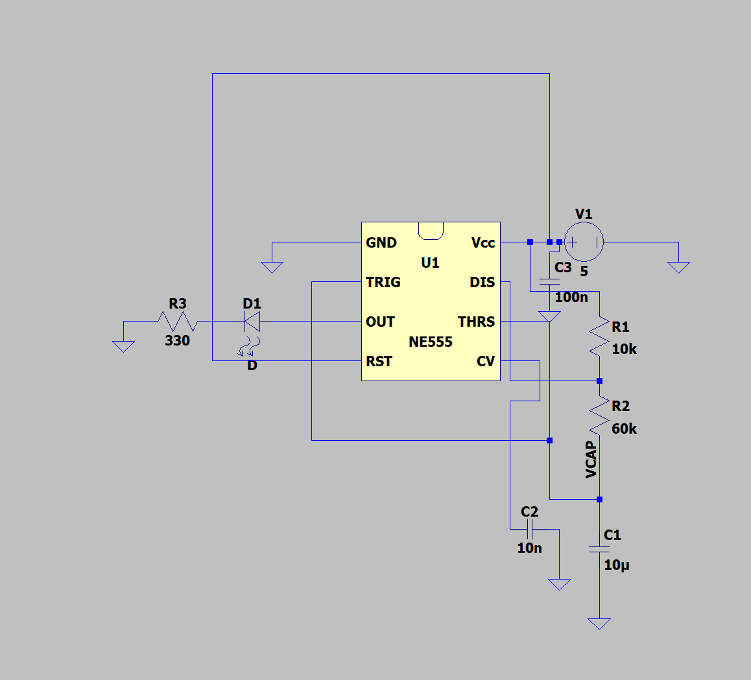
Figure 1. LTspice NE555 astable circuit after construction, including VCAP, output branch and decoupling.
- RESET was tied to VCC to keep the timer enabled.
- TRIGGER and THRESHOLD were tied to the timing-capacitor node VCAP.
- The 10 nF CONTROL capacitor and 100 nF VCC decoupling capacitor were separated from the 10 uF timing capacitor.
- The output node was labelled VOUT and the timing node VCAP for clean waveform and measurement references.
- Transient command used: .tran 0 5s 0 1ms startup.
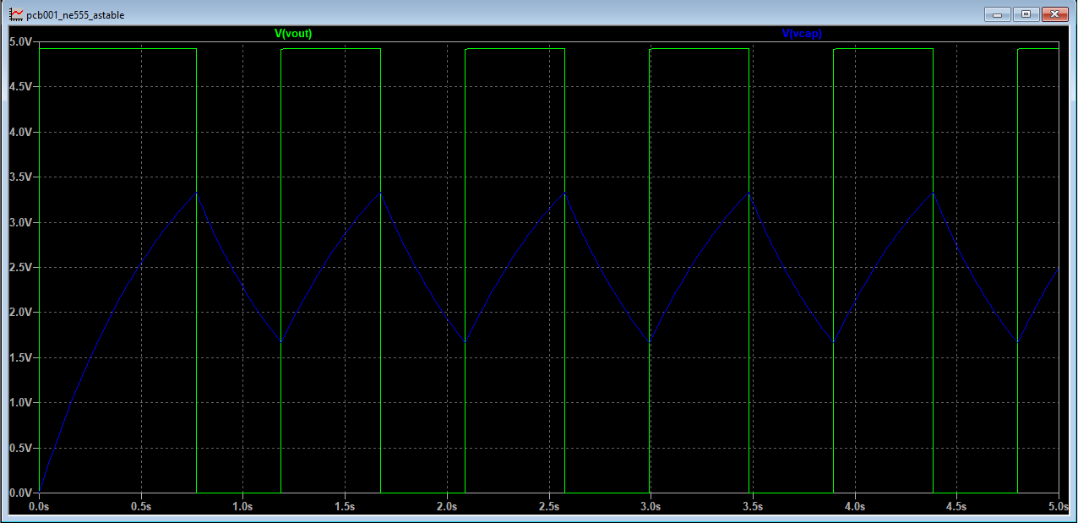
Figure 2. Successful LTspice transient result: VOUT square wave and VCAP exponential charge/discharge between approximately 1/3 and 2/3 VCC.
Quantity | Analytical | LTspice midpoint | Relative error
tHIGH | 485.100 ms | 485.925 ms | +0.170%
tLOW | 415.800 ms | 416.961 ms | +0.279%
Period | 900.900 ms | 902.886 ms | +0.220%
Frequency | 1.1100 Hz | 1.10756 Hz | -0.220%
Duty cycle | 53.846% | 53.819% | -0.050%
VCAP minimum | 1.6667 V | 1.66567 V | -0.060%
VCAP maximum | 3.3333 V | 3.33433 V | +0.030%
Midpoint LTspice verification result: PASS. The model reproduced the analytical timing and switching thresholds with sub-0.3% timing deviation.

6. LTspice Full-Range Sweep and Measurement Correction
The fixed midpoint timing resistor was parameterized so a single LTspice run could execute RB = 10 kOhm, 60 kOhm and 110 kOhm. The first sweep exposed a test-method problem: period and frequency were correct, but tHIGH and duty became negative at steps 1 and 3 because the first FALL after TD=1 s sometimes occurred before the first RISE.
Corrected edge-time measurement strategy
.step param RBval list 10k 60k 110k
.meas tran TR1 WHEN V(vout)=2.5 TD=1s RISE=1
.meas tran TR2 WHEN V(vout)=2.5 TD=1s RISE=2
.meas tran TF1 WHEN V(vout)=2.5 TD=1s FALL=1
.meas tran TF2 WHEN V(vout)=2.5 TD=1s FALL=2
.meas tran tHIGH PARAM if(TF1>TR1, TF1-TR1, TF2-TR1)
.meas tran PERIOD PARAM TR2-TR1
.meas tran tLOW PARAM PERIOD-tHIGH
.meas tran FREQ PARAM 1/PERIOD
.meas tran DUTY PARAM 100*tHIGH/PERIOD
.meas tran VCAP_MIN MIN V(vcap) FROM 1s TO 5s
.meas tran VCAP_MAX MAX V(vcap) FROM 1s TO 5s
RB | tHIGH (ms) | tLOW (ms) | Period (ms) | Frequency (Hz) | Duty | VCAP min / max
10 kOhm | 138.819 | 69.535 | 208.354 | 4.7995 | 66.627% | 1.6657 / 3.3343 V
60 kOhm | 485.925 | 416.961 | 902.886 | 1.1076 | 53.819% | 1.6657 / 3.3343 V
110 kOhm | 833.112 | 764.317 | 1597.429 | 0.6260 | 52.153% | 1.6657 / 3.3343 V
Engineering lesson: a failing measurement result is not automatically a failing circuit. The waveform and period data showed the oscillator was correct; the negative timing values were caused by a test-edge selection error. The measurement method was corrected rather than changing a working design.

7. LED Output-Stage Verification
The output branch was instrumented with .meas statements for branch current and VOUT extrema. The first run produced ILED,max ~= 12.735 mA. Inspection of D1 revealed that the selected device was a 1N4148 silicon switching diode, not an LED.
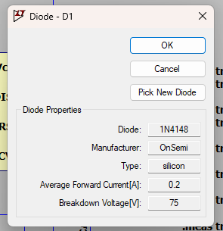
Figure 3. LTspice D1 properties showing the initially selected 1N4148 silicon diode model.
- With the 1N4148 model, the inferred forward drop was around the ordinary silicon-diode range, so the branch current was not representative of a visible LED.
- D1 was changed to a built-in LED model for simulation purposes. This model is a verification proxy; exact physical LED selection remains a BOM task.
- The 330 Ohm resistor was deliberately left unchanged so the original analytical design could be tested rather than tuned to the simulator.
RB | ILED max | ILED avg | VOUT max | VOUT min
10 kOhm | 9.005 mA | 3.980 mA | 4.9643 V | ~0 V
60 kOhm | 9.006 mA | 3.188 mA | 4.9643 V | ~0 V
110 kOhm | 9.006 mA | 2.950 mA | 4.9643 V | ~0 V
LED output-stage result: PASS. Peak current of approximately 9.0 mA agrees with the 9.1 mA first-pass hand calculation and confirms RLED = 330 Ohm for the current design.

8. Tinkercad Virtual Breadboard - Purpose and Architecture
Tinkercad was inserted as an explicit bridge between SPICE verification and KiCad PCB capture. LTspice verifies electrical behaviour using a device model; Tinkercad forces the design to be translated into actual DIP-8 pin numbers, breadboard connectivity, component orientation, potentiometer terminals and physical-style wiring.
Verification flow used today: hand analysis -> LTspice -> Tinkercad virtual breadboard -> Arduino quantitative logger -> KiCad next.
555 pin | Name | Tinkercad connection
1 | GND | Ground rail
2 | TRIGGER | VCAP
3 | OUTPUT | LED -> 330 Ohm -> GND
4 | RESET | Positive rail
5 | CONTROL | 10 nF -> GND
6 | THRESHOLD | VCAP
7 | DISCHARGE | RA/RB junction
8 | VCC | Positive rail
Supply difference. The virtual breadboard used a 3-cell 1.5 V holder, so the circuit ran at approximately 4.49 V rather than the 5.0 V LTspice design point. This was retained as a useful second operating condition. The 555 thresholds scaled with supply voltage, while the RC timing remained close to the analytical predictions.

9. Tinkercad Construction Worklog
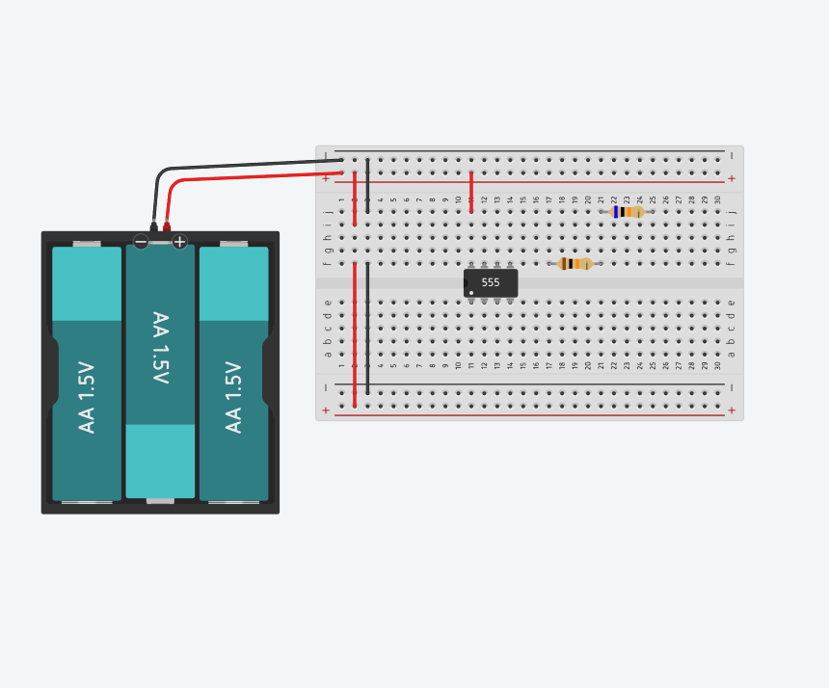
Figure 4. Early Tinkercad build: 555 straddling the breadboard centre gap, battery rails established and timing components staged.
1. Placed the 555 across the centre trench and mapped the physical DIP pin numbers from the orientation marker.
2. Established the positive and ground rails and connected the 555 power, ground and RESET connections.
3. Added the 100 nF supply decoupling capacitor and kept it separate from the timing network.
4. Connected RA = 10 kOhm from the positive rail to Pin 7 DISCHARGE.
5. Connected the fixed RB = 10 kOhm from Pin 7 toward the potentiometer.
6. Placed a 100 kOhm potentiometer and used it as a variable resistance element in the timing path.
7. Tied Pins 2 and 6 together to form VCAP and connected the pot output and C1 = 10 uF to that node.
8. Connected C2 = 10 nF from CONTROL (Pin 5) to ground.
9. Connected the LED branch from Pin 3 through the LED and 330 Ohm resistor to ground.
10. Performed repeated screenshot checks to verify breadboard columns and correct several visually ambiguous connections before simulation.
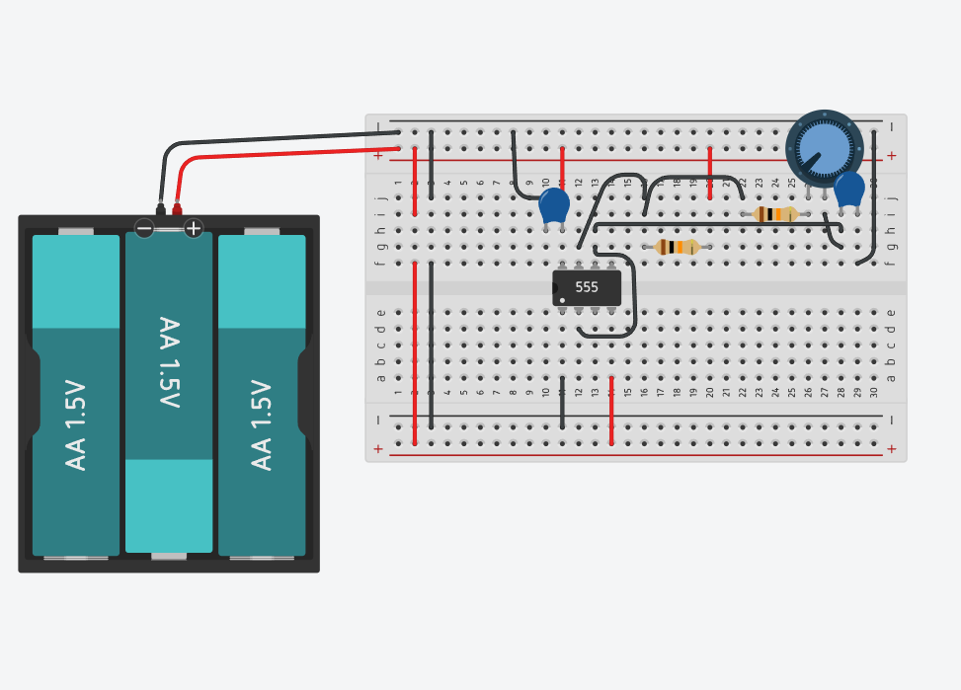
Figure 5. Tinkercad model after the timing network, potentiometer and VCAP interconnections were established.
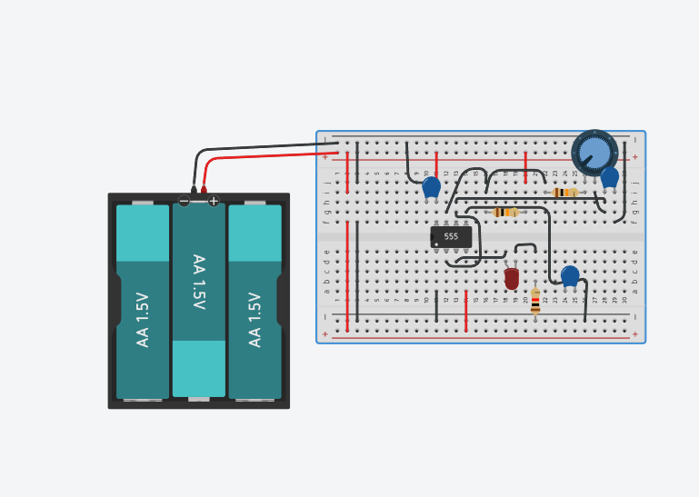
Figure 6. Completed virtual breadboard before Arduino data logging: NE555 astable, timing network, LED branch and auxiliary capacitors.

10. Oscilloscope Instrumentation
Two Tinkercad oscilloscopes were used to replicate the LTspice two-waveform observation. VOUT was probed at Pin 3 and VCAP at the Pins 2/6 timing node, each referenced to circuit ground.
- An initial scope timebase was accidentally set in nanoseconds. This showed only an isolated transition because the 555 period is hundreds of milliseconds to seconds.
- The timebase was corrected to the 100-200 ms/div range, allowing complete output cycles to be observed.
- At the 4.49 V breadboard supply, VCAP was expected to switch close to 1.50 V and 2.99 V, while VOUT switched between approximately 0 V and 4.38 V.
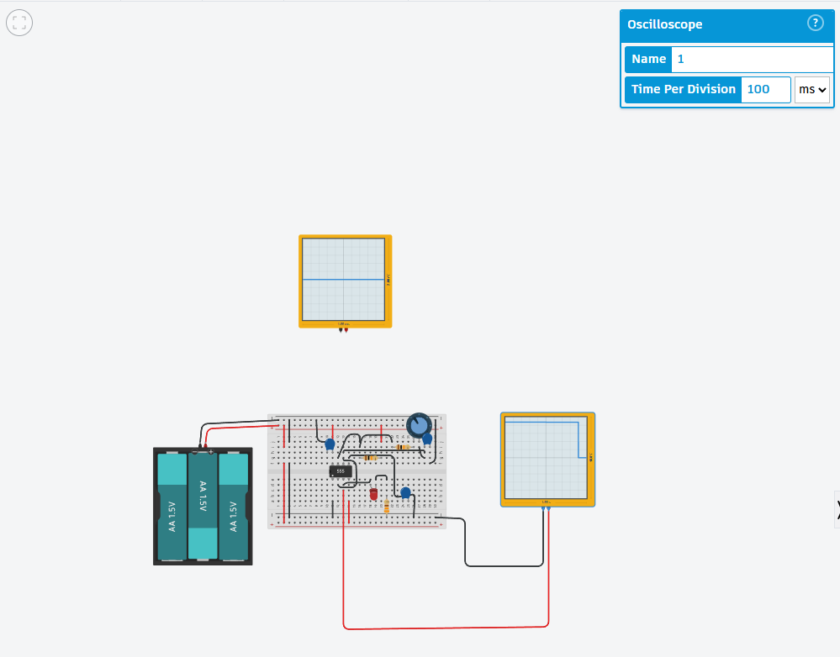
Figure 7. Tinkercad oscilloscope instrumentation used to observe the 555 output at a millisecond-scale timebase.

11. Arduino Uno R3 Measurement Logger
Because Tinkercad does not provide LTspice-style .meas automation, an Arduino Uno R3 was added solely as a passive data logger. It did not power or control the 555 circuit.
Arduino input | Circuit node | Purpose
A0 | Pin 3 / VOUT | Measure output HIGH/LOW waveform
A1 | VCAP / Pins 2+6 | Measure timing-capacitor voltage
A2 | Positive supply rail | Measure actual battery voltage
GND | Circuit ground rail | Common voltage reference
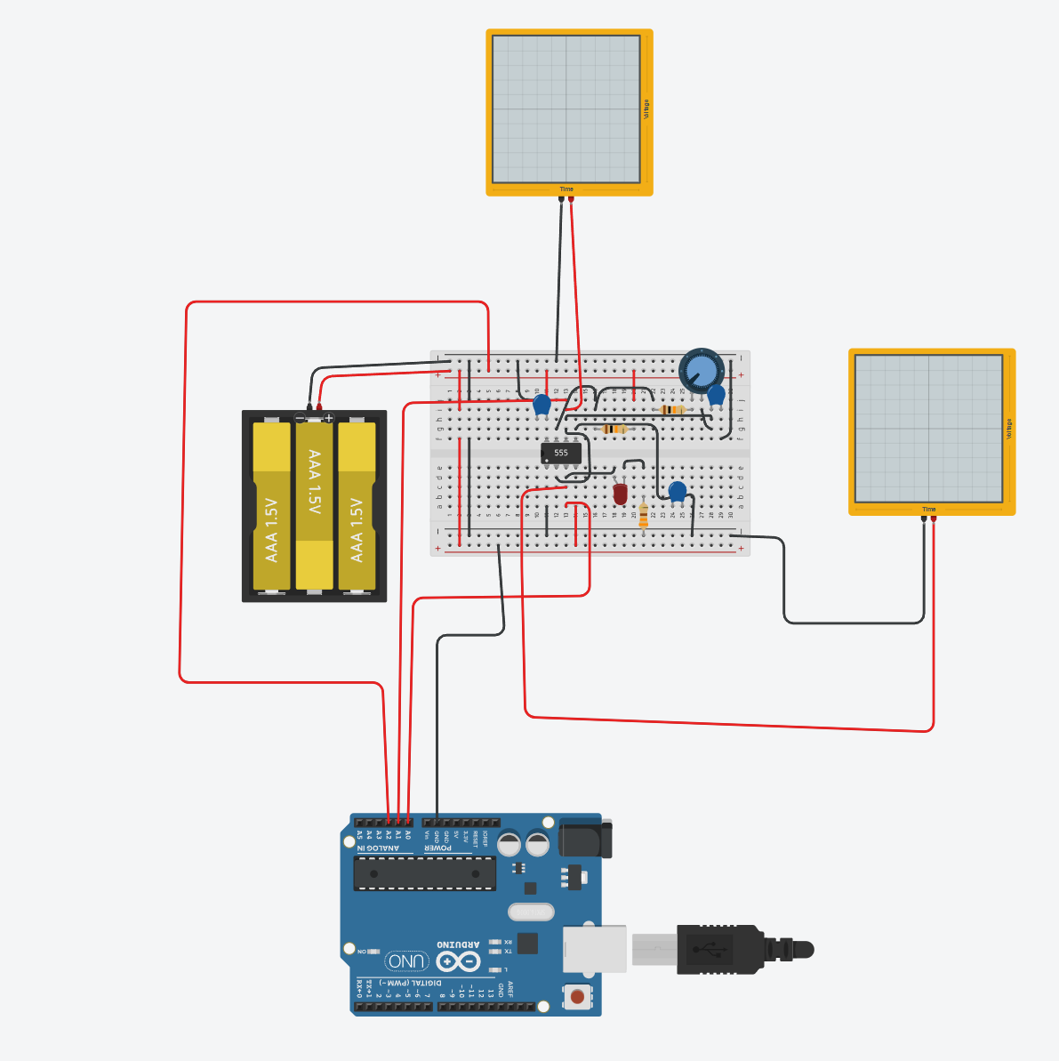
Figure 8. Arduino Uno R3 connected as a four-wire measurement instrument alongside the two Tinkercad oscilloscopes.
Reference-wiring fault and diagnosis. The first Arduino dataset contained negative voltages and VCC=0 V. This was traced to Arduino GND being referenced to the positive rail. After moving the logger ground to the actual negative rail, VOUT, VCAP and VCC became physically meaningful positive measurements. The timing pattern in the erroneous dataset was already consistent with the oscillator, which helped distinguish a reference problem from a circuit problem.
Logger development. The Arduino software evolved from raw CSV-style sampling into an engineering logger that waits for settling, samples every 10 ms, detects rising/falling output edges, rejects partial starting cycles, averages complete-cycle timing and prints a compact measurement summary.
Final measurement strategy
Measurement window: 8000 ms
Sample interval: 10 ms
State threshold: VOUT > 2.5 V => HIGH
Edge logic:
LOW -> HIGH = RISE, starts a valid cycle
HIGH -> LOW = FALL, ends tHIGH
next RISE = ends tLOW and period
A partial cycle already in progress when capture begins is ignored for cycle averages.

12. Tinkercad Quantitative Results: Minimum, Midpoint, Maximum
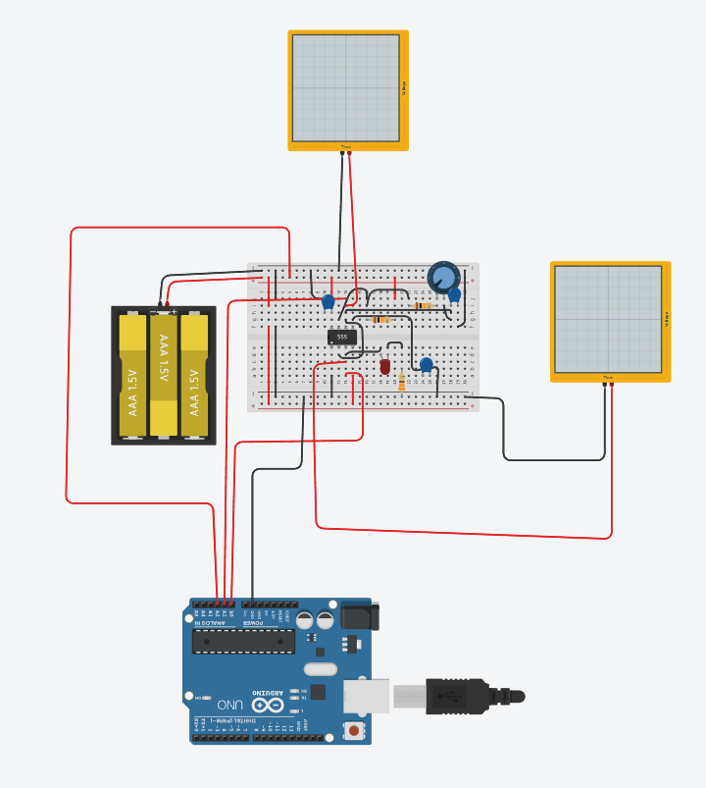
Figure 9. Tinkercad/Arduino configuration used for the minimum-resistance (fast) potentiometer measurement.
Metric | Minimum / fast result
Complete cycles analysed | 38
Average tHIGH | 138.421 ms
Average tLOW | 69.500 ms
Average period | 207.921 ms
Frequency | 4.8095 Hz
Duty cycle | 66.574%
VCAP min / max | 1.5005 V / 2.9912 V
VOUT min / max | 0.0000 V / 4.3793 V
Average VCC | 4.4901 V
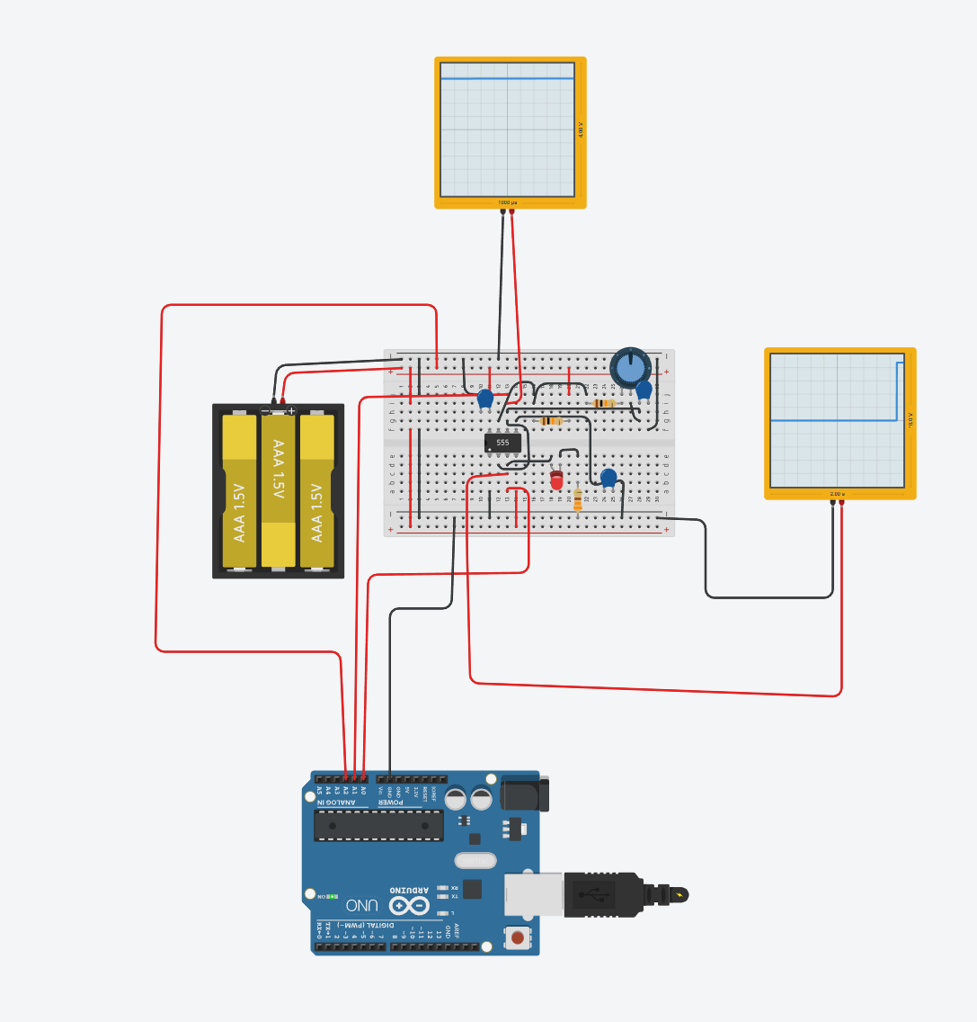
Figure 10. Tinkercad/Arduino configuration at the midpoint potentiometer setting.
Metric | Midpoint result
Complete cycles analysed | 8
Average tHIGH | 481.250 ms
Average tLOW | 420.000 ms
Average period | 901.250 ms
Frequency | 1.1096 Hz
Duty cycle | 53.398%
VCAP min / max | 1.5005 V / 2.9912 V
VOUT min / max | 0.0000 V / 4.3793 V
Average VCC | 4.4913 V
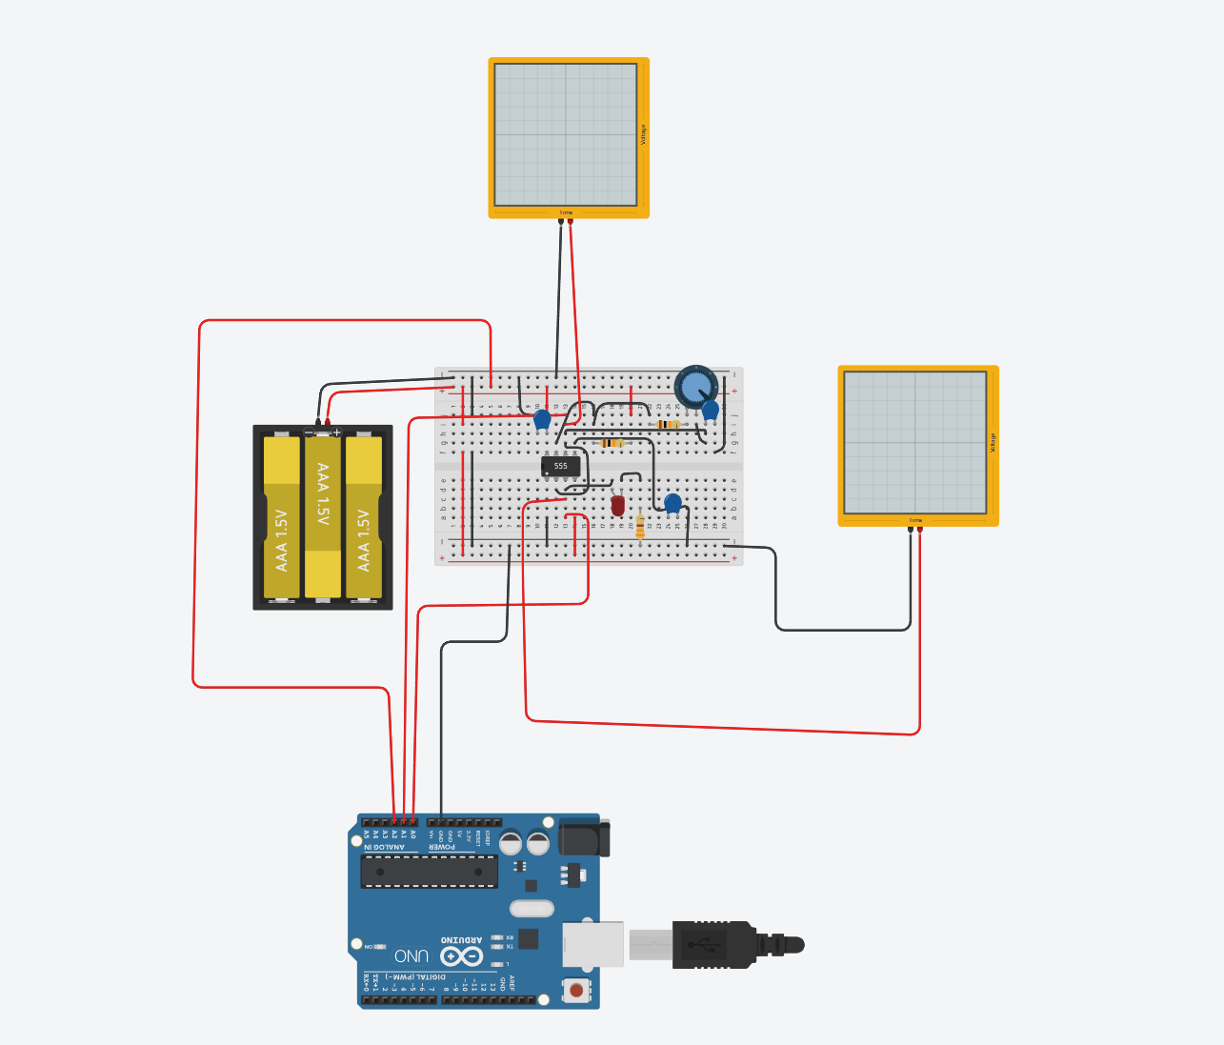
Figure 11. Tinkercad/Arduino configuration at the maximum-resistance (slow) potentiometer setting.
Metric | Maximum / slow result
Complete cycles analysed | 4
Average tHIGH | 822.500 ms
Average tLOW | 775.000 ms
Average period | 1597.500 ms
Frequency | 0.6260 Hz
Duty cycle | 51.487%
VCAP min / max | 1.5005 V / 2.9912 V
VOUT min / max | 0.0000 V / 4.3793 V
Average VCC | 4.4916 V
Threshold check. For VCC around 4.49 V, the ideal 1/3 and 2/3 thresholds are approximately 1.497 V and 2.994 V. All three Tinkercad runs measured approximately 1.5005 V and 2.9912 V, providing direct evidence that the timer is switching at the expected normalized thresholds.

13. Three-Way Verification Comparison
Setting | Quantity | Analytical | LTspice | Tinkercad
Minimum | tHIGH (ms) | 138.600 | 138.819 | 138.421
Minimum | tLOW (ms) | 69.300 | 69.535 | 69.500
Minimum | Period (ms) | 207.900 | 208.354 | 207.921
Minimum | Frequency (Hz) | 4.8100 | 4.7995 | 4.8095
Minimum | Duty (%) | 66.667 | 66.627 | 66.574
Midpoint | tHIGH (ms) | 485.100 | 485.925 | 481.250
Midpoint | tLOW (ms) | 415.800 | 416.961 | 420.000
Midpoint | Period (ms) | 900.900 | 902.886 | 901.250
Midpoint | Frequency (Hz) | 1.1100 | 1.1076 | 1.1096
Midpoint | Duty (%) | 53.846 | 53.819 | 53.398
Maximum | tHIGH (ms) | 831.600 | 833.112 | 822.500
Maximum | tLOW (ms) | 762.300 | 764.317 | 775.000
Maximum | Period (ms) | 1593.900 | 1597.429 | 1597.500
Maximum | Frequency (Hz) | 0.6274 | 0.6260 | 0.6260
Maximum | Duty (%) | 52.174 | 52.153 | 51.487
Setting | Tinkercad period error vs analytical | Tinkercad frequency error vs analytical | Interpretation
Minimum | +0.010% | -0.010% | Essentially exact period match
Midpoint | +0.039% | -0.036% | Essentially exact period match
Maximum | +0.226% | -0.222% | Excellent agreement at slow end
Sampling uncertainty. The Tinkercad logger sampled every 10 ms. Individual HIGH and LOW durations can therefore show several-millisecond quantization error at detected edges, especially at the midpoint and slow settings. Full periods are much less sensitive because edge quantization partially cancels and multiple complete cycles are averaged.
The most important cross-tool result is frequency: analytical 4.810 / 1.110 / 0.627 Hz, LTspice 4.800 / 1.108 / 0.626 Hz, and Tinkercad 4.810 / 1.110 / 0.626 Hz. The three independent representations agree across the full adjustment range.

14. Verification Gates and Design-Freeze Decision
Gate | Status | Evidence
G1A - Analytical design | PASS | RC exponential derivation, threshold calculations, three-point timing predictions, LED resistor calculation
G1B - Full-range LTspice | PASS | 10/60/110 kOhm sweep; timing and thresholds agree closely with analysis
G1C - LED output stage | PASS | LED model gives ~9.0 mA peak with 330 Ohm; VOUT remains well behaved
G1D - Tinkercad virtual breadboard | PASS | Physical-style wiring and three-point Arduino measurements reproduce expected operation
Pre-KiCad electrical design | READY | No unresolved functional issue remains before schematic capture
Item | Freeze status | Note
RA 10 kOhm | Frozen | Verified analytically and in both simulators
RB fixed 10 kOhm | Frozen | Provides defined minimum resistance
Potentiometer 100 kOhm | Frozen electrically | Exact physical part/footprint still to select
C1 10 uF | Frozen electrically | Exact dielectric/package still to select
C2 10 nF | Frozen | Control bypass
C3 100 nF | Frozen | Supply decoupling
RLED 330 Ohm | Frozen | ~9 mA peak in LTspice LED model
LED exact part number | Open BOM detail | Choose a real through-hole LED before footprint freeze
Nominal PCB supply | 5 V | Tinkercad 4.49 V run was a secondary verification condition

15. Issues, Corrections, and Engineering Lessons
Issue / observation | What happened | Engineering lesson
LTspice negative tHIGH values | Fixed edge numbers paired a FALL before a RISE for some stepped cases | Verify test logic before blaming the DUT; derive robust measurements from explicit event timestamps.
Wrong diode model | 1N4148 gave ~12.7 mA, inconsistent with the LED assumption | Model identity matters. A symbol that looks like a diode/LED is not enough; inspect the actual device model.
Tinkercad pin ambiguity | Several screenshots required close inspection of columns and DIP orientation | Physical translation is a separate verification problem from schematic correctness.
Scope timebase in ns | Only a transition was visible | Instrumentation must be configured to the expected signal timescale.
Arduino GND initially on wrong reference | Negative apparent voltages and VCC=0 V | A measurement system requires a correct shared reference; strange signs often indicate reference errors.
Partial-cycle averaging | A preliminary logger could count a cycle already in progress at capture start | Qualification logic should require a complete RISE-FALL-RISE sequence before accepting a cycle.
Tinkercad at 4.49 V vs LTspice at 5 V | Threshold voltages shifted but timing remained almost unchanged | Normalized 555 thresholds track VCC; RC timing is largely supply-independent in the ideal astable model.

16. Next Work Package - KiCad Schematic Capture
1. Create the KiCad project and schematic sheet for PCB-001.
2. Place NE555, RA, RB fixed, 100 kOhm potentiometer, C1/C2/C3, LED, 330 Ohm resistor, 5 V connector and test points.
3. Reproduce the verified connectivity exactly; do not introduce functional changes during capture.
4. Add net labels such as VCC, GND, VCAP and VOUT for clarity.
5. Select exact physical components and assign footprints only after checking real datasheets and package dimensions.
6. Run ERC and resolve/justify every warning before moving to PCB Editor.
7. Plan test points for +5 V, GND, VOUT and VCAP to preserve the same validation observability used in LTspice/Tinkercad.
8. Only after schematic/footprint review: board outline, placement, routing, GND pour, DRC and design review.
Do not redesign the circuit in KiCad. The next task is faithful capture of a circuit whose functionality has already been demonstrated three ways.

Appendix A. Final Arduino Measurement Logger
The following code captures an 8-second window after a 2-second settle time, samples every 10 ms, records voltage extrema, detects edges and averages only complete RISE-FALL-RISE cycles. It is aligned with the 8-second evidence reported in this worklog.
const int VOUT_PIN = A0;
const int VCAP_PIN = A1;
const int VCC_PIN = A2;
const float ADC_REF = 5.0;
const float ADC_MAX = 1023.0;
const unsigned long SETTLE_TIME_MS = 2000;
const unsigned long CAPTURE_TIME_MS = 8000;
const unsigned long SAMPLE_TIME_MS = 10;
const float STATE_THRESHOLD = 2.5;
unsigned long captureStart;
unsigned long nextSample;
bool stateInitialised = false;
bool previousState = false;
bool haveRise = false;
bool haveFall = false;
unsigned long riseTime = 0;
unsigned long fallTime = 0;
double sumHigh = 0.0;
double sumLow = 0.0;
double sumPeriod = 0.0;
unsigned int completeCycles = 0;
float vcapMin = 99.0;
float vcapMax = -99.0;
float voutMin = 99.0;
float voutMax = -99.0;
double vccSum = 0.0;
unsigned long sampleCount = 0;
bool finished = false;
void setup() {
Serial.begin(115200);
Serial.println("PCB-001 NE555 TINKERCAD VERIFICATION");
Serial.println("Allowing circuit to settle for 2 seconds...");
delay(SETTLE_TIME_MS);
captureStart = millis();
nextSample = captureStart;
Serial.println("EDGE LOG");
Serial.println("Time(ms)\tEdge\tVCAP(V)\tVOUT(V)");
}
void loop() {
if (finished) return;
unsigned long now = millis();
unsigned long elapsed = now - captureStart;
if (elapsed >= CAPTURE_TIME_MS) {
printSummary();
finished = true;
return;
}
if (now >= nextSample) {
int rawVout = analogRead(VOUT_PIN);
int rawVcap = analogRead(VCAP_PIN);
int rawVcc = analogRead(VCC_PIN);
float vout = rawVout * ADC_REF / ADC_MAX;
float vcap = rawVcap * ADC_REF / ADC_MAX;
float vcc = rawVcc * ADC_REF / ADC_MAX;
bool currentState = (vout > STATE_THRESHOLD);
if (vcap < vcapMin) vcapMin = vcap;
if (vcap > vcapMax) vcapMax = vcap;
if (vout < voutMin) voutMin = vout;
if (vout > voutMax) voutMax = vout;
vccSum += vcc;
sampleCount++;
if (!stateInitialised) {
previousState = currentState;
stateInitialised = true;
}
else if (currentState != previousState) {
if (currentState) {
Serial.print(elapsed);
Serial.print("\tRISE\t");
Serial.print(vcap, 4);
Serial.print("\t");
Serial.println(vout, 4);
if (haveRise && haveFall) {
unsigned long tHigh = fallTime - riseTime;
unsigned long tLow = elapsed - fallTime;
unsigned long period = elapsed - riseTime;
sumHigh += tHigh;
sumLow += tLow;
sumPeriod += period;
completeCycles++;
}
riseTime = elapsed;
haveRise = true;
haveFall = false;
}
else {
Serial.print(elapsed);
Serial.print("\tFALL\t");
Serial.print(vcap, 4);
Serial.print("\t");
Serial.println(vout, 4);
if (haveRise) {
fallTime = elapsed;
haveFall = true;
}
}
previousState = currentState;
}
nextSample += SAMPLE_TIME_MS;
}
}
void printSummary() {
Serial.println("============================================================");
Serial.println("PCB-001 TINKERCAD MEASUREMENT SUMMARY");
Serial.println("============================================================");
Serial.print("Complete cycles analysed : ");
Serial.println(completeCycles);
if (completeCycles > 0) {
double avgHighMs = sumHigh / completeCycles;
double avgLowMs = sumLow / completeCycles;
double avgPeriodMs = sumPeriod / completeCycles;
double frequencyHz = 1000.0 / avgPeriodMs;
double dutyPercent = 100.0 * avgHighMs / avgPeriodMs;
Serial.println("TIMING");
Serial.print("Average tHIGH (ms) : "); Serial.println(avgHighMs, 3);
Serial.print("Average tLOW (ms) : "); Serial.println(avgLowMs, 3);
Serial.print("Average period (ms) : "); Serial.println(avgPeriodMs, 3);
Serial.print("Frequency (Hz) : "); Serial.println(frequencyHz, 4);
Serial.print("Duty cycle (%) : "); Serial.println(dutyPercent, 3);
}
Serial.println("VOLTAGES");
Serial.print("VCAP minimum (V) : "); Serial.println(vcapMin, 4);
Serial.print("VCAP maximum (V) : "); Serial.println(vcapMax, 4);
Serial.print("VOUT minimum (V) : "); Serial.println(voutMin, 4);
Serial.print("VOUT maximum (V) : "); Serial.println(voutMax, 4);
if (sampleCount > 0) {
Serial.print("Average VCC (V) : ");
Serial.println(vccSum / sampleCount, 4);
}
Serial.println("Capture duration : 8000 ms");
Serial.println("Sample interval : 10 ms");
Serial.println("============================================================");
Serial.println("CAPTURE COMPLETE");
}

Appendix B. Final LTspice .meas / .step Block
.meas tran TR1 WHEN V(vout)=2.5 TD=1s RISE=1
.meas tran TR2 WHEN V(vout)=2.5 TD=1s RISE=2
.meas tran TF1 WHEN V(vout)=2.5 TD=1s FALL=1
.meas tran TF2 WHEN V(vout)=2.5 TD=1s FALL=2
.meas tran tHIGH PARAM if(TF1>TR1, TF1-TR1, TF2-TR1)
.meas tran PERIOD PARAM TR2-TR1
.meas tran tLOW PARAM PERIOD-tHIGH
.meas tran FREQ PARAM 1/PERIOD
.meas tran DUTY PARAM 100*tHIGH/PERIOD
.meas tran VCAP_MIN MIN V(vcap) FROM 1s TO 5s
.meas tran VCAP_MAX MAX V(vcap) FROM 1s TO 5s
.meas tran ILED_MAX MAX abs(I(R3)) FROM 1s TO 5s
.meas tran ILED_AVG AVG abs(I(R3)) FROM 1s TO 5s
.meas tran VOUT_MAX MAX V(vout) FROM 1s TO 5s
.meas tran VOUT_MIN MIN V(vout) FROM 1s TO 5s
.step param RBval list 10k 60k 110k
.tran 0 5s 0 1ms startup

Appendix C. Pre-KiCad Quick Reference
Parameter | Value / expected range
Nominal PCB VCC | 5.0 V
RA | 10 kOhm
RB fixed | 10 kOhm
Potentiometer | 100 kOhm
Effective RB | 10-110 kOhm
C1 timing | 10 uF
C2 CONTROL bypass | 10 nF
C3 VCC decoupling | 100 nF
RLED | 330 Ohm
Expected LED peak current | ~9 mA
Fast frequency | ~4.81 Hz
Midpoint frequency | ~1.11 Hz
Slow frequency | ~0.627 Hz
Nominal 5 V thresholds | ~1.667 V and ~3.333 V
Tinkercad ~4.49 V thresholds | ~1.50 V and ~2.99 V
Reference material: project-supplied Philips Semiconductors NE/SA/SE555 family datasheet; LTspice 24.1.10 simulation logs; Tinkercad virtual-breadboard screenshots; Arduino Uno R3 Serial Monitor summaries captured during the 14 August 2026 work session.

