PCB-001
NE555 Astable LED Flasher
Detailed Engineering Worklog
Work period: 13 August 2026, 21:13 to 14 August 2026, 08:29 (Ireland)
Project | PCB-001 - Adjustable NE555 astable LED flasher
Repository | pcb-001-ne555-astable-led-flasher
Primary tools | LTspice 24.1.10, Git/GitHub, MATLAB, NE555 datasheet
Design stage | Circuit engineering and pre-KiCad simulation verification
Current verification point | Midpoint timing configuration verified
Document cutoff | 14 August 2026, 08:29

Purpose: preserve a traceable record of planning, design decisions, LTspice construction, numerical verification, issues encountered, and next actions.

1. Executive Summary
This work period advanced PCB-001 from project-organization refinement into a quantitatively verified LTspice implementation of the NE555 astable core. The central technical achievement was the successful numerical confirmation of the midpoint timing configuration (RA = 10 kOhm, RB = 60 kOhm, C = 10 uF) against the analytical model.
- Refined the repository/worklog organization and established timestamped session-record conventions.
- Revisited the project schedule and converted the 14 August circuit-engineering block from broad datasheet study into an execution-focused design session.
- Inserted LTspice simulation as a formal verification stage before KiCad schematic capture.
- Completed the analytical baseline for the NE555 astable timing network and LED output branch.
- Constructed the NE555 astable circuit incrementally in LTspice, correcting wiring ambiguities as they appeared.
- Added timing-node and output net labels to make waveform analysis deterministic and readable.
- Ran a 5 s startup transient simulation and visually verified VCAP and VOUT behavior.
- Added .meas statements and obtained numerical values for HIGH time, LOW time, period, frequency, duty cycle, and capacitor threshold extrema.
- Confirmed that the midpoint simulation matches the ideal analytical prediction to within approximately 0.3% for the main timing quantities.

Current gate status
Gate | Status | Evidence
G0 - Project definition | PASS | Scope, repo, worklog structure, and milestones established.
G1A - Analytical design | PASS | Timing equations, threshold values, and LED resistor baseline completed.
G1B - Midpoint simulation | PASS | LTspice waveform and .meas results agree with analytical model.

2. Session Scope and Starting Point
Starting point. The previous worklog session had already established the project concept, high-level requirements, initial repository structure, NE555 datasheet orientation, MATLAB astable-cycle animation, and the need for a dedicated worklog folder. The new work period began with repository/worklog housekeeping and then moved into circuit-design verification.
Session end boundary used for this log. The prior worklog folder convention referenced 2026-08-13_2113. This document therefore logs work from that point through 08:29 on 14 August 2026.

3. Repository and Worklog Organization
- Recognized that the original project-directory creation command did not include a dedicated timestamped worklog structure.
- Established a top-level worklogs/ directory for detailed session records, separate from docs/engineering-log.md.
- Defined the timestamp convention YYYY-MM-DD_HHMM so worklog folders sort chronologically.
- Defined the intended session structure: detailed Word report, session-summary.md, and evidence/ subdirectory.
- Identified that Git does not track empty directories; a placeholder such as .gitkeep is required if an empty evidence/ folder must appear in the repository.
- Observed Git state showing the local main branch ahead of origin/main by one commit while the working tree was clean.
- Provided the PowerShell push workflow for synchronizing committed local changes to the GitHub remote.
worklogs/
└── 2026-08-13_2113/
├── PCB-001_Engineering_Log_2026-08-13.docx
├── session-summary.md
└── evidence/
└── .gitkeep
Traceability note: The conversation did not contain a final Git push success message, so remote synchronization should not be recorded as independently confirmed in this worklog.

4. Project Scheduling Refinement
The project schedule was revisited to keep PCB-001 moving without rushing into PCB layout. The key planning change was to separate analytical design, simulation verification, KiCad capture, footprint verification, PCB layout, and design review into distinct gates.
Stage | Purpose | Exit condition
Analytical design | Predict timing and LED behavior before simulation. | Equations and component values justified.
LTspice verification | Challenge analytical predictions with a device model. | Waveform and .meas agreement.
KiCad schematic | Capture the verified circuit. | ERC reviewed.
Footprint engineering | Map symbols to real packages. | All footprints checked.
PCB layout | Placement, routing, ground strategy. | Routed Rev-A candidate.
Design review | Independent-style review and DRC. | Design freeze decision.

14 August circuit-engineering block
- Replaced broad datasheet study with a 90-minute execution plan.
- Focused the block on timing-network design, LED current-limiting, complete circuit definition, and design-record updates.
- Added the rule that KiCad PCB layout should not begin until circuit behavior is understood and simulation-verified.

5. Analytical Baseline Before LTspice
Candidate midpoint design used for the first simulation:
Parameter | Value | Role
VCC | 5 V | NE555 supply
RA | 10 kOhm | Fixed charge-path resistor
RB | 60 kOhm | Midpoint effective timing resistance
C1 | 10 uF | Timing capacitor
C2 | 10 nF | Control-voltage bypass

Threshold predictions
- Trigger threshold: VTRIG ≈ VCC/3 = 1.6667 V.
- Upper threshold: VTH ≈ 2VCC/3 = 3.3333 V.
- Expected steady-state capacitor behavior: VCAP repeatedly charges and discharges between these two levels.

Timing equations
tHIGH = 0.693 (RA + RB) C
tLOW = 0.693 RB C
T = tHIGH + tLOW
f = 1 / T
Duty = 100 * tHIGH / T
Quantity | Analytical prediction
tHIGH | 0.485100 s
tLOW | 0.415800 s
Period T | 0.900900 s
Frequency f | 1.110001 Hz
Duty cycle | 53.8462 %

LED output baseline
A 330 Ohm current-limiting resistor was selected for the first-pass LED branch. Using an idealized 5 V HIGH output and approximately 2 V LED forward drop gives about 9.1 mA, which is suitable as a first simulation target.

6. LTspice Circuit Construction
The circuit was constructed incrementally rather than all at once. This allowed each connection to be reviewed before the transient simulation was run.
1. Placed the built-in NE555 device model and a 5 V DC source.
2. Connected the NE555 GND pin to node 0 and tied RESET high to the VCC net.
3. Placed R1 = 10 kOhm from VCC to the DISCHARGE node.
4. Placed R2 = 60 kOhm from the DISCHARGE node to the timing node.
5. Joined TRIGGER and THRESHOLD to the timing node.
6. Placed C1 = 10 uF from the timing node to ground.
7. Placed C2 = 10 nF from CONTROL VOLTAGE to ground.
8. Added the LED output branch from OUT through D1 and R3 = 330 Ohm to ground.
9. Added C3 = 100 nF supply decoupling from VCC to ground.
10. Labeled the timing node VCAP and the output node VOUT for readable waveform and .meas references.

Corrections made during construction
- The NE555 GND connection was initially omitted and then corrected.
- The control-voltage (CV) wiring was repeatedly checked because crossing wires made the schematic visually ambiguous.
- The LED resistor was initially shown as 10 kOhm and was corrected to 330 Ohm.
- The supply-decoupling capacitor C3 = 100 nF was added before the final simulation.
- The timing-node label VCAP was placed on the R2/TRIG/THRS/C1 junction.
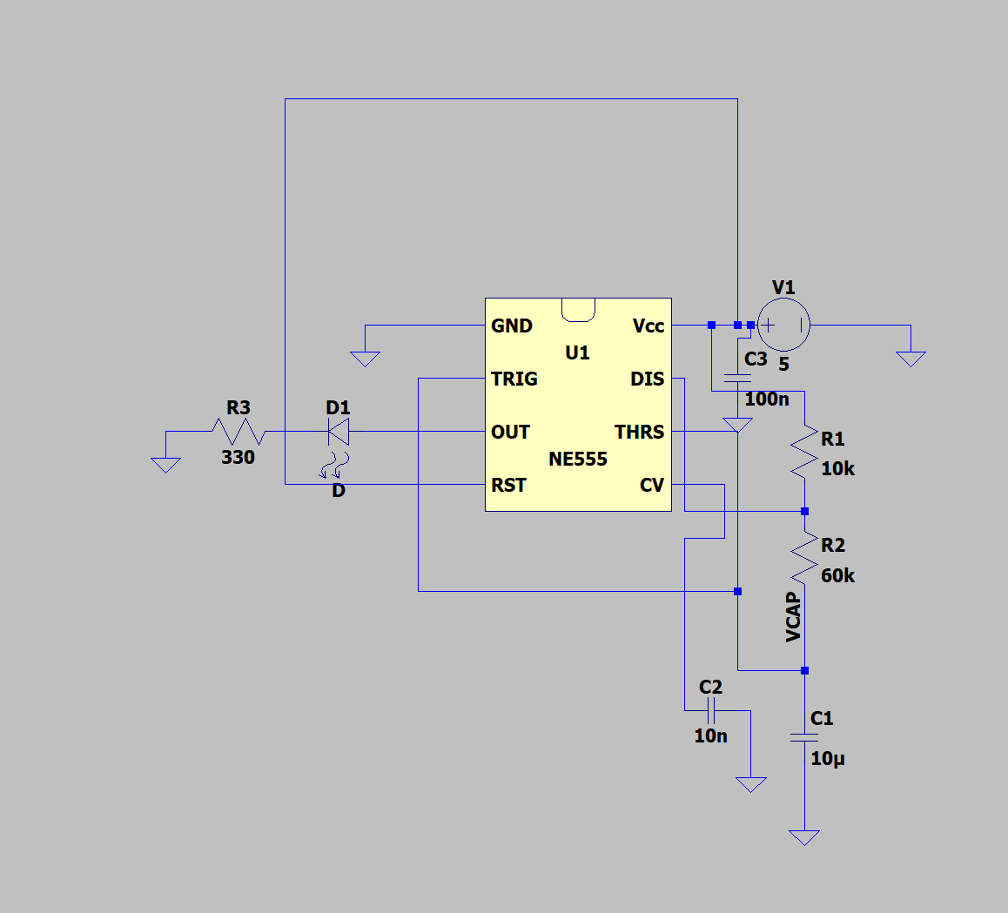
Figure 1. First-pass LTspice schematic used for the successful transient verification.

7. Transient Simulation Setup
.tran 0 5s 0 1ms startup
- Stop time: 5 s, providing several steady-state oscillation cycles.
- Maximum timestep: 1 ms, providing adequate time resolution for the approximately 0.9 s period.
- startup enabled so the timing capacitor begins from an uncharged startup condition.
- First startup cycle treated as a transient and excluded from steady-state timing measurements.

Observed waveforms
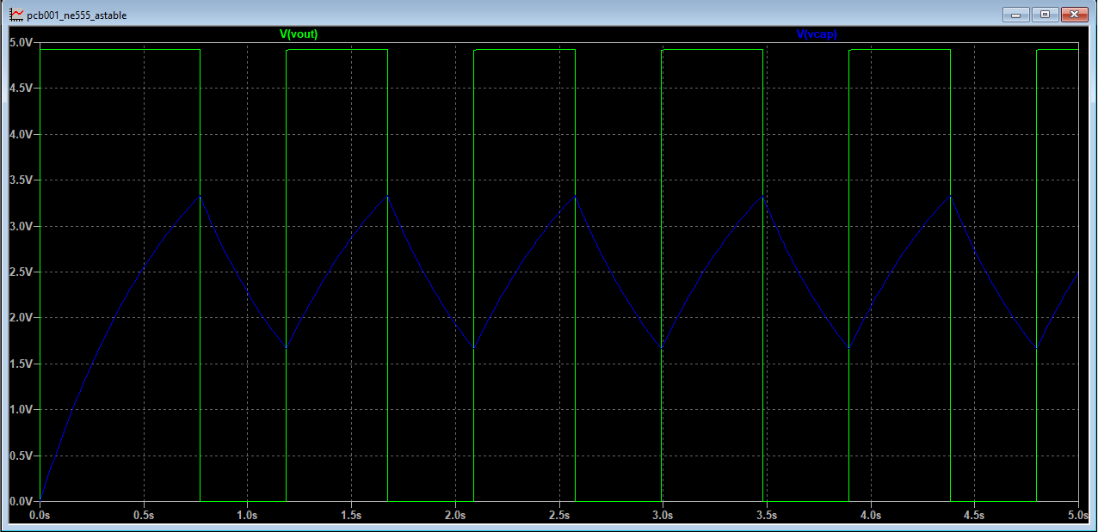
Figure 2. LTspice transient result: VOUT (green) and VCAP (blue).
- VOUT switches between approximately 0 V and 4.9 V.
- VCAP rises toward approximately 3.33 V while the output is HIGH.
- When VCAP reaches the upper threshold, VOUT switches LOW and the timing capacitor discharges.
- VCAP falls toward approximately 1.67 V; at the lower threshold VOUT switches HIGH again.
- The repeated charge/discharge behavior matches the intended astable operating cycle.

8. Numerical Verification Using .meas
The visual waveform check was upgraded to numerical verification using LTspice .meas statements. A 1 s delay was used so edge counting begins after the startup transient.
.meas tran tHIGH TRIG V(vout) VAL=2.5 TD=1s RISE=1 TARG V(vout) VAL=2.5 TD=1s FALL=1
.meas tran tLOW TRIG V(vout) VAL=2.5 TD=1s FALL=1 TARG V(vout) VAL=2.5 TD=1s RISE=2
.meas tran PERIOD TRIG V(vout) VAL=2.5 TD=1s RISE=1 TARG V(vout) VAL=2.5 TD=1s RISE=2
.meas tran FREQ PARAM 1/PERIOD
.meas tran DUTY PARAM 100*tHIGH/PERIOD
.meas tran VCAP_MIN MIN V(vcap) FROM 1s TO 5s
.meas tran VCAP_MAX MAX V(vcap) FROM 1s TO 5s

LTspice 24.1.10 measurement results
Measurement | Result | LTspice interval/method
tHIGH | 0.485924888329 s | 1.18652501599 s -> 1.67244990432 s
tLOW | 0.416960804006 s | 1.67244990432 s -> 2.08941070833 s
Period | 0.902885692335 s | 1.18652501599 s -> 2.08941070833 s
Frequency | 1.10755991427 Hz | Derived as 1/PERIOD
Duty cycle | 53.819092766 % | Derived as 100*tHIGH/PERIOD
VCAP minimum | 1.66566741467 V | Measured from 1 s to 5 s
VCAP maximum | 3.33433270454 V | Measured from 1 s to 5 s

9. Analytical vs Simulation Comparison
Quantity | Analytical | LTspice | Relative error
tHIGH | 0.485100 | 0.485925 | +0.170%
tLOW | 0.415800 | 0.416961 | +0.279%
Period | 0.900900 | 0.902886 | +0.220%
Frequency | 1.110001 | 1.107560 | -0.220%
Duty cycle | 53.846154 | 53.819093 | -0.050%
VCAP min | 1.666667 | 1.665667 | -0.060%
VCAP max | 3.333333 | 3.334333 | +0.030%
Verification conclusion: The midpoint LTspice model agrees with the analytical model to substantially better than 1% for every measured timing and threshold quantity. The largest observed relative deviation is approximately 0.28% (tLOW). This is sufficient to mark the midpoint simulation verification as PASS.

10. Issues, Observations, and Lessons Learned
Observation | Engineering lesson / follow-up
Schematic readability matters | Wire crossings and long routing made CV, THRS, and timing-node connectivity harder to inspect than necessary. Future schematics should use net labels earlier and reduce long perimeter wires.
Git tracks files, not folders | Empty evidence directories will not appear in GitHub unless they contain a tracked placeholder or real artifact.
Simulation should verify a prediction | The analytical model was completed before LTspice; the simulator was therefore used as a verification tool rather than a discovery tool.
Startup is not steady state | The first timing-capacitor cycle begins from 0 V and should not be used for steady-state period measurements.
Ideal equations are still useful | Despite the more realistic NE555 model, the basic ln(2)-based timing equations predicted the observed behavior extremely closely.
Project paths need normalization | The LTspice log shows a generated netlist under simulation\simulation\ltspice. The intended repository structure is simulation\ltspice; this duplicate directory level should be checked and cleaned up before the next commit.

11. Artifacts Created or Updated During This Work Period
Artifact | Reference | Status
LTspice schematic | pcb001_ne555_astable.asc | Constructed and simulation-tested.
LTspice generated netlist | pcb001_ne555_astable.net | Generated by LTspice 24.1.10.
Simulation evidence | V(vout) and V(vcap) transient waveform | Successful steady-state astable behavior.
Measurement configuration | .meas directives | Numerical HIGH/LOW/period/frequency/duty/threshold verification.
Worklog structure | worklogs/YYYY-MM-DD_HHMM/ | Timestamped session-document convention established.
Project schedule | 14-24 August sequence | Revised to insert LTspice verification before KiCad.

12. Project Status at 08:29, 14 August 2026
Work item | Status | Comment
Project/repository structure | ACTIVE | Worklog convention refined; remote sync should be rechecked.
NE555 functional understanding | COMPLETE | Astable threshold and charge/discharge behavior understood.
Analytical midpoint design | COMPLETE | Timing and duty predictions established.
LTspice midpoint construction | COMPLETE | Circuit runs correctly.
LTspice midpoint .meas verification | PASS | Sub-0.3% timing error vs ideal model.
Potentiometer range sweep | NOT STARTED | RB = 10 kOhm, 60 kOhm, 110 kOhm still to verify as a set.
KiCad schematic capture | NOT STARTED | Blocked until full simulation gate is closed.

13. Next Work Session - Recommended Actions
1. Parameterize RB in LTspice and run the same numerical checks at 10 kOhm, 60 kOhm, and 110 kOhm.
2. Confirm the expected full flash-rate range (approximately 4.81 Hz at minimum resistance and 0.627 Hz at maximum resistance).
3. Measure LED current with .meas or direct waveform probing and verify the 330 Ohm resistor choice.
4. Normalize the LTspice repository path so files live under simulation\ltspice rather than simulation\simulation\ltspice.
5. Save simulation screenshots and measurement output into the timestamped evidence folder.
6. Update docs/design-notes.md with the final verified component values and analytical-vs-simulation table.
7. Commit the completed simulation evidence to Git and confirm origin/main is synchronized.
8. Only after the full-range simulation gate passes, begin KiCad schematic capture.

14. Suggested Gate Decision
G1B - Simulation Verification: CONDITIONAL PASS
Reason: The midpoint configuration is fully verified and passes comfortably. However, the intended adjustable design spans RB = 10 kOhm to 110 kOhm. The project should not formally freeze the timing network until the minimum and maximum settings have also been simulated and measured.

15. Session Closeout
- Technical objective achieved: a working NE555 astable LTspice model has been constructed and numerically validated at the midpoint configuration.
- Project-management objective achieved: the workflow now has a clear prediction -> simulation -> comparison -> gate structure.
- No KiCad layout work was started prematurely.
- Primary remaining dependency before schematic freeze: full timing-resistance sweep and associated measurement evidence.
Document generated at the 08:29 worklog cutoff on 14 August 2026. Measurements transcribed from the LTspice 24.1.10 SPICE Error Log supplied during the session.

