PRE-HARDWARE SOFTWARE ACTIVITY RECORD
Synthetic plant-model baseline | Independent capstone-style engineering project
Prepared for: Fortune Olose
Repository: fortuneolose/ros2-raspberry-pi-robot-supervisor
Session date: 25 July 2026
Record prepared: 25 July 2026, 22:38:01 IST
Evidence branch: agent/add-model-baseline
Review state: Draft PR #2; stacked on draft PR #1

Progress snapshot The initial synthetic modelling milestone is complete and reproducible. The broader pre-hardware software programme is approximately 20% complete (18.75% by the milestone-count method documented in Section 7).
Evidence boundary MODEL-001-SYNTHETIC is a software-development result. It is not a physical plant-identification result and does not validate a controller, observer, fixed-point implementation, ROS 2 system, FPGA design, or safety function.

1. Purpose and scope
This record documents the activities completed during the current software milestone, the files produced, the evidence generated, the repository publication sequence, and the current state of the wider pre-hardware software programme. Completion times are evidence-backed by the generated report, Git commits, pull-request metadata, and GitHub Actions logs.
All times are shown in Irish Summer Time (IST, UTC+01:00) and UTC. Provider timestamps containing fractional seconds are rounded to the nearest whole second for readability.

2. Timestamped activity log
Table 1. Verified completion sequence
Ireland time | UTC | Completed action | Evidence / outcome
21:35:04 | 20:35:04 | Generated reproducible synthetic model evidence. | JSON report, 1,001-sample time-series CSV and PNG response graph produced.
21:35:27 | 20:35:27 | Recorded the validated local implementation. | Local commit b918652: “Add synthetic plant model baseline.”
Before 22:05:59 | Before 21:05:59 | Restored the GitHub Codex Connector and verified repository write access. | The provider exposed the installation and repository permissions, but not an exact installation timestamp.
22:05:59 | 21:05:59 | Published the exact committed file tree to GitHub. | Remote commit 12be797; 14 changed files and 2,027 additions.
22:06:21 | 21:06:21 | Opened the review branch as a stacked draft pull request. | Draft PR #2 targets agent/clarify-project-description and contains one commit.
22:06:54 | 21:06:54 | Completed remote continuous-integration validation. | Model-validation jobs passed on Python 3.12 and Python 3.13.

3. Technical implementation delivered

3.1 Model definition
The implemented model represents an encoder-equipped DC motor using shaft position, shaft speed and armature current as states. Armature voltage and opposing load torque are inputs; encoder position is the measured output.
x = [θ, ω, i]ᵀ u = [v, τload]ᵀ y = [θ]
dθ/dt = ω
J·dω/dt = Kt·i − b·ω − τload
L·di/dt = v − R·i − Ke·ω

3.2 File register
Table 2. Files added or updated by the model-baseline milestone
Repository path | Class | Purpose
models/dc_motor.py | Python | Builds the continuous state-space model, applies zero-order-hold discretisation, evaluates controllability/observability and simulates the discrete system.
models/validate_model.py | Python | Loads parameters, executes the development simulation and generates the JSON, CSV and PNG evidence artifacts.
models/__init__.py | Python | Defines the models package interface for clean imports.
tests/test_model_001.py | Python test | Provides eight automated parameter, dimension, unit, rank, equilibrium and response checks.
models/parameters/synthetic_motor.json | Configuration | Stores the explicitly synthetic motor parameters, provenance and preliminary 1 ms sample period.
data/processed/model_001_synthetic_report.json | Evidence | Machine-readable matrices, ranks, assumptions, environment versions, final simulated state and PASS result.
data/processed/model_001_synthetic_step.csv | Evidence | Contains 1,001 samples from 0 to 1 s for voltage, load torque, position, speed and current.
docs/media/model_001_synthetic_step.png | Evidence | Plots the three simulated states for a 1 V open-loop development input.
docs/model_baseline.md | Markdown | Formal engineering record of equations, units, assumptions, exclusions, checks and the next gate.
models/README.md | Markdown | Explains model scope, reproduction commands and artifact locations.
README.md | Markdown | Advertises the first executable non-hardware milestone and links to its evidence.
.github/workflows/model-tests.yml | CI | Runs the tests and regenerates evidence under Python 3.12 and 3.13.
requirements-dev.txt | Dependencies | Pins supported NumPy, SciPy and Matplotlib version ranges.
.gitignore | Repository | Excludes Python caches, virtual environments and Matplotlib runtime files.

4. Results and engineering interpretation
Table 3. MODEL-001-SYNTHETIC results
Metric | Result | Interpretation
Continuous controllability rank | 3 of 3 | All three states are controllable from armature voltage for this numerical fixture.
Continuous observability rank | 3 of 3 | All three states are observable from encoder position for this numerical fixture.
Discrete controllability rank | 3 of 3 | The 1 ms ZOH discretisation retains full voltage-input controllability.
Discrete observability rank | 3 of 3 | The 1 ms ZOH discretisation retains full encoder-position observability.
Final shaft position at 1 s | 0.048441 rad | Approximately 2.78°. Position continues accumulating because it integrates speed.
Final shaft speed at 1 s | 0.083037 rad/s | Approximately 0.793 rpm for the deliberately slow synthetic parameter set.
Final armature current at 1 s | 0.864130 A | A simulated state value only; it is not a driver, supply or conductor rating.
Automated tests | 8 passed | Local test suite and both GitHub Actions matrix jobs completed successfully.
Meaning of PASS The JSON PASS result is based on the four continuous/discrete rank checks. The unit tests independently check parameter validation, dimensions, units, zero-input equilibrium and a finite positive-voltage response. PASS does not establish real-motor accuracy or closed-loop performance.
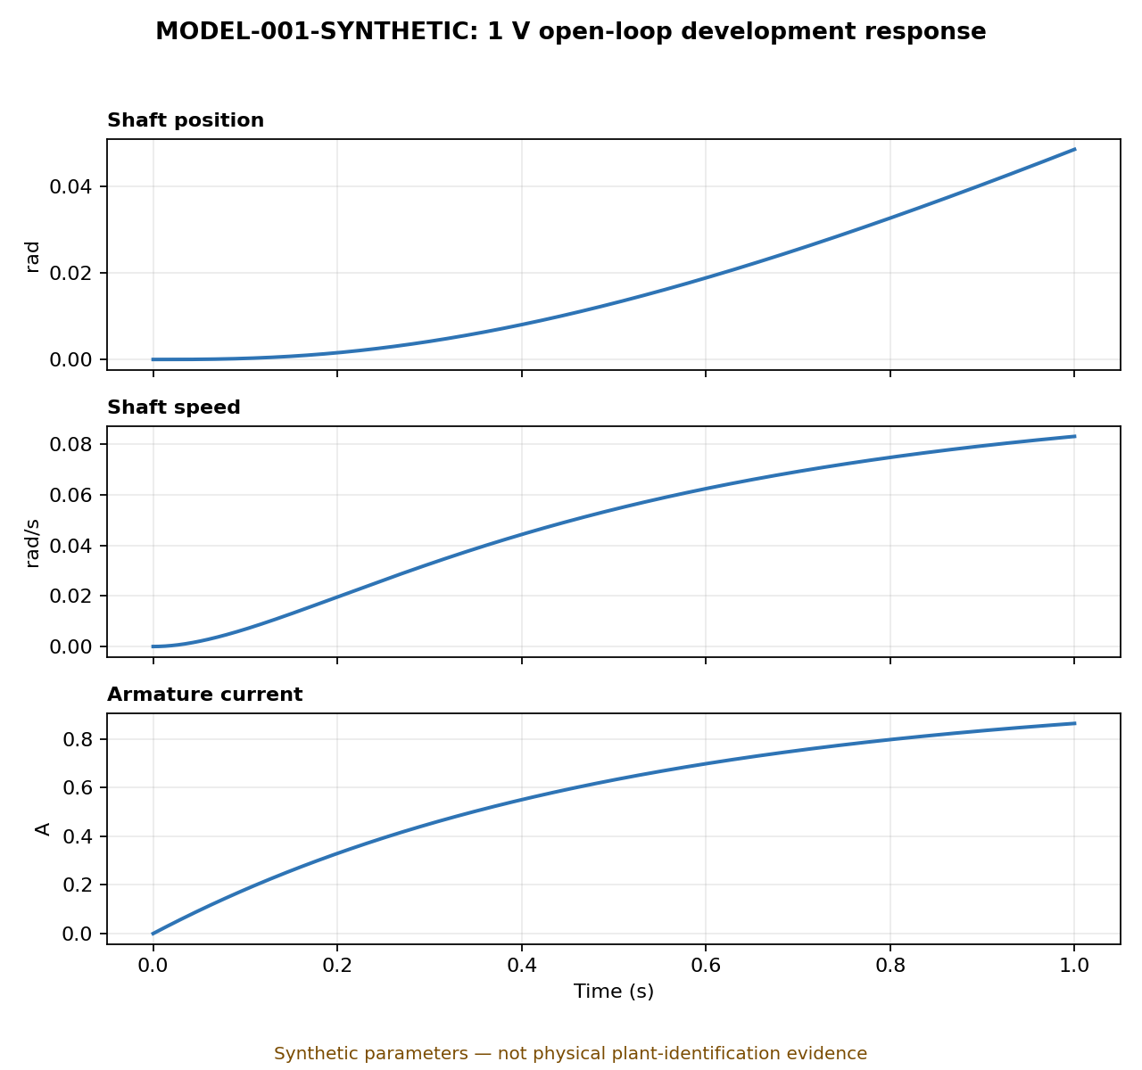
Figure 1. Synthetic 1 V open-loop response. Smooth curves reflect the ideal linear model; no PWM ripple, noise, saturation, dead zone, backlash, quantisation or thermal variation is included.

5. Verification and reproducibility
Local test execution python3 -m unittest discover -s tests -v completed with eight passing tests.
Syntax/bytecode check python3 -m compileall -q models tests completed without errors.
Remote CI The Model validation workflow completed successfully on Python 3.12 and 3.13.
Exact publication scope Remote comparison confirmed one commit, 14 changed files, 2,027 additions and no divergence from the documentation branch.
Recorded software environment Python 3.12.13, NumPy 2.3.5, SciPy 1.17.0 and Matplotlib 3.10.8.

6. Limitations and claims boundary
Table 4. Current limitations and claims boundary
Area | Current limitation
Physical parameters | No motor, encoder, driver or load has been selected and identified.
Control system | No state-feedback gain, observer gain, stability margin or closed-loop metric has been established.
Nonlinear behaviour | Saturation, PWM ripple, stiction, dead zone, backlash, noise, quantisation and temperature effects are omitted.
Implementation | No fixed-point model, Raspberry Pi timing result, ROS 2 node implementation or FPGA RTL result exists yet.
Safety | No watchdog, interlock, E-stop, safe-state latency or fault-latching behaviour has been physically demonstrated.
Safe portfolio claim Implemented a parameterised, reproducible and automatically tested state-space modelling workflow using a clearly labelled synthetic DC-motor fixture.

7. Pre-hardware software completion assessment
A single percentage is necessarily a planning estimate because the remaining milestones differ in difficulty. To avoid overstating progress, this record uses a transparent milestone-count method: complete = 1.0, partial = 0.5 and not started = 0.0.
Table 5. Milestone-count progress assessment
Milestone | State | Evidence or gap
Requirements, architecture and traceability baseline | Partial | Draft PR #1 contains the baseline documents; it is unmerged and numerical thresholds remain preliminary.
Synthetic floating-point plant-model workflow | Complete | Code, tests, documentation, generated evidence and CI are present and passing.
Reviewed physical parameter set / plant identification | Not started | Synthetic values are not yet source-backed or measured.
Floating-point state-feedback controller | Not started | No gain, pole-selection, LQR or tracking design is present.
State observer and estimation tests | Not started | No observer gain, noise study or estimation-error evidence is present.
Closed-loop performance and robustness campaign | Not started | No settling, overshoot, disturbance, saturation or uncertainty results exist.
Bit-accurate fixed-point reference model | Not started | No word-length study or floating/fixed comparison exists.
Pre-hardware ROS 2 and RTL simulation integration | Not started | No implemented nodes, simulated interfaces, RTL or common-vector tests exist.
Calculation (1 complete milestone + 0.5 partial milestone) ÷ 8 milestones = 18.75%, reported as approximately 20% overall. The current synthetic model milestone itself is 100% complete.

8. Why Python was used instead of MATLAB
Python was selected for the first executable baseline because the repository needed a licence-free, headless workflow that reviewers and GitHub Actions could reproduce from a clean checkout. NumPy, SciPy and Matplotlib provide the matrix operations, zero-order-hold discretisation, simulation and plotting needed at this stage. Python also aligns with later ROS 2 tooling, telemetry processing and automated verification.
This was an implementation choice, not a judgment that MATLAB is technically inferior. MATLAB remains highly suitable for control design and would make the portfolio stronger if it independently reproduces the Python result.
Table 6. Appropriate division of responsibility
Tool / evidence | Recommended role
Python | Canonical CI model, automated regression tests, evidence generation, ROS 2 support and later verification tooling.
MATLAB | Independent matrix and response cross-check, pole-placement/LQR exploration, observer design and optional Simulink studies.
Cross-tool evidence | Load the same parameter set, apply ss/c2d/ctrb/obsv, compare matrices within a declared tolerance and reproduce the step response.

9. Recommended next actions
1. Add a MATLAB parity script. Reconstruct the same model from the JSON parameters and compare A, B, C, D, ZOH matrices and response data against Python.
2. Implement state-feedback and observer workflows. Use the synthetic fixture to verify the design process while keeping final gains explicitly provisional.
3. Define measurable performance thresholds. Record preliminary rise-time, settling-time, overshoot, control-effort and estimation-error criteria.
4. Add robustness scenarios. Exercise load torque, parameter uncertainty, sensor noise, saturation and sample-time variation.
5. Prepare physical-parameter provenance. Select the motor/encoder/driver and document datasheet or identification sources before claiming MODEL-001 acceptance.
6. Merge the stacked pull requests in order. Merge PR #1 first, retarget PR #2 to main, confirm CI, then merge the model baseline.

