CONTROLLER AND OBSERVER WORK SESSION RECORD
MODEL-010-SYNTHETIC | Second executable non-hardware milestone
Prepared for: Fortune Olose
Repository: fortuneolose/ros2-raspberry-pi-robot-supervisor
Session date: 27 July 2026
Record prepared: 27 July 2026, 22:58:14 IST
Local branch: agent/add-controller-observer-baseline
Publication state: Implemented and validated locally; not committed or pushed

Session outcome A discrete floating-point state-feedback controller, steady-state reference precompensator and Luenberger observer were implemented around the synthetic motor model. Sixteen repository tests and thirteen machine-readable development checks passed.
Evidence boundary The result validates a software workflow only. The motor parameters, pole targets, gains, voltage limit, load pulse and thresholds are synthetic; no hardware-ready controller or physical safety claim is made.

1. Purpose and evidence basis
This record documents the latest non-hardware project session, including the actions completed, engineering significance, skills demonstrated, generated evidence and remaining limitations. It records work performed after the initial MODEL-001 synthetic plant-model milestone.
Completion times are derived from the Git reflog, final file modification records, the generated MODEL-010 JSON timestamp and a deliberately timestamped final regression run. Times are shown in Irish Summer Time (IST, UTC+01:00) and UTC. File timestamps from the execution host were converted to Dublin time before inclusion.

2. Progress change
Measure | Before session | After session | Interpretation
Synthetic plant-model milestone | Complete | Complete | MODEL-001 remains the model foundation.
Controller and observer milestone | Not implemented | Development complete | Synthetic floating-point baseline passes.
Pre-hardware software programme | 18.75% (~20%) | 31.25% (~31%) | 2.5 of eight weighted work packages.
Physical demonstrator | Not constructed | Not constructed | No physical progress is claimed.
Progress method The 31.25% figure reuses the previously defined eight-package planning method and treats 2.5 weighted software packages as complete. It is an internal planning indicator, not earned-value evidence or physical demonstrator completion.

3. Timestamped activity log
Table 1. Evidence-backed session timeline
Ireland time | UTC | Completed action | Recorded evidence
22:16:20 | 21:16:20 | Reconciled the live repository and created the local development branch. | Git reflog records checkout to agent/add-controller-observer-baseline.
22:24:45 | 21:24:45 | Finalized the synthetic control configuration, validator and test suite. | Controller JSON, validation module and MODEL-010 tests reached their reviewed file state.
22:26:53 | 21:26:53 | Updated project status, reproduction instructions, CI and requirements traceability. | README, model guide, workflow and traceability files updated.
22:27:34 | 21:27:34 | Recorded the MODEL-010 development result in the verification report. | Test-report status and evidence section updated.
22:28:01 | 21:28:01 | Finalized the core controller library and engineering baseline document. | Dimensionally correct observer checks and disclosed peaking limitation retained.
22:45:41 | 21:45:41 | Started the timestamped final regression and evidence-generation run. | Validation command emitted explicit Dublin and UTC start times.
22:45:44 | 21:45:44 | Completed final tests, compilation, evidence generation and whitespace validation. | 16/16 tests and 13/13 MODEL-010 checks passed; CSV and two plots regenerated.
Timestamp note The 22:24-22:28 entries identify final recorded file states, not the first keystroke or start of each activity. The final regression interval is directly timestamped and therefore has the strongest completion evidence.

4. Work implemented and skills demonstrated
Table 2. Engineering work-to-skill mapping
Work area | Implementation | Skill demonstrated | Significance
Discrete control | Mapped s-plane pole targets to the z-plane and placed discrete poles. | Sampled-data state-space design and stability. | Creates a reproducible controller-design path.
State feedback | Implemented v = -K xhat + N r with reference precompensation. | Gain design and steady-state control analysis. | Moves the model into closed-loop control.
State estimation | Implemented a discrete Luenberger observer from encoder position. | Observability, innovation feedback and pole placement. | Estimates speed and current from one measurement.
Actuator modelling | Added explicit ±6 V clipping and saturation flags. | Constraint-aware simulation and defensive numerical design. | Prevents requests for unlimited voltage.
Disturbance testing | Injected an unmeasured 1 mN m opposing load pulse. | Transient and disturbance-recovery analysis. | Tests recovery beyond a reference step.
Numerical integrity | Replaced a mixed-unit norm with componentwise normalized limits. | Dimensional analysis and skeptical verification. | Avoids combining incompatible physical units.
Python engineering | Used NumPy, SciPy, Matplotlib, typed dataclasses, JSON and CSV. | Scientific Python, modular design and evidence automation. | Produces reusable code and evidence.
Verification | Added eight MODEL-010 tests and thirteen generated pass checks. | Unit, boundary and regression testing. | Raises the total to sixteen passing tests.
Documentation | Updated README, test report, model guide, traceability and CI. | Requirements traceability and technical communication. | Keeps claims, evidence and limitations aligned.
Version control | Reconciled PR state and isolated work on a local branch. | Branch discipline and change-stack awareness. | Leaves existing draft PRs unchanged.

5. Measured controller results
The nominal development scenario commands a 0.01 rad position step for two seconds. The controller is limited to ±6 V. These thresholds are software fixtures and are not final physical requirements.
Metric | Observed result | Development limit | Decision
10-90% rise time | 0.424 s | <= 0.600 s | PASS
2% settling time | 0.759 s | <= 1.000 s | PASS
Overshoot | 0% | <= 5% | PASS
Steady-state error | 3.16e-8 rad | <= 1e-4 rad | PASS
Peak applied voltage | 5.544 V | <= 6 V | PASS
Nominal saturated samples | 0 | 0 | PASS
Load-pulse recovery | 0.561 s | <= 0.700 s | PASS
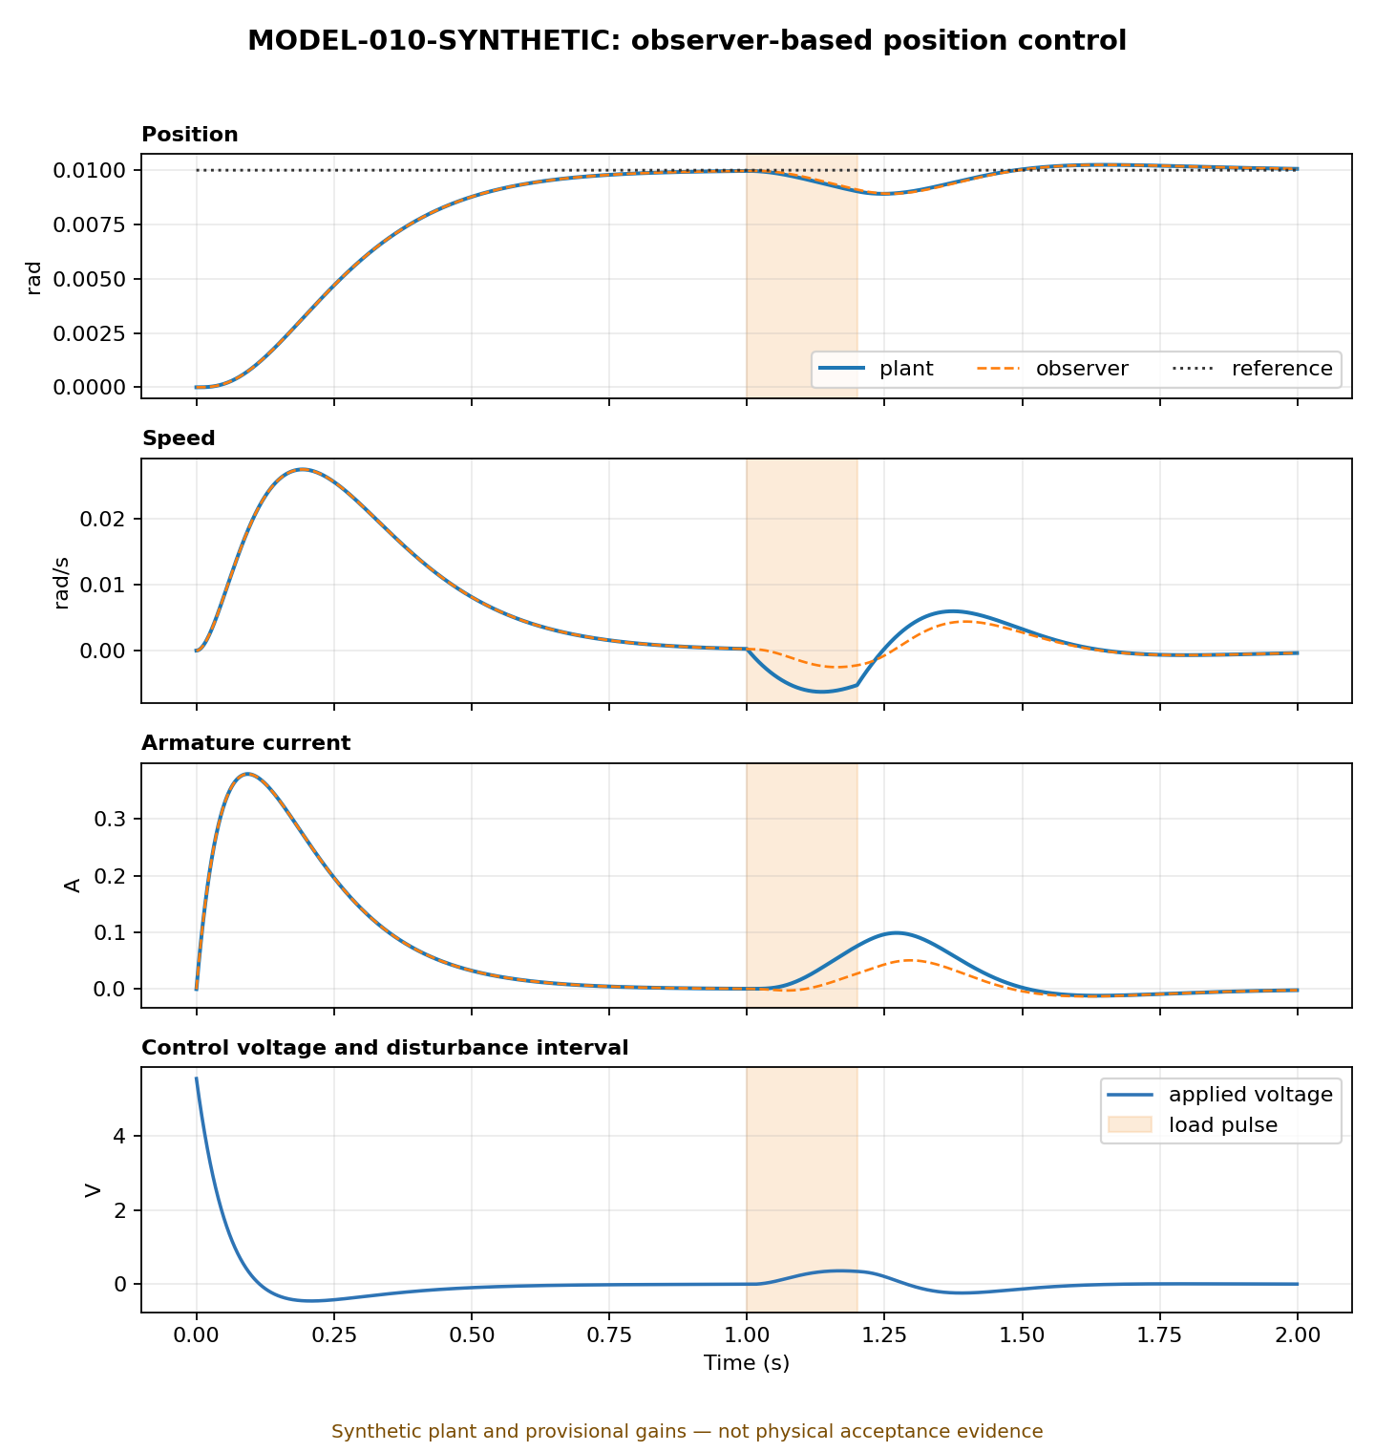
Figure 1. Synthetic observer-based position response. The shaded interval marks the opposing load-torque pulse.

6. Observer result and critical interpretation
The observer estimates shaft position, shaft speed and armature current from encoder position and the applied voltage. Convergence is evaluated using separate physical limits for each state instead of a dimensionally invalid norm that mixes incompatible units.
Component error | Development limit | Final error
Position | 1e-5 rad | -3.32e-10 rad
Speed | 1e-4 rad/s | -9.19e-9 rad/s
Current | 1e-4 A | -1.05e-7 A
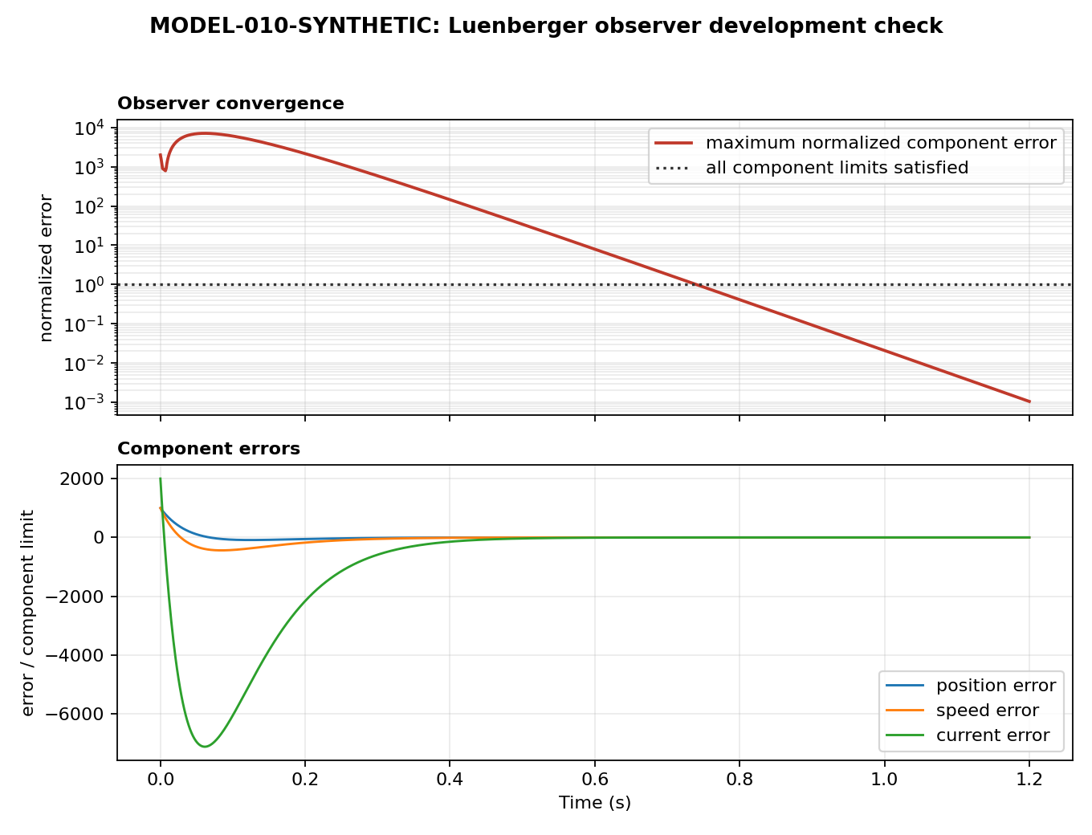
Figure 2. Normalized observer errors. All component limits remain satisfied after 0.741 s.
Important finding The normalized maximum observer error rises from 2000 to approximately 7113 before decaying. In physical terms, current-estimate peaking dominates. The pass result does not remove the need for later noise, range, saturation and observer-speed trade-off analysis.

7. Artifacts added or updated
Core implementation `models/control.py`, `models/validate_controller.py`, `models/parameters/synthetic_controller.json`
Automated verification `tests/test_model_010.py` and the expanded GitHub Actions workflow
Machine-readable evidence `model_010_synthetic_report.json` and the 2,000-row, 16-column `model_010_synthetic_response.csv`
Visual evidence `model_010_synthetic_closed_loop.png` and `model_010_synthetic_observer.png`
Engineering documentation `docs/controller_observer_baseline.md`, README, model guide, test report and traceability matrix

8. Limitations and uncompleted work
Synthetic plant No selected or identified physical motor parameters are used.
Robustness Measurement noise, delay, parameter uncertainty, quantisation and constant-load rejection remain untested.
Fixed point No bit-accurate word-length, rounding, saturation or overflow model has been implemented.
Platform integration ROS 2, Raspberry Pi scheduling, FPGA RTL and communications remain unimplemented.
MATLAB parity MATLAB and Octave were unavailable in the execution environment, so cross-tool numerical parity has not been demonstrated.
Publication The session files are local and uncommitted; remote PRs #1 and #2 remain unchanged.

9. Recommended next gate
The next non-hardware deliverable should be robustness and uncertainty analysis: deterministic sensor noise, parameter sweeps, sample delay, actuator saturation, persistent load and observer-pole trade-offs. Once the floating-point behaviour is reviewed, the next major implementation stage is a bit-accurate fixed-point reference model.
For publication, merge draft PR #1, retarget and merge draft PR #2, then publish this controller/observer milestone as a separate reviewed change.

