



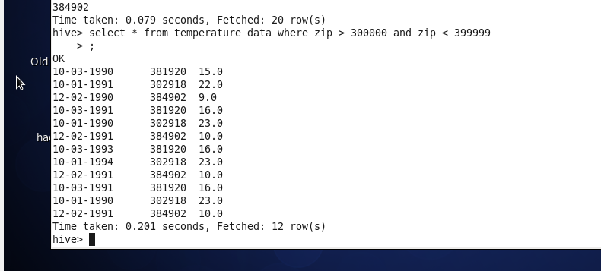



To solve this part of the assignment we should first convert our date table to understand for hive form - it could be done for example by using solution from here <https://stackoverflow.com/questions/16426703/how-to-convert-a-date-dd-mm-yyyy-to-yyyy-mm-dd-hhmmss-android>

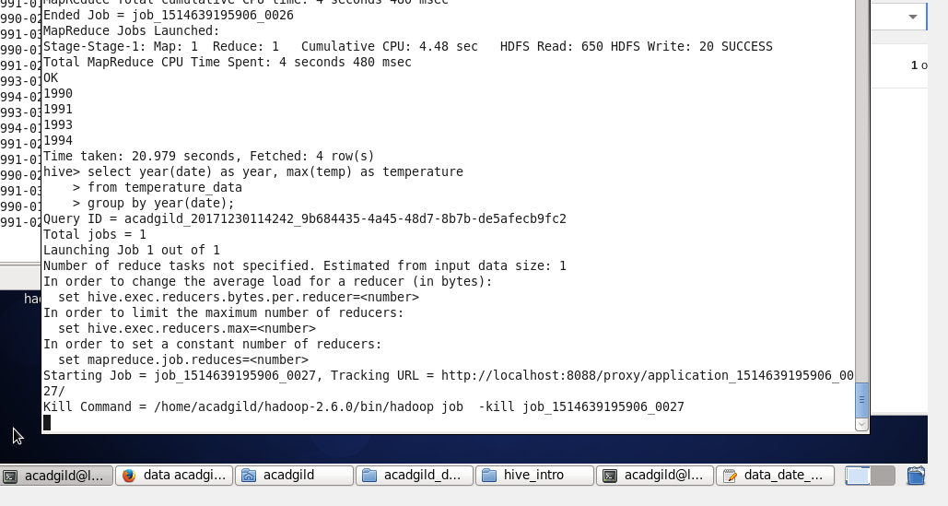

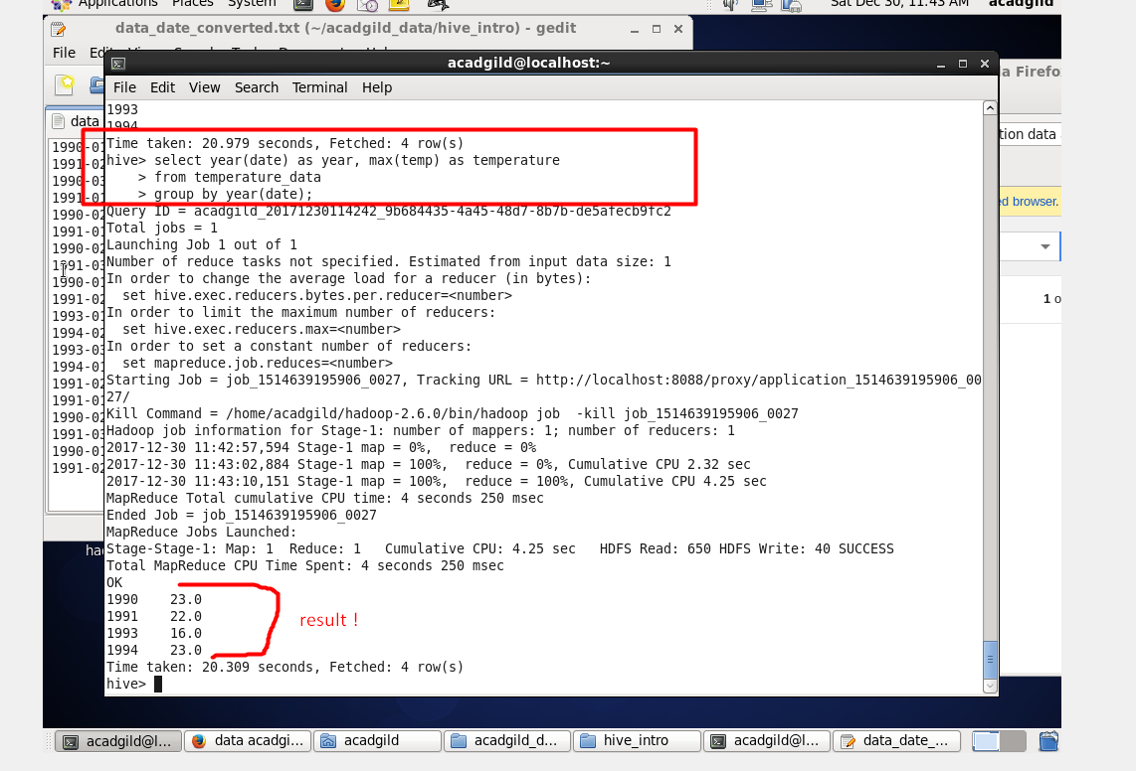



Let’s figure out first what years haven’t two entities;

Run the query

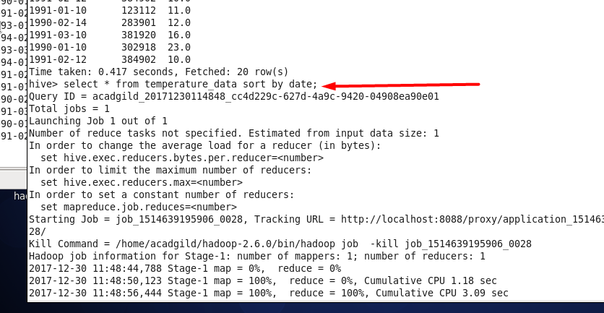

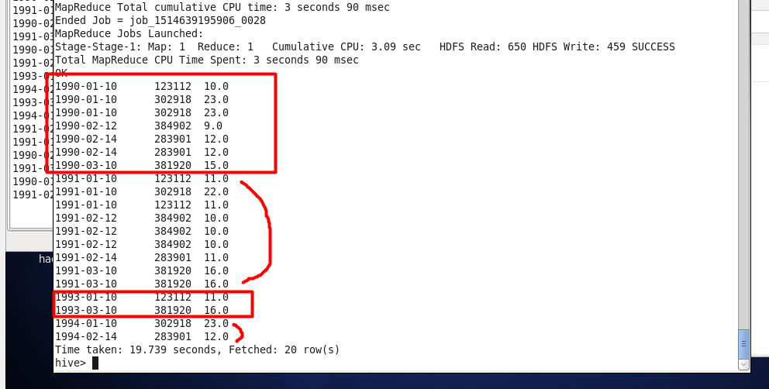

So each year has at least 2 entities …

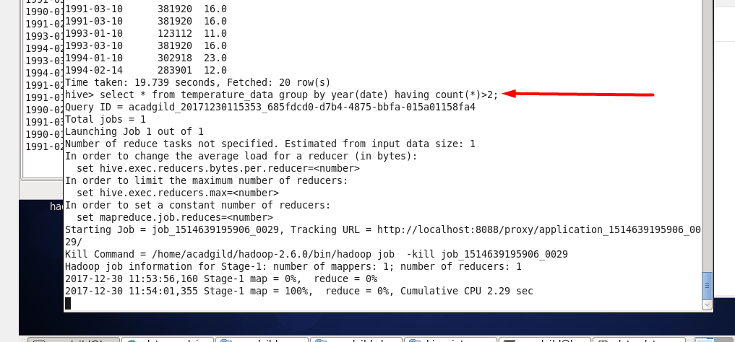

For test purpose let’s run the script at the slide above and we should get two record ;

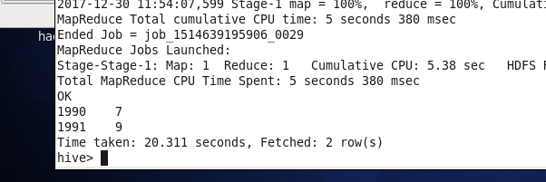

Our final script will be :

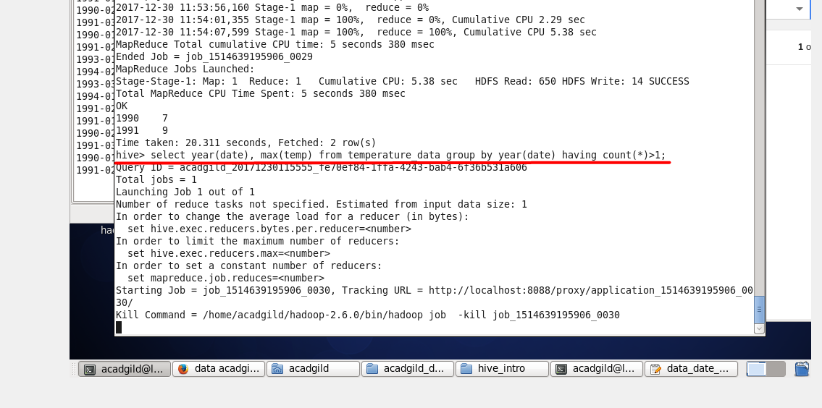

The answer :

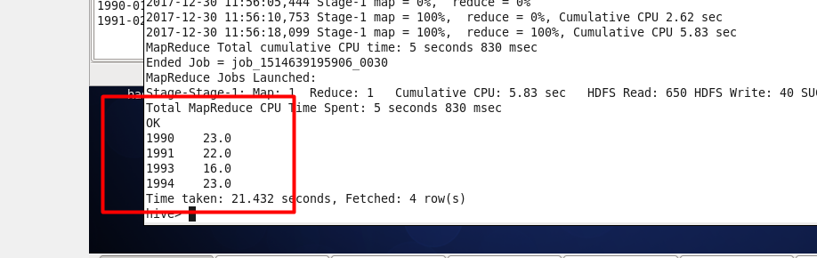



Creating view and running it to check

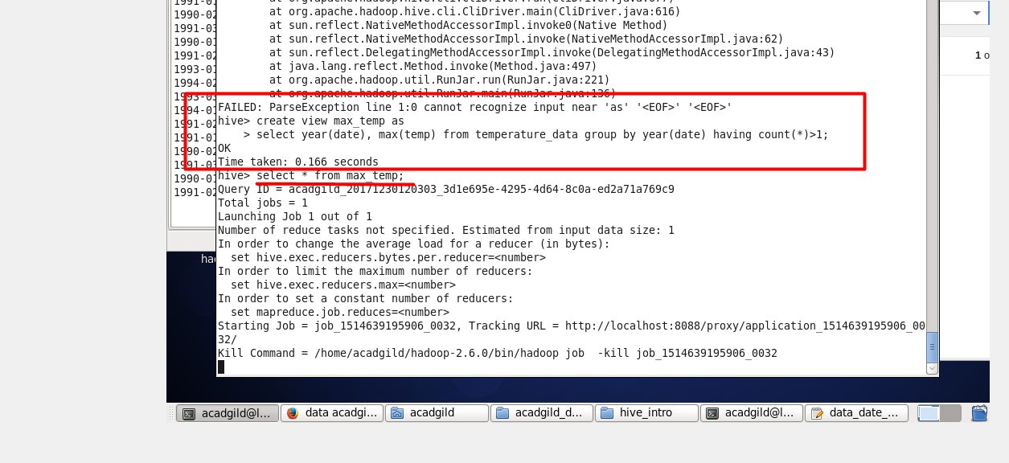

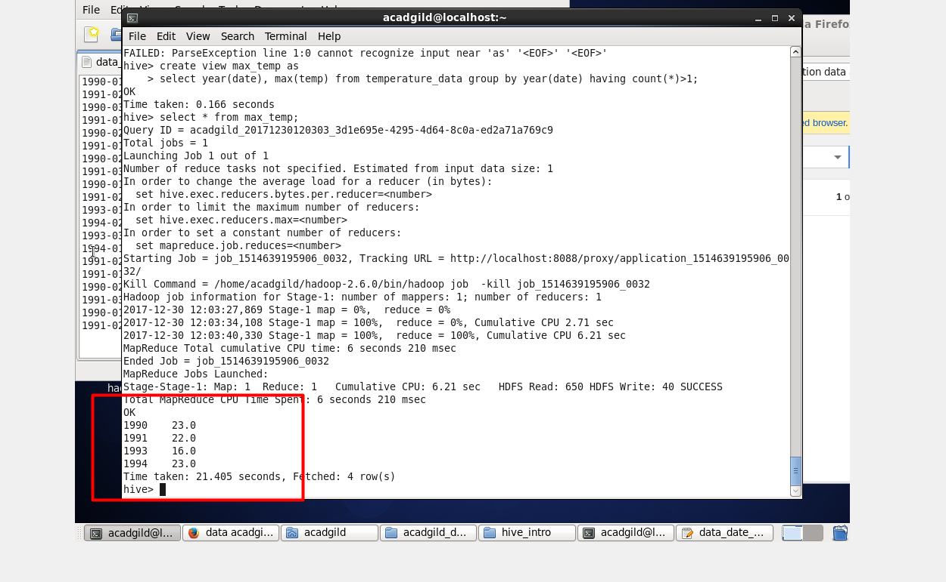



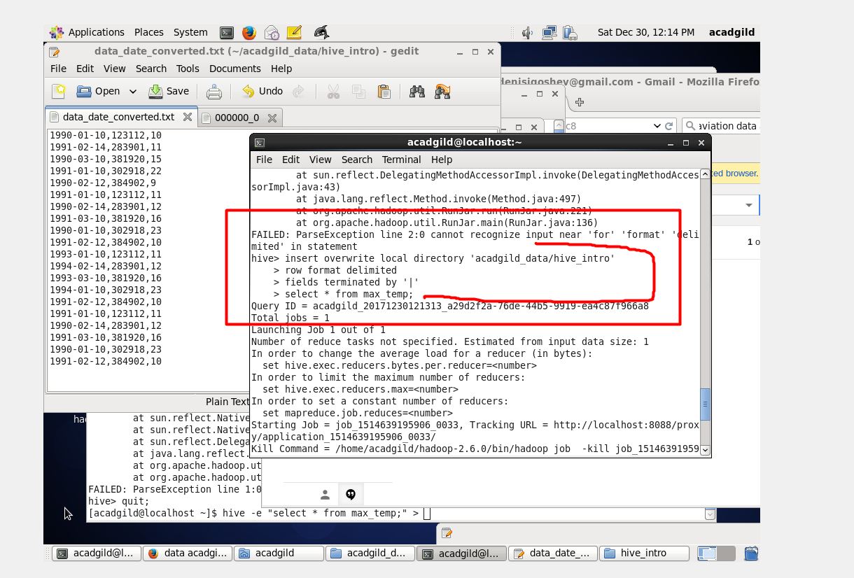

Out result file on the local fs below :

