Task 1:

Check whether /user/acadgild directory exists or not in the HDFS.

If it doesn't exist, then create this.

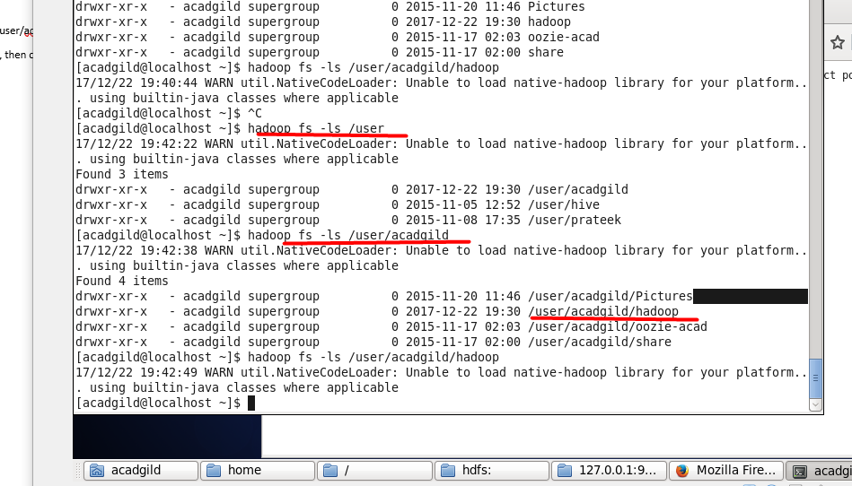

Checked – the directory exist

Task 2:

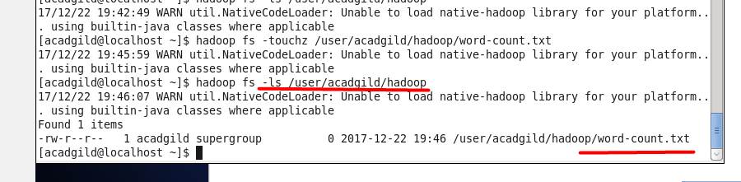

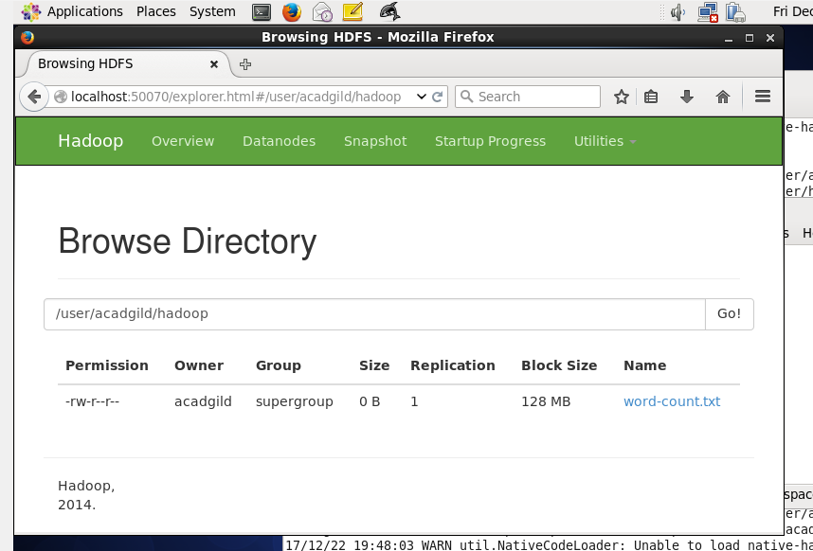

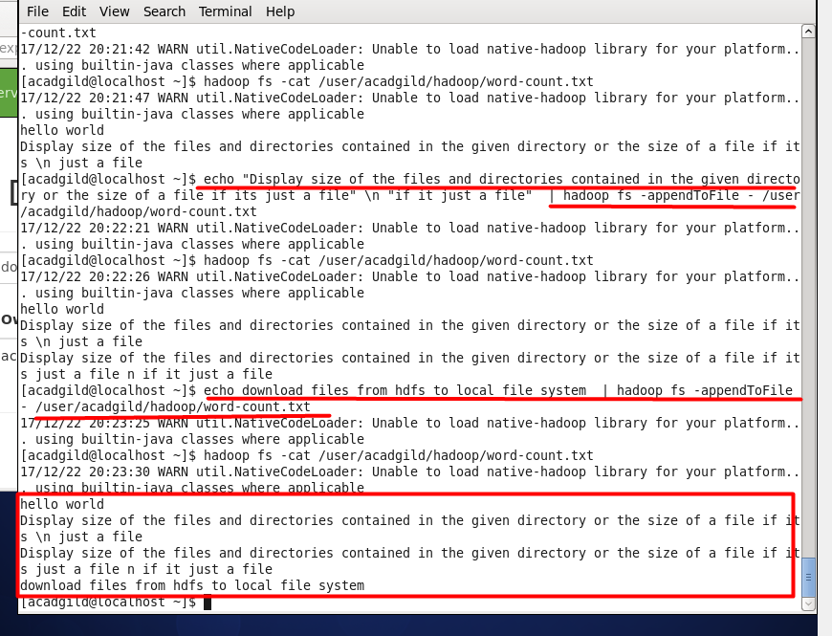

Assignment 2.2

Task 3

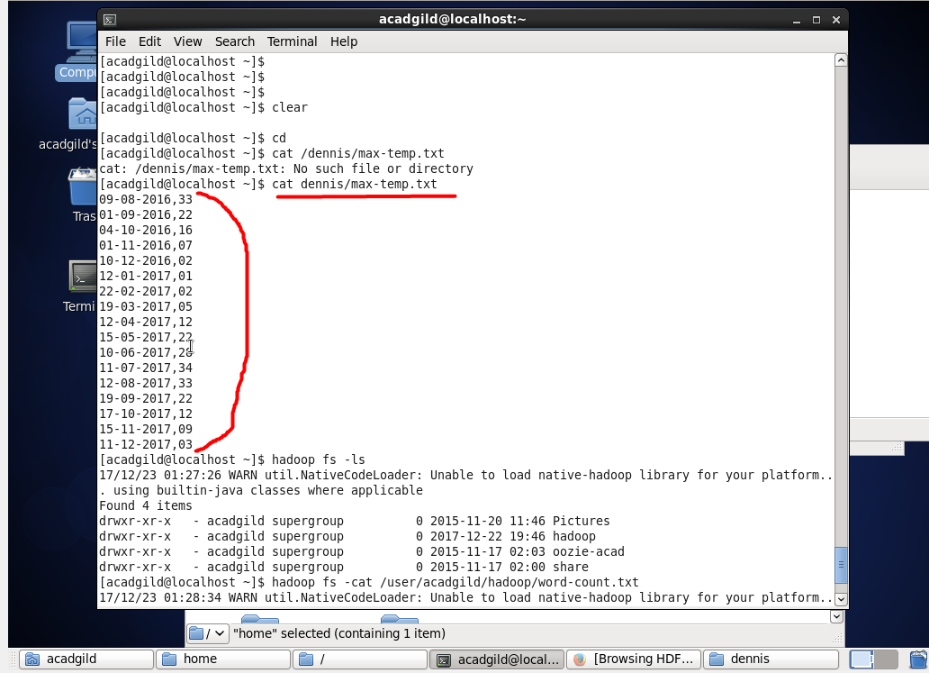

The file with data on local fs was created

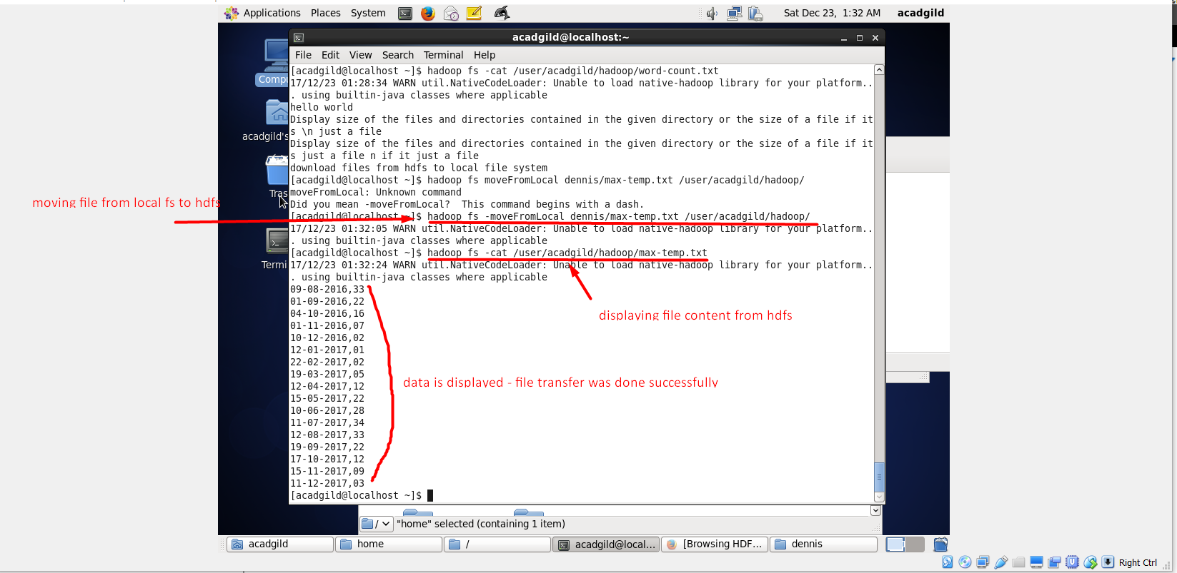

Task 4 – changing ownership of the file

Change the permission of the file /user/acadgild/hadoop/max-temp.txt, such that

only the owner and the group members have full control over the file. Others do not have any control over it.

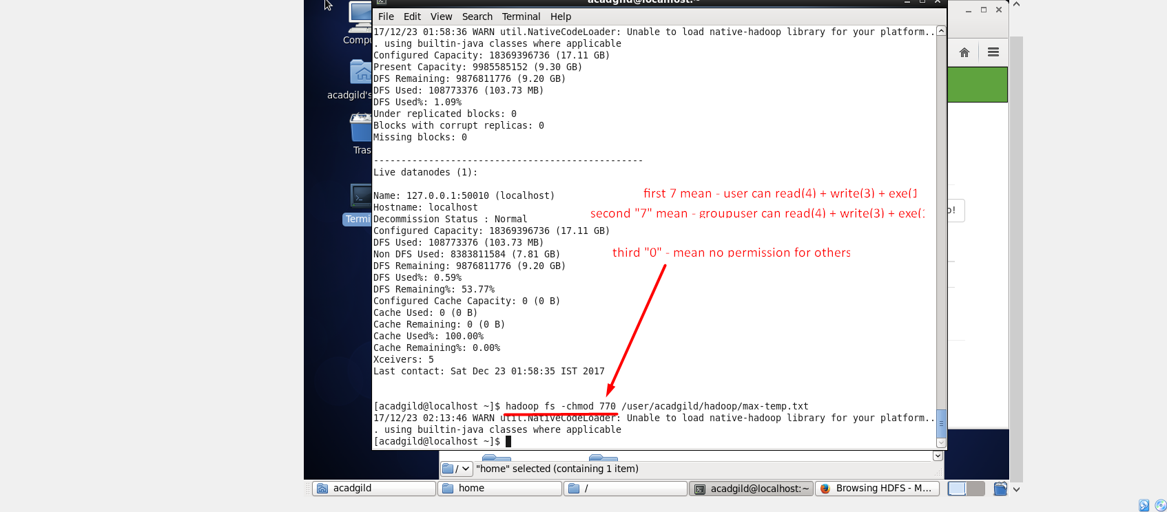

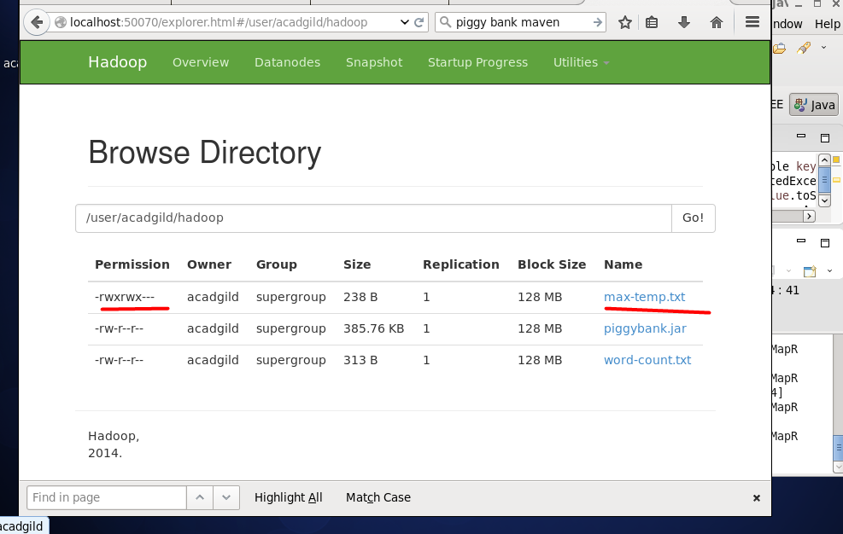

The permission could also be changed with another command argument list. For example like in the pic below

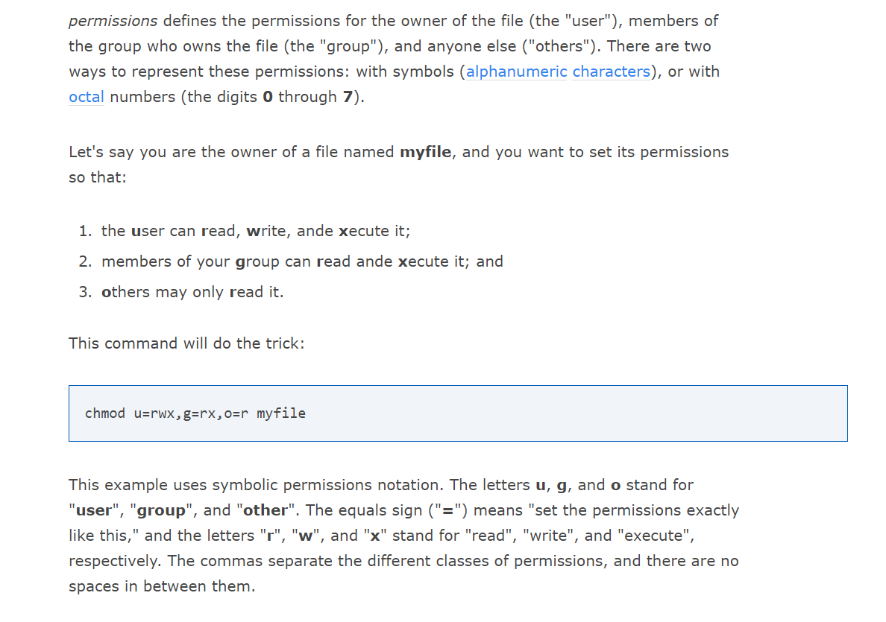

https://www.computerhope.com/unix/uchmod.htm