

First of all we need to format date column for hive correct interpretation of the information

For this purpose let use build it google sheet functionality

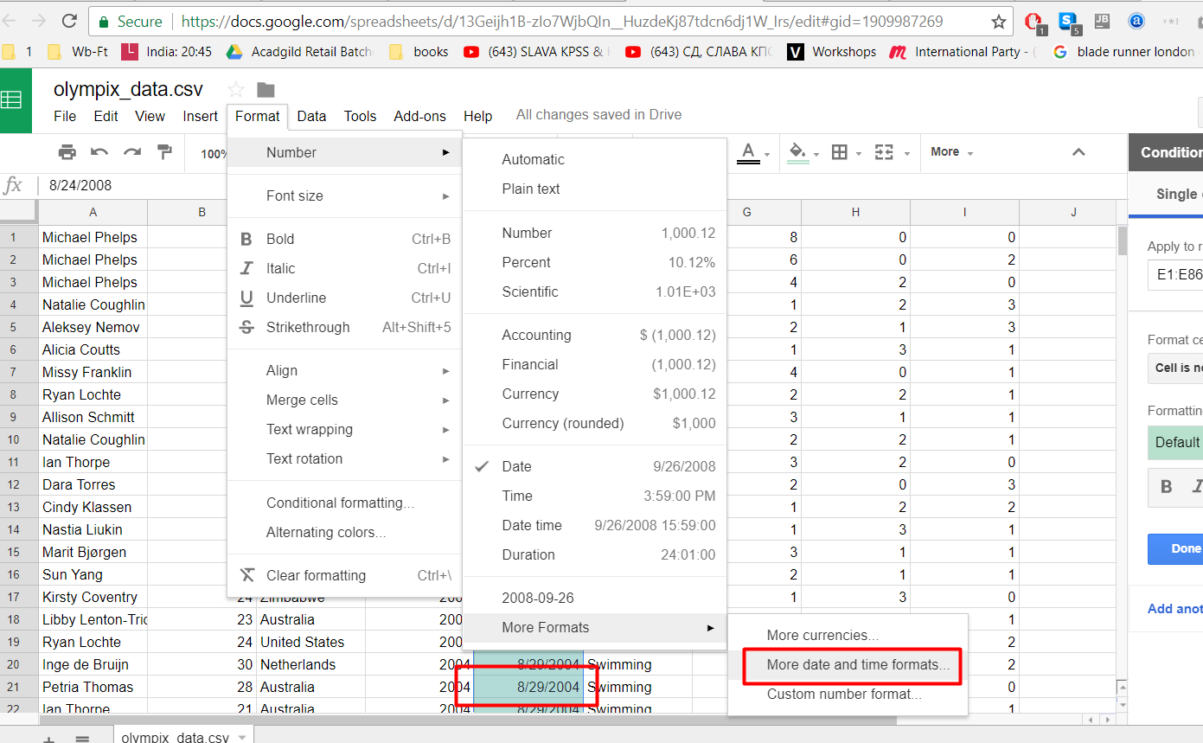

Choosing appropriate format

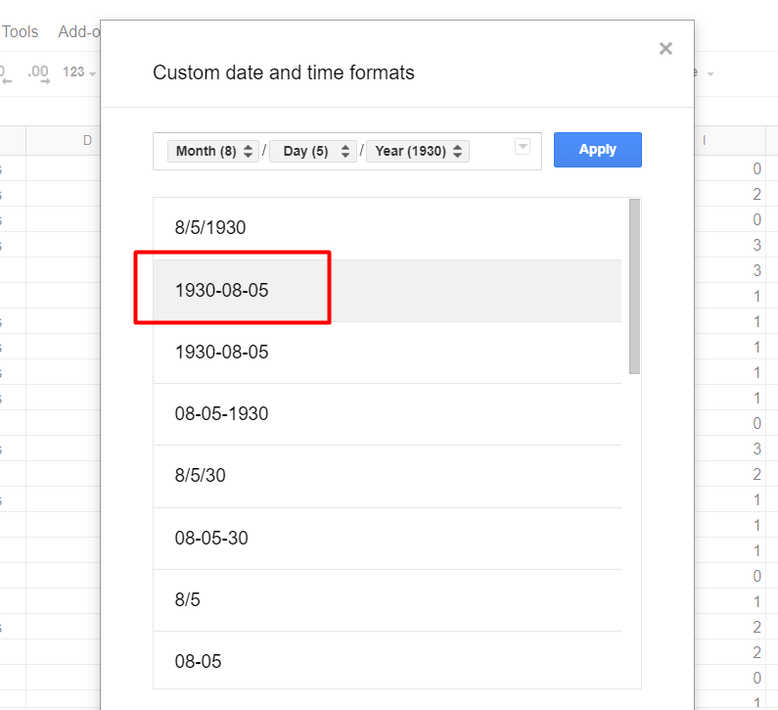

Now data is ready to load into hive

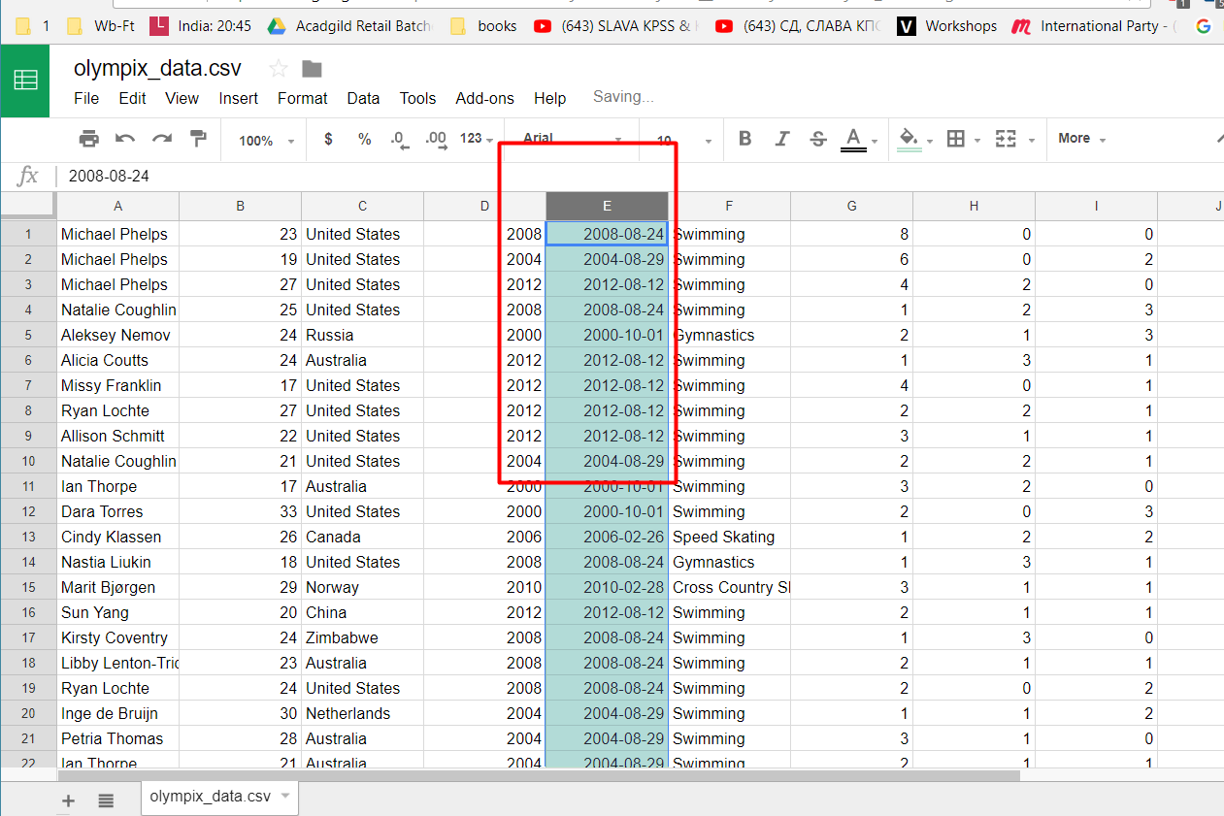

After loading the data, lets run the simple select query and check that the data is present :

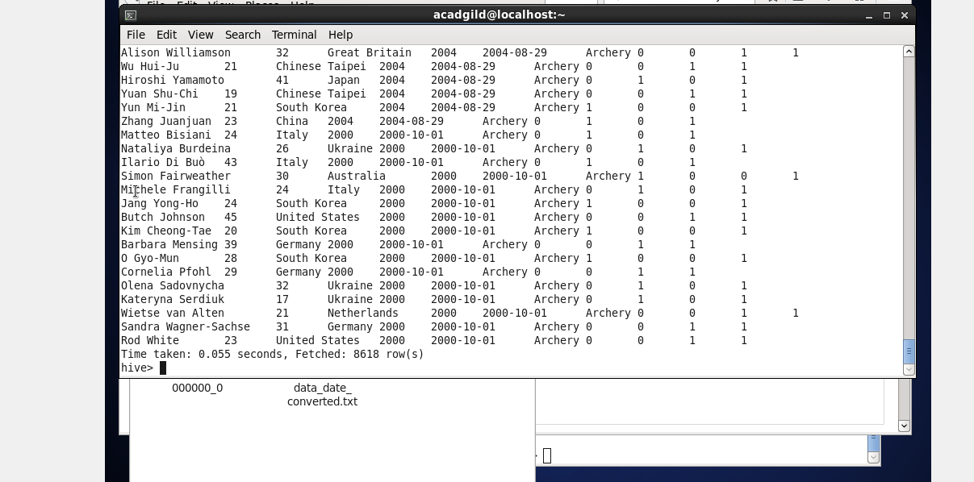

**The Problem 1**

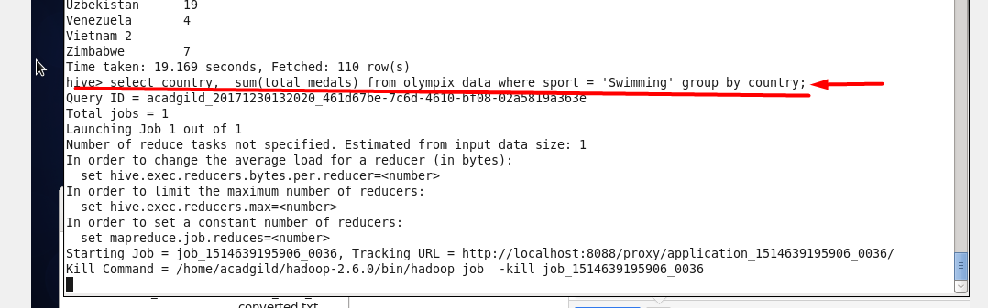

The result :

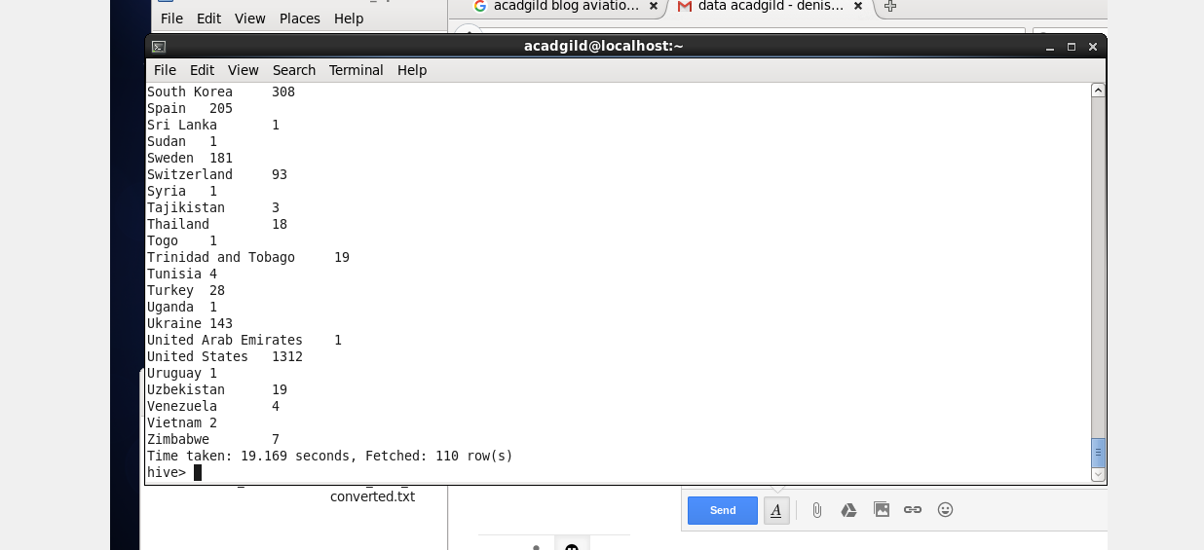

**The Problem 2**



I don't know what does “year wise” expression mean I assume that it is mean won by years

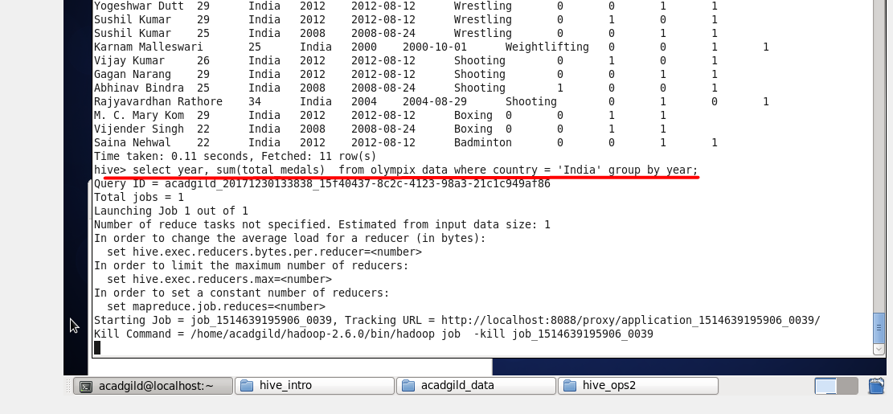

The result :

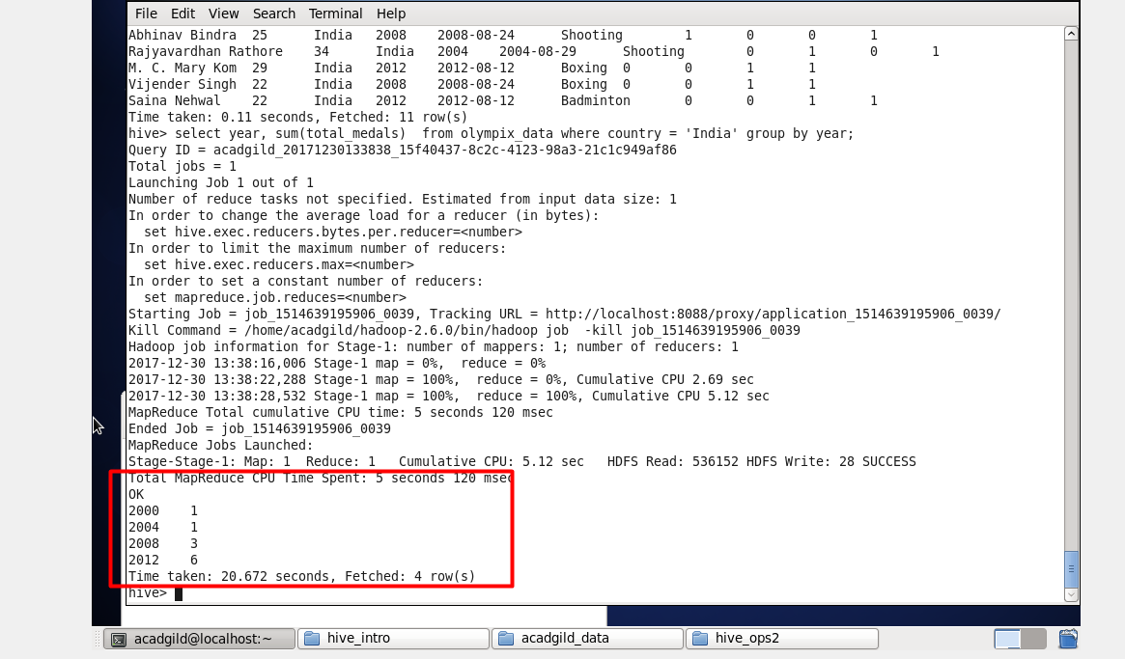

**The Problem 3**



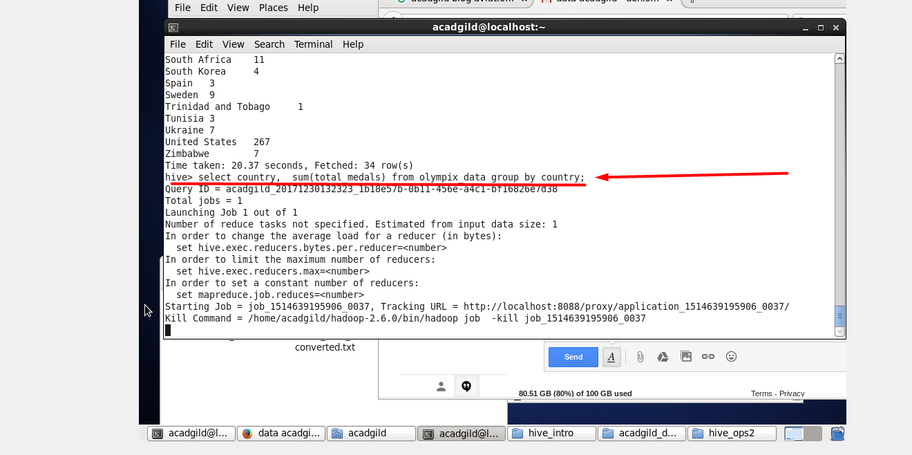

Part of the result table

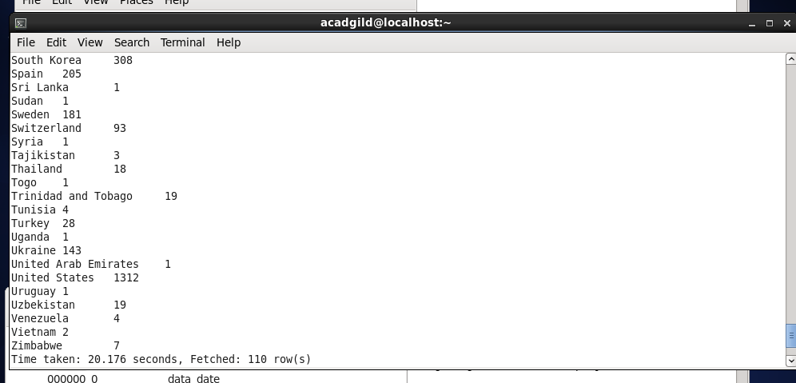

**The Problem 4**

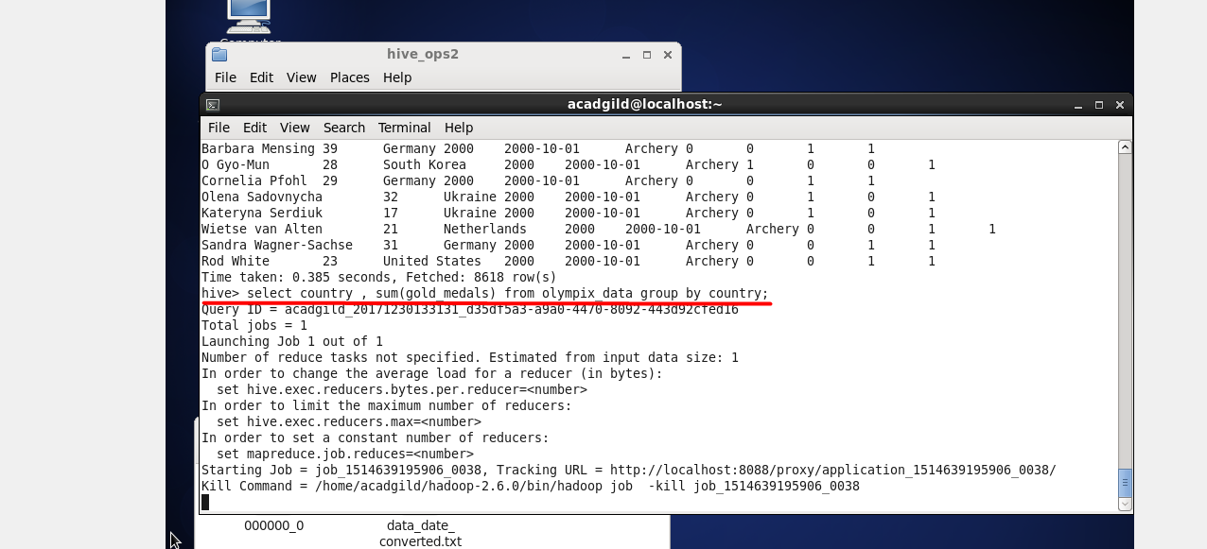

Part of the result table:

