

**Assignment 1**

Move data to hdfs

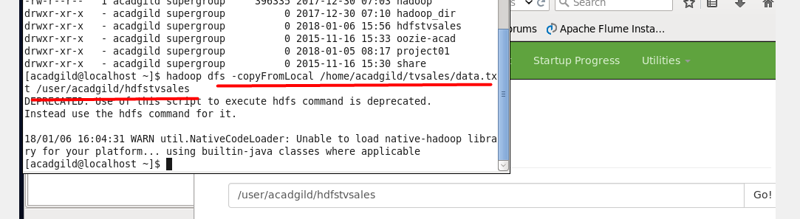

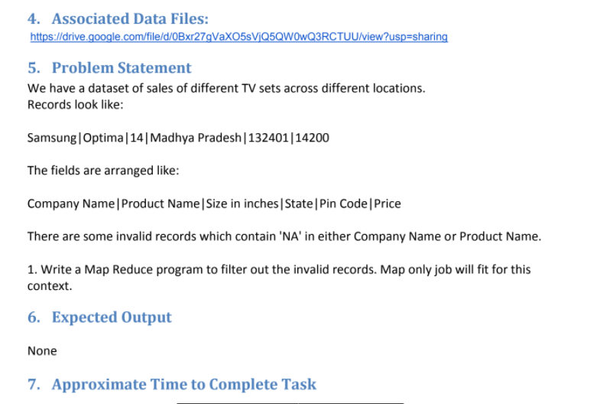

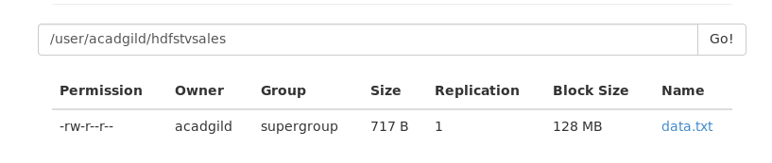

Now let's make jar file to execute our mapreduce job

Our mapper class which override map methods in which all business logic of data filtration is happen

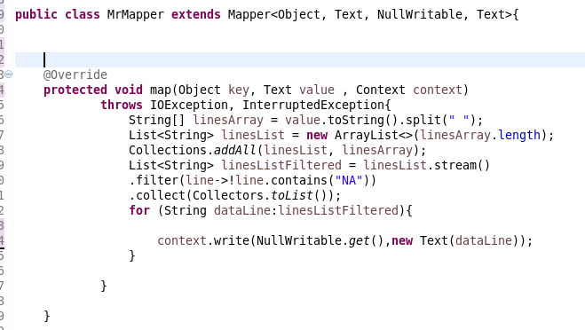

Because we make only filtration there is nothing interesting in reduce class in this case scenario.

Our driver class from which the execution will start

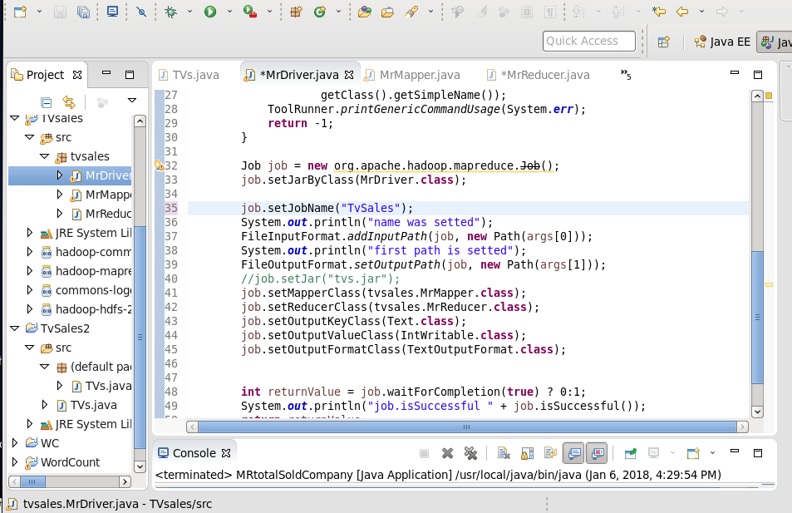

Creating runnable jar :

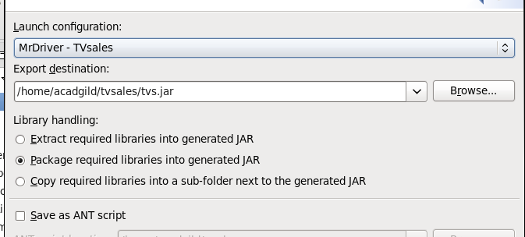

Mapreduce job execution

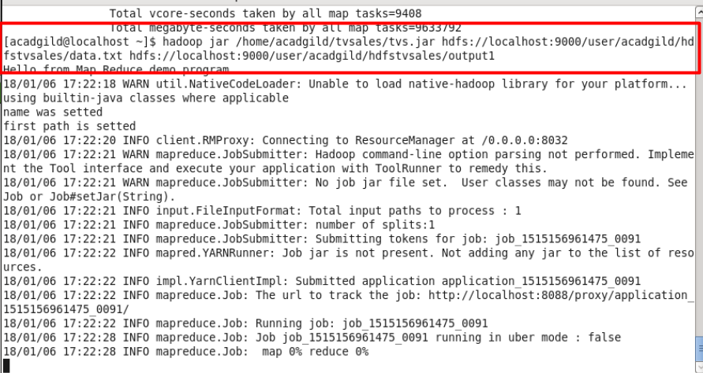

The output result

