

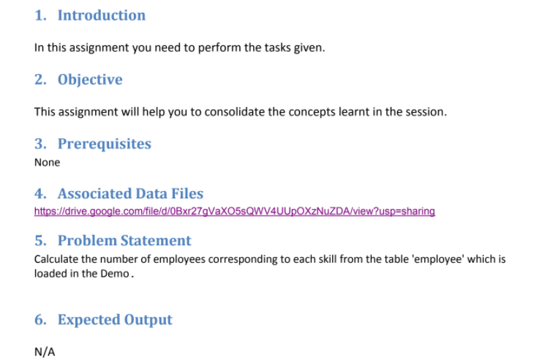

Create database

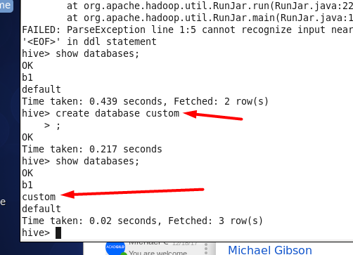

The data to work with :

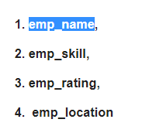

Amit,Big Data,1,BBSR  
Venkat,Web Technology,2,BBSR  
Aditya,DBA,1,BNG  
Ravinder,Java,2,BBSR  
Sunil,C#,1,BBSR  
Anil,ASP,2,BNG  
Mihir,Big Data,3,BBSR  
Mohit,Java,1,BBSR

Create tables :

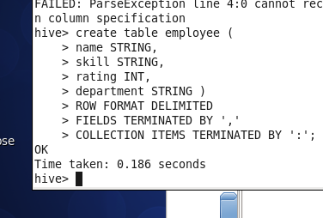

Upload data to the table

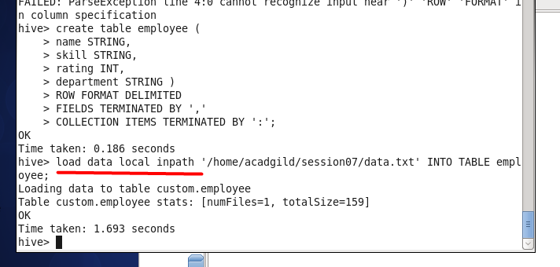

Solution :

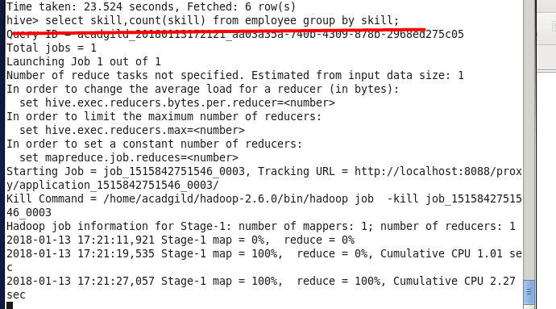

Result :

