

Problem statement :

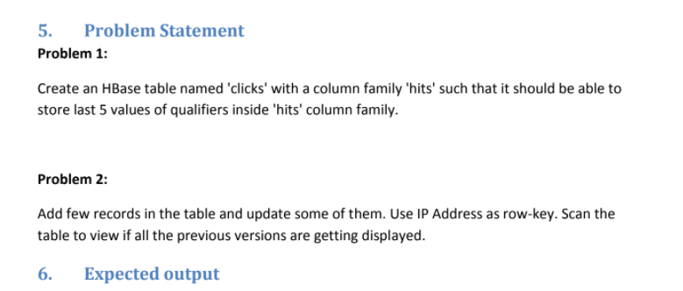

Problem 1:



Start up the hbase and list what we have :

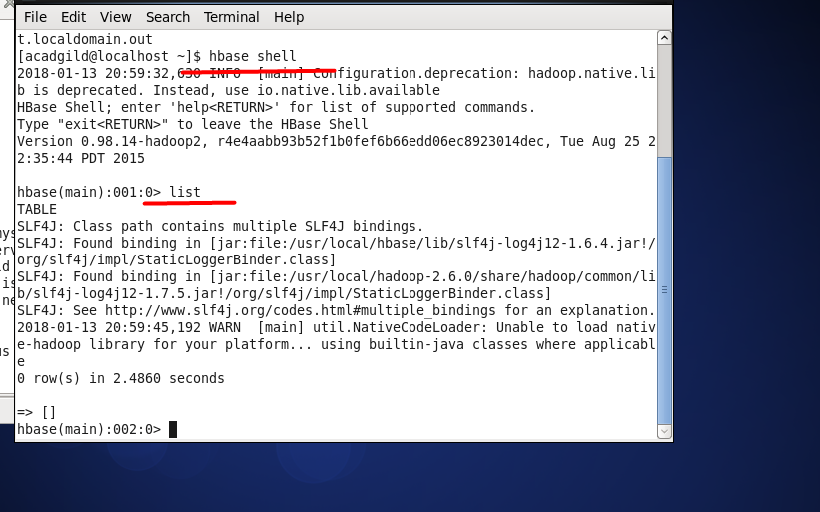

Create table and column family :

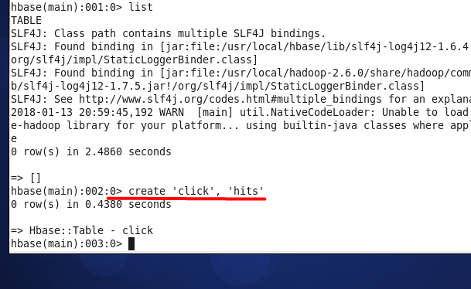

This is pretty much enough to be able to store at least 5 values inside column family hits

Let's check it out:

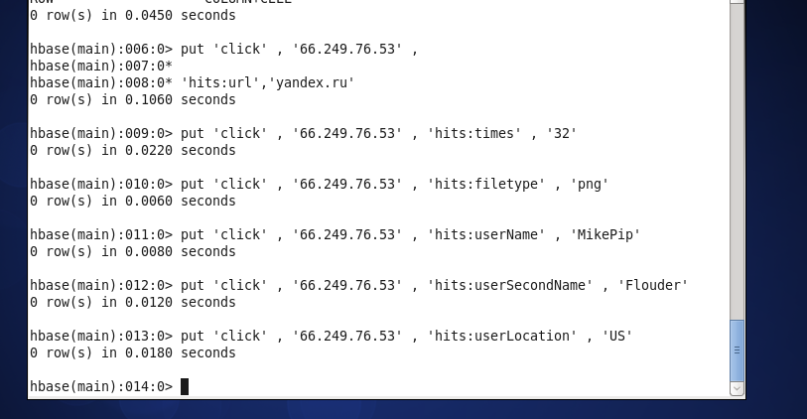

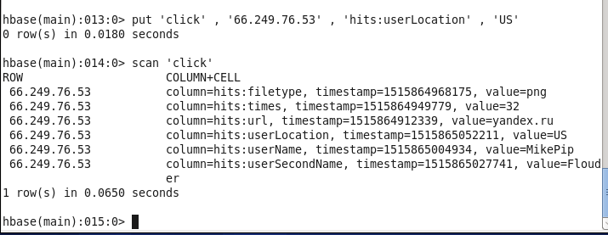

Problem 2:



Change number of versions :

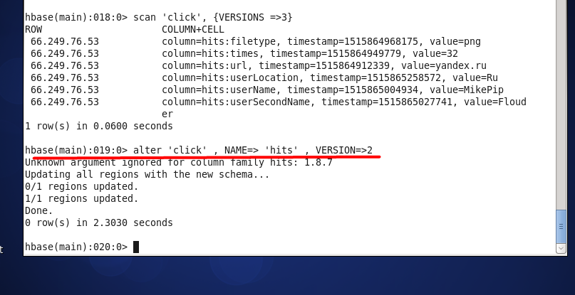

Put alternative value and display it ( make sure that indeed only two versions )

