<https://docs.google.com/viewerng/viewer?url=https://s3.amazonaws.com/acadgildsite/course/bigdatadeveloper/session10/ACD_BDD2.5_Session_10_Assignment_1_Main.pdf>

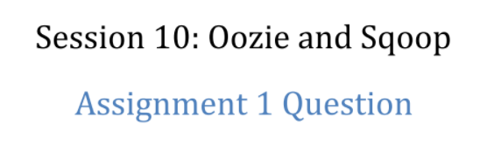

The problem statement :

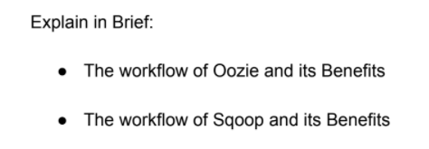

The problem 1



Apache Oozie is an open source project based on Java™ technology that simplifies the process of creating workflows and managing coordination among jobs. In principle, Oozie offers the ability to combine multiple jobs sequentially into one logical unit of work.

**The Benefit(s):**

One advantage of the Oozie framework is that it is fully integrated with the Apache Hadoop stack and supports Hadoop jobs for Apache MapReduce, Pig, Hive, and Sqoop. In addition, it can be used to schedule jobs specific to a system, such as Java programs. Therefore, using Oozie, Hadoop administrators are able to build complex data transformations that can combine the processing of different individual tasks and even sub-workflows. This ability allows for greater control over complex jobs and makes it easier to repeat those jobs at predetermined periods.

In practice, there are different types of Oozie jobs:

* *Oozie Workflow* jobs — Represented as directed acyclical graphs to specify a sequence of actions to be executed.
* *Oozie Coordinator* jobs — Represent Oozie workflow jobs triggered by time and data availability.
* *Oozie Bundle*— Facilitates packaging multiple coordinator and workflow jobs, and makes it easier to manage the life cycle of those jobs.

## How does Oozie work?

An Oozie workflow is a collection of actions arranged in a directed acyclic graph (DAG). This graph can contain two types of nodes: control nodes and action nodes. *Control nodes*, which are used to define job chronology, provide the rules for beginning and ending a workflow and control the workflow execution path with possible decision points known as fork and join nodes. *Action nodes* are used to trigger the execution of tasks. In particular, an action node can be a MapReduce job, a Pig application, a file system task, or a Java application. (The shell and ssh actions have been deprecated).

Oozie is a native Hadoop stack integration that supports all types of Hadoop jobs and is integrated with the Hadoop stack. In particular, Oozie is responsible for triggering the workflow actions, while the actual execution of the tasks is done using Hadoop MapReduce. Therefore, Oozie becomes able to leverage existing Hadoop machinery for load balancing, fail-over, etc. Oozie detects completion of tasks through callback and polling. When Oozie starts a task, it provides a unique callback HTTP URL to the task, and notifies that URL when it is complete. If the task fails to invoke the callback URL, Oozie can poll the task for completion. Figure 1 illustrates a sample Oozie workflow that combines six action nodes (Pig scrip, MapReduce jobs, Java code, and HDFS task) and five control nodes (Start, Decision control, Fork, Join, and End). Oozie workflows can be also parameterized. When submitting a workflow job, values for the parameters must be provided. If the appropriate parameters are used, several identical workflow jobs can occur concurrently.

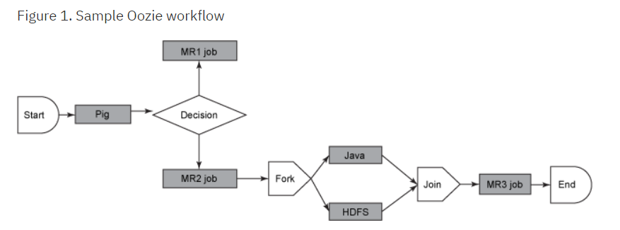

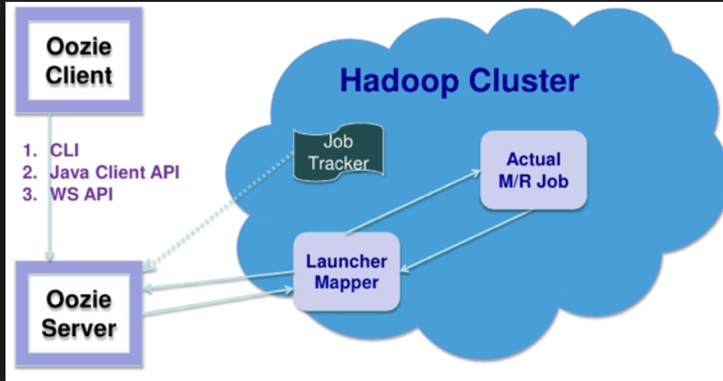

In practice, it is sometimes necessary to run Oozie workflows on regular time intervals, but in coordination with other conditions, such as the availability of specific data or the completion of any other events or tasks. In these situations, Oozie Coordinator jobs allow the user to model workflow execution triggers in the form of the data, time, or event predicates where the workflow job is started after those predicates get satisfied. The Oozie Coordinator can also manage multiple workflows that are dependent on the outcome of subsequent workflows. The outputs of subsequent workflows become the input to the next workflow. This chain is called a *data application pipeline*.

Oozie workflow definition language is XML-based and it is called the *Hadoop Process Definition Language.* Oozie comes with a command-line program for submitting jobs. This command-line program interacts with the Oozie server using REST. To submit or run a job using the Oozie client, give Oozie the full path to your workflow.xml file in HDFS as a parameter to the client. Oozie does not have a notion of global properties. All properties, including the *jobtracker* and the *namenode*, must be submitted as part of every job run. Oozie uses an RDBMS for storing state.

The problem 2



Sqoop is a tool designed to easily import information from structured databases (such as SQL) and related Hadoop systems (such as Hive and HBase) into your Hadoop cluster. You can also use Sqoop to extract data from Hadoop and export it to relational databases and enterprise data warehouses.

The benefit(s):

* Allows the transfer of data with a variety of structured data stores like Postgres, Oracle, Teradata, and so on.
* Can execute the data transfer in parallel, so execution can be quick and more cost effective. Helps to integrate with sequential data from the mainframe. This helps not only to limit the usage of the mainframe, but also reduces the high cost in executing certain jobs using mainframe hardware.
* Since the data is transferred and stored in Hadoop, Sqoop allows us to offload certain processing done in the **ETL** (**Extract**, **Load** and **Transform**) process into low-cost, fast, and effective Hadoop processes.
* Sqoop can execute the data transfer in parallel, so execution can be quick and more cost effective.