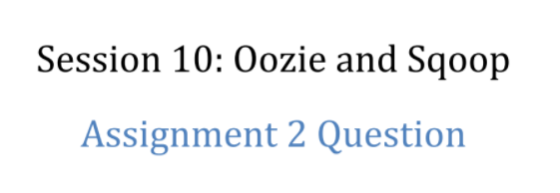

**Problem statement :**

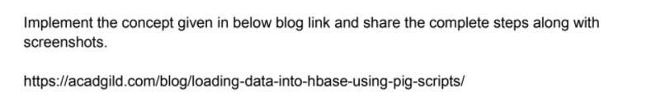

<https://www.google.com/url?q=https://acadgild.com/blog/loading-data-into-hbase-using-pig-scripts/&ust=1516284120000000&usg=AFQjCNFbdGLMrWocvLPj1mX0ianSvJwgng&hl=en-US>

**Solution :**

Let ‘s use movie database grouplens.org for this assignment. The format of the data is :

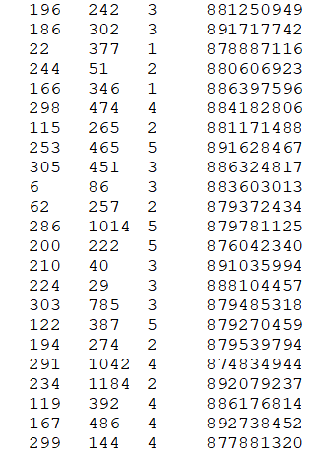

Where :

Column 1 : user id

Column 2 : movie id

Column 3 : rating

Column 4 : time stamp

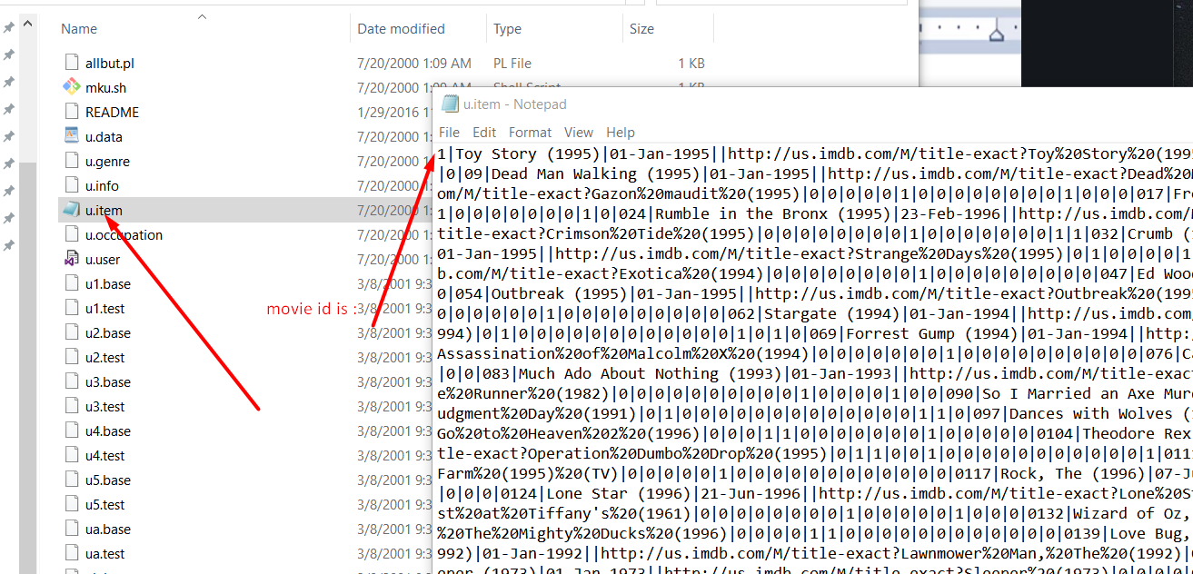

This is the file where the movie id and movie description is mapped

Now let’s import this data to the hbase

For this purpose first of all we will use hive view ( we use HDP_2.5 ) let’s open it

Use upload button for uploading data from desktop to virtual machine

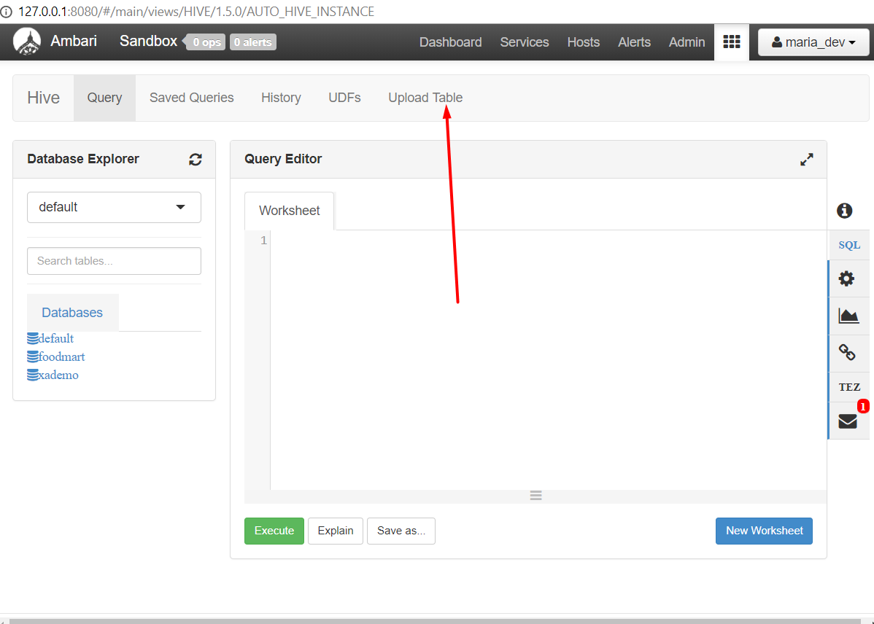

Choosing delimiter :

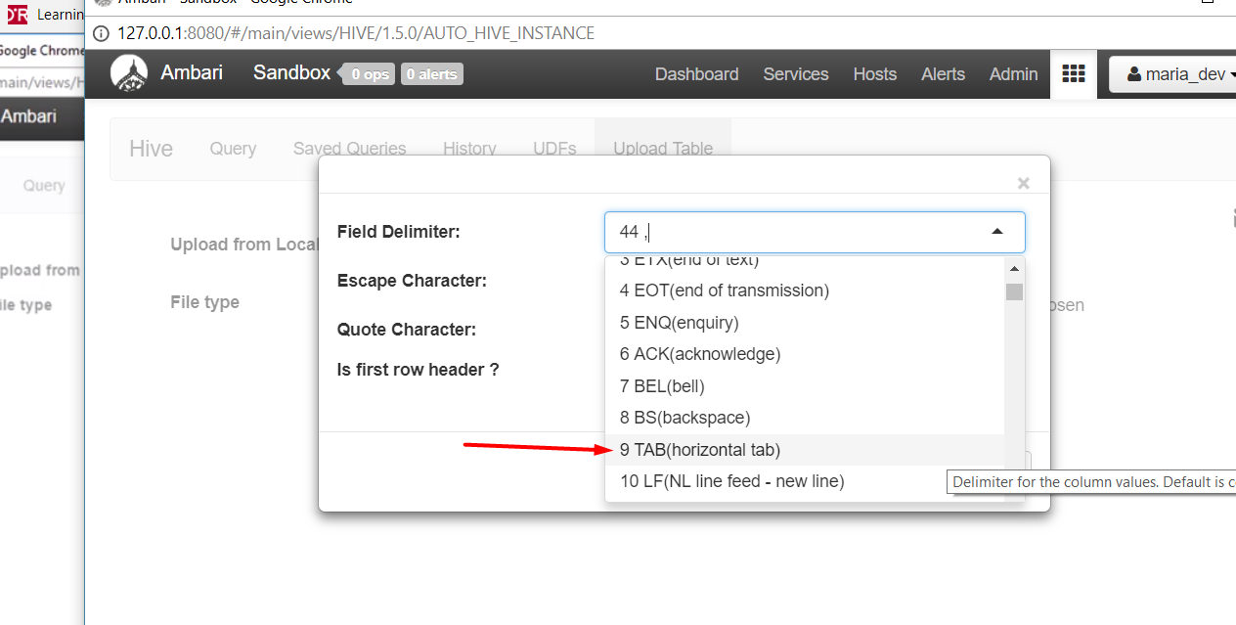

Prep table and upload

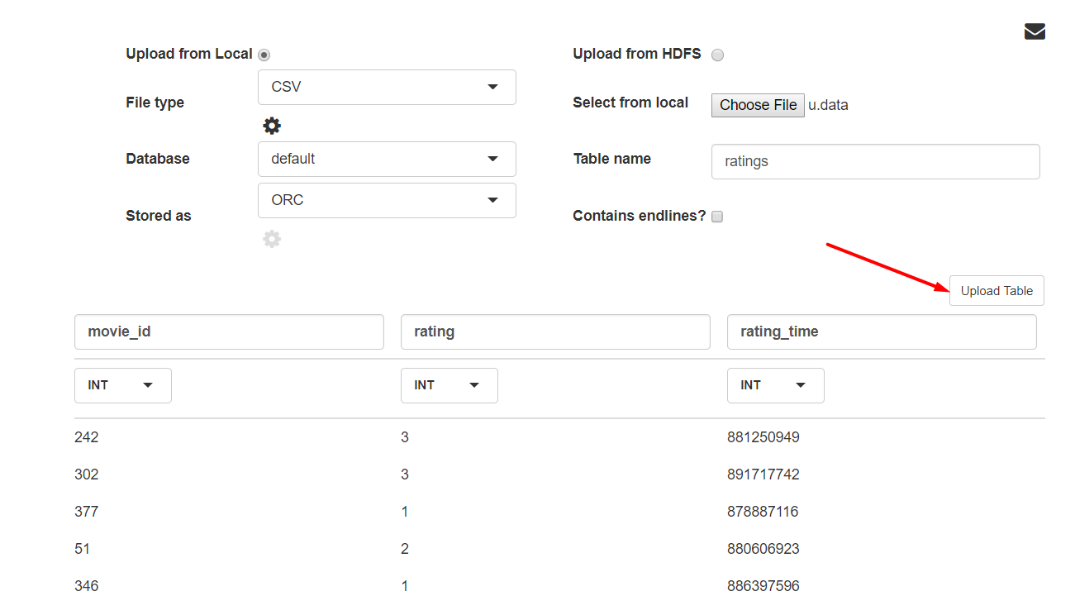

Now lets upload to the hadoop fs another table ( database ) about the details of the movies

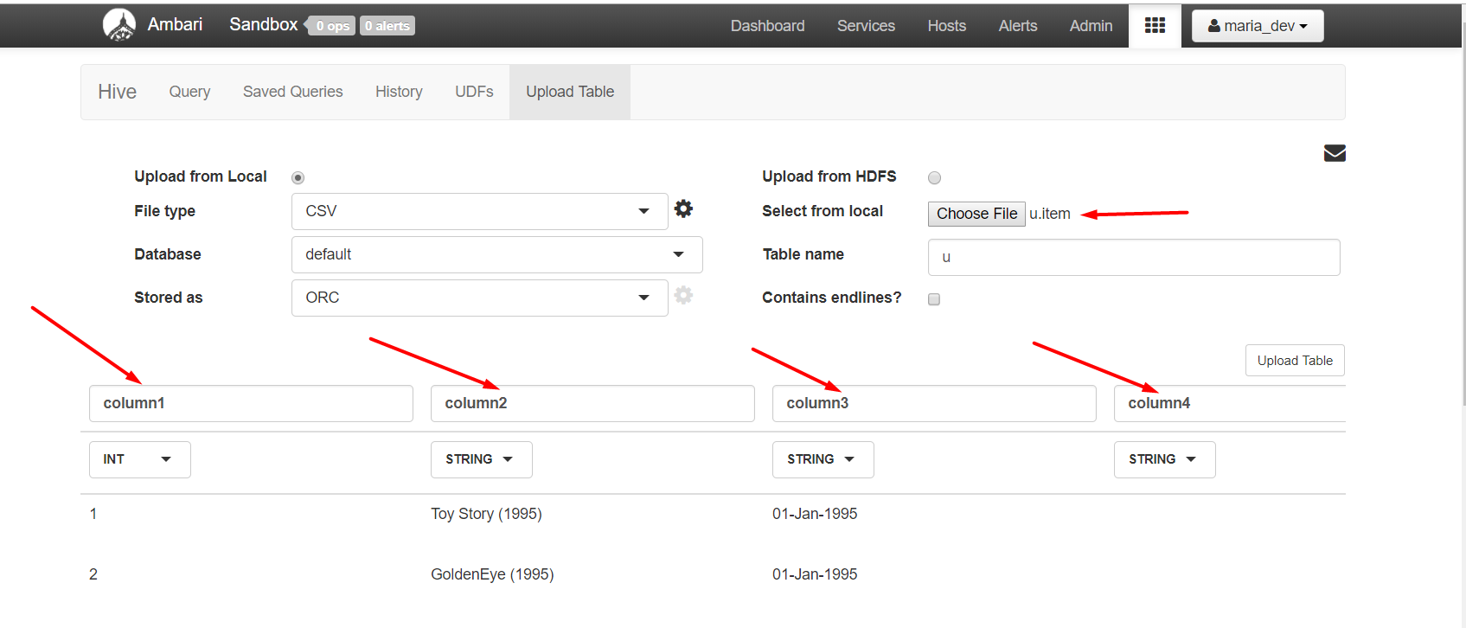

Do the same - gives the names of the column and upload

We care only about first two column so other column names are don’t matter

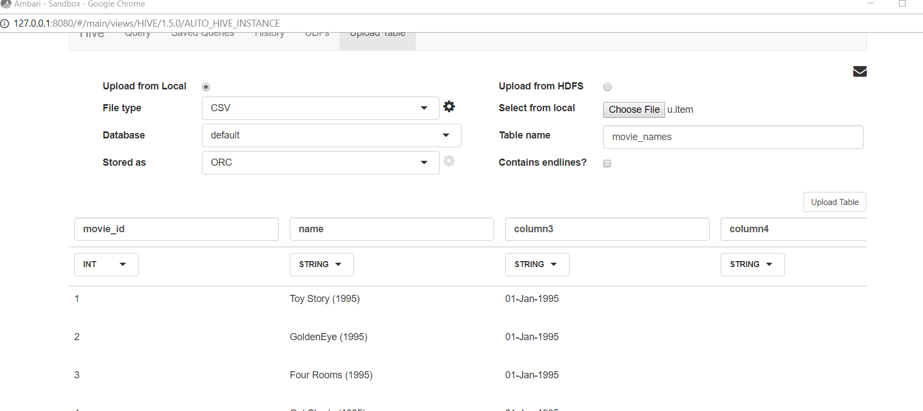

Let's check that upload is done correctly and run some query to this databases.

Here our uploaded databases

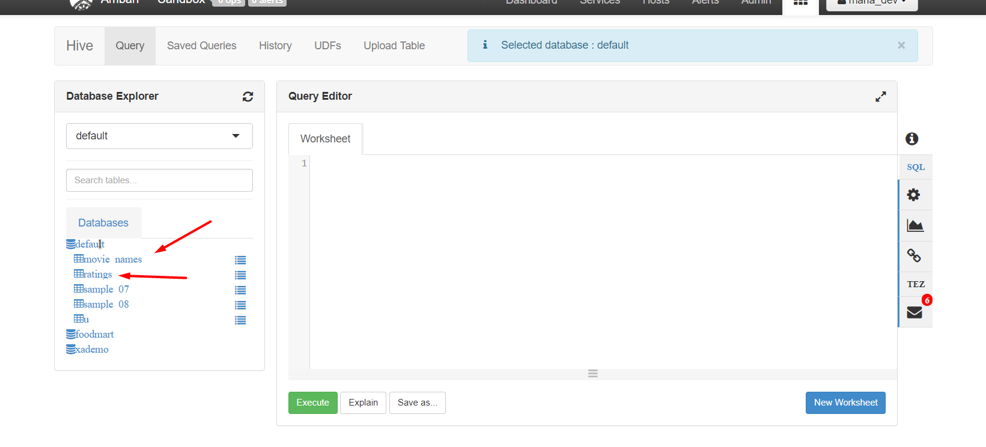

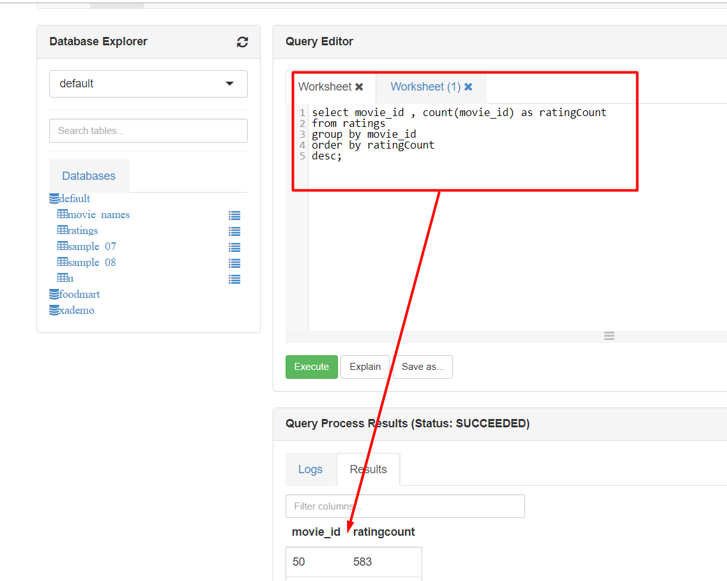

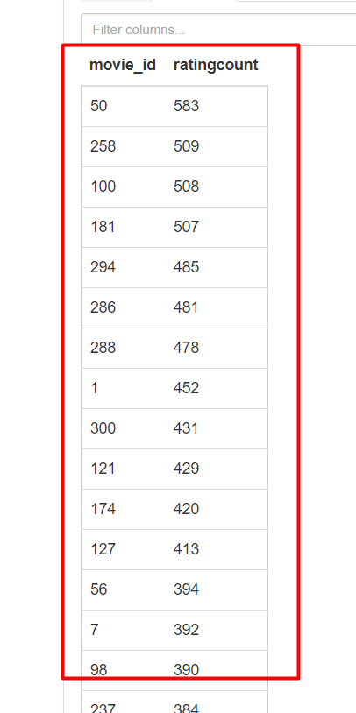

Looks good the VB from HortonWork is working now lets solve the problem

Now let’s add one more file to hadoop fs

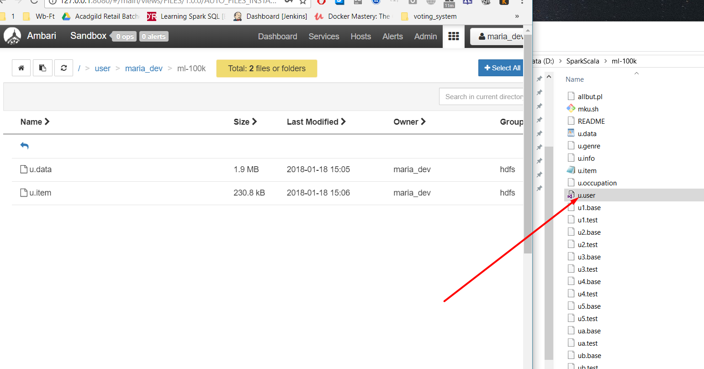

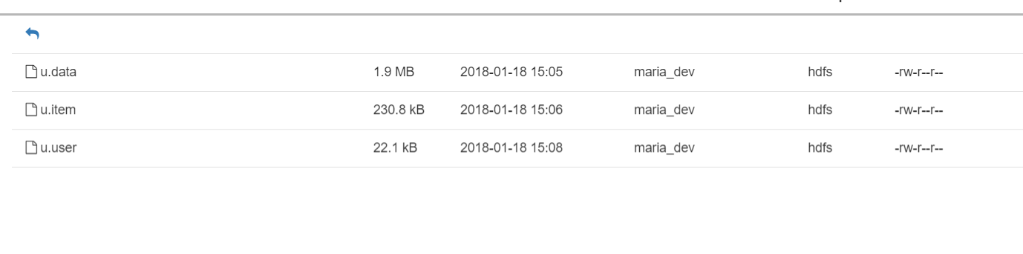

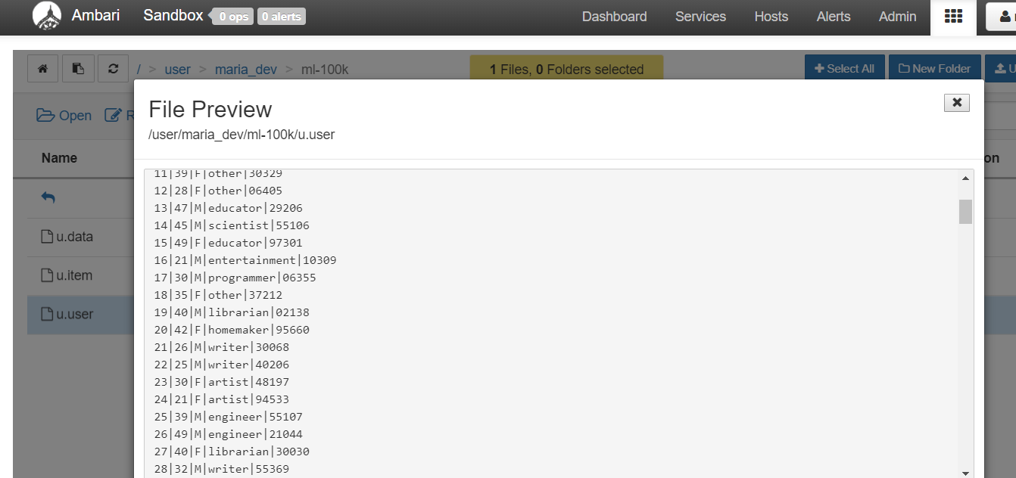

Lets start the Hbase server

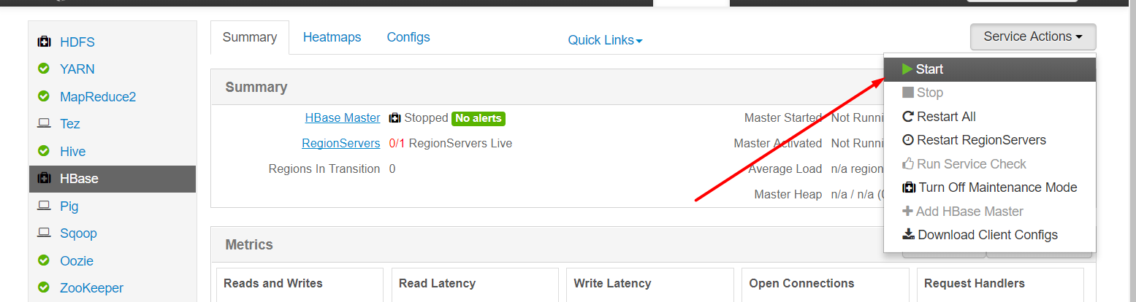

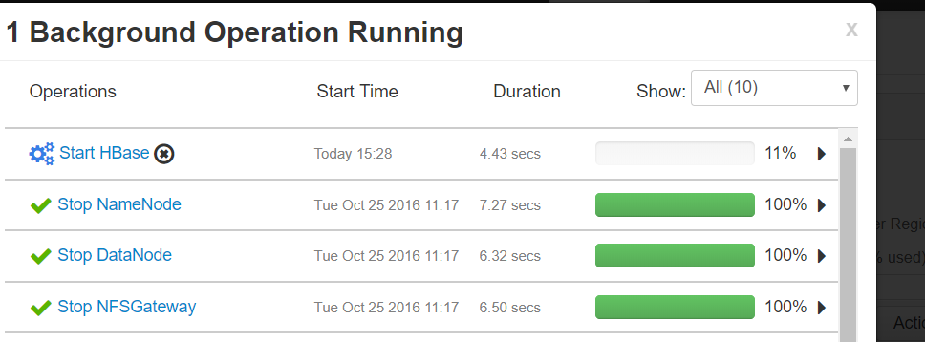

Let’s enter to the Hbase shell through putty

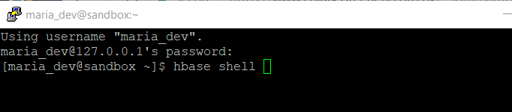

Create table and column family

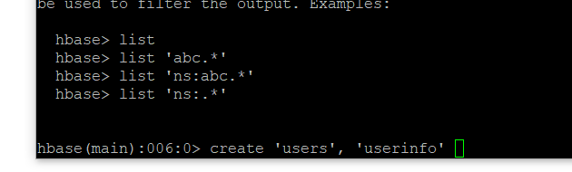

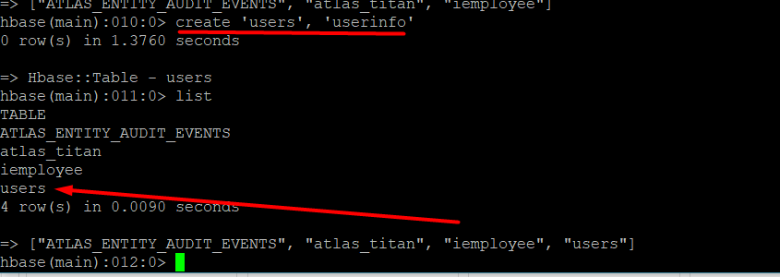

Prep pig script

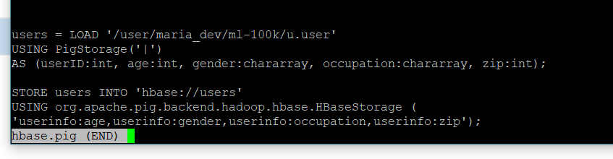

Now lets run the script

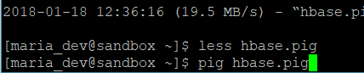

So far so good the pig start the job

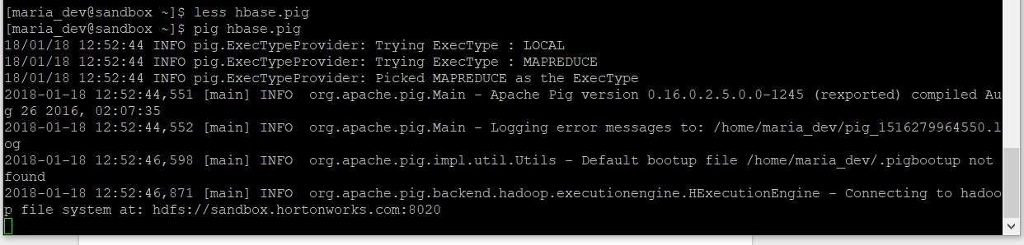

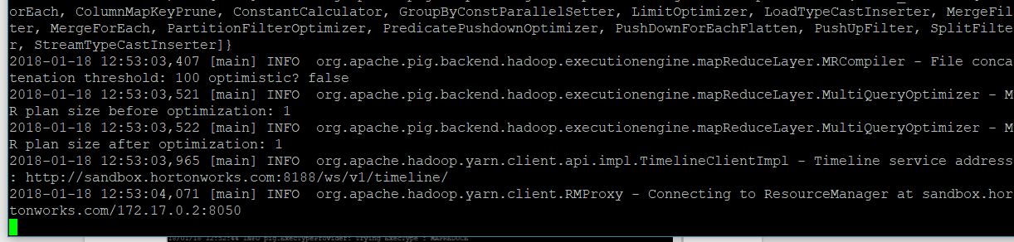

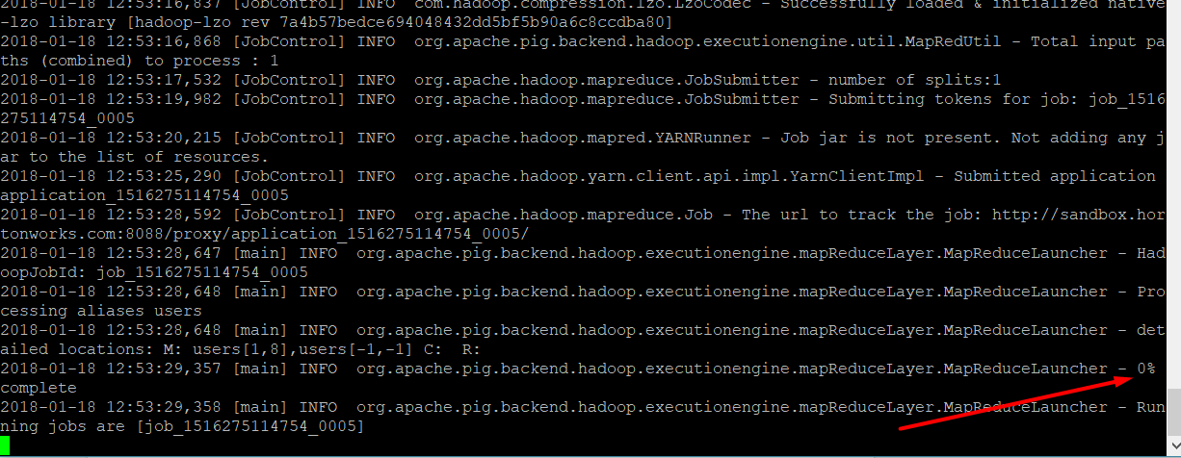

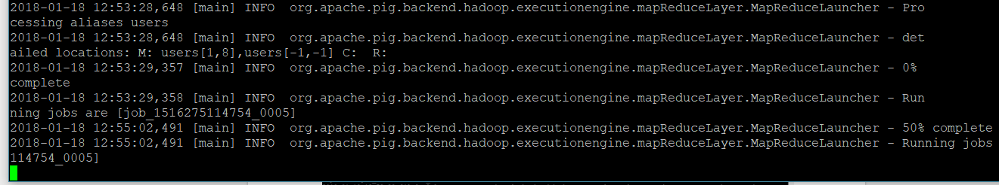

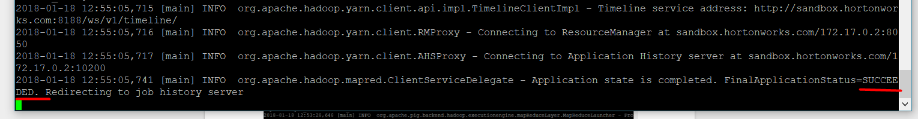

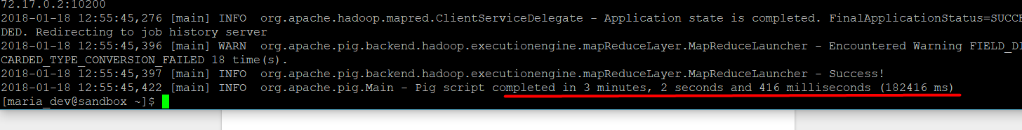

Lets enter the hbase again and take a pick on our data that just have been uploaded

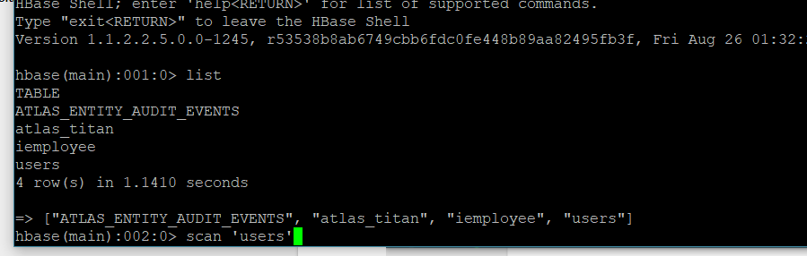

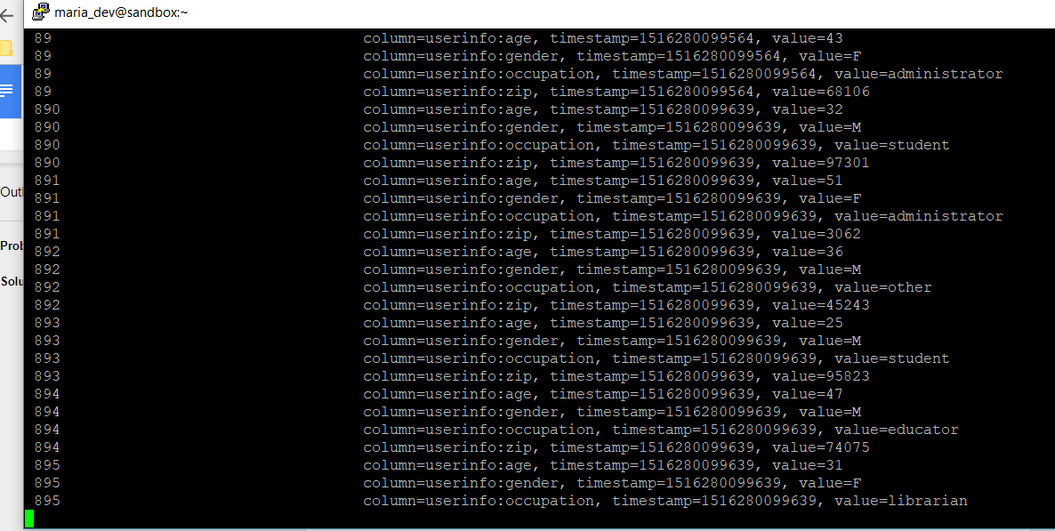

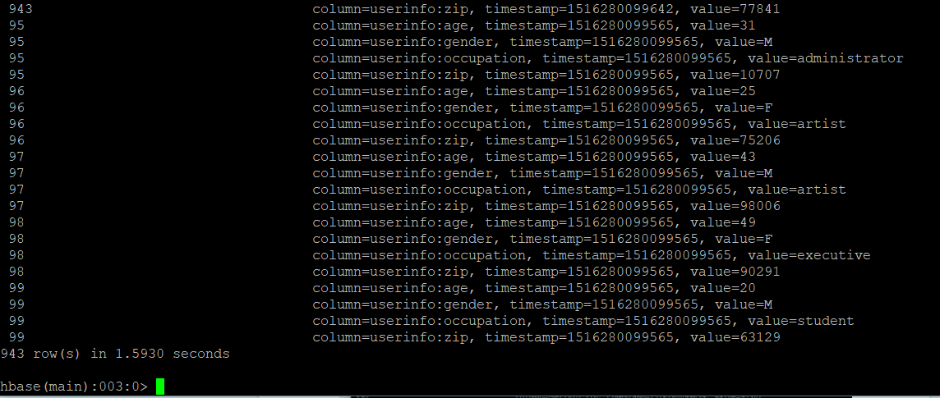

As u can see the data indeed is present