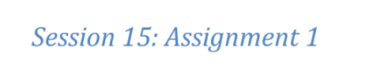

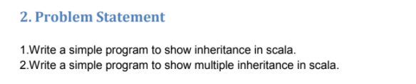

To show inheritance and multiple inheritance, to the previous program ( about calculator ) we add class SmartFraction where we implements methods def gcd and reduceFraction and add trait “FractionUtil” which help as to print our fractions. Let's take a look on the result.

