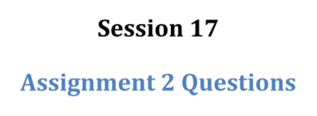

Assignment outline:

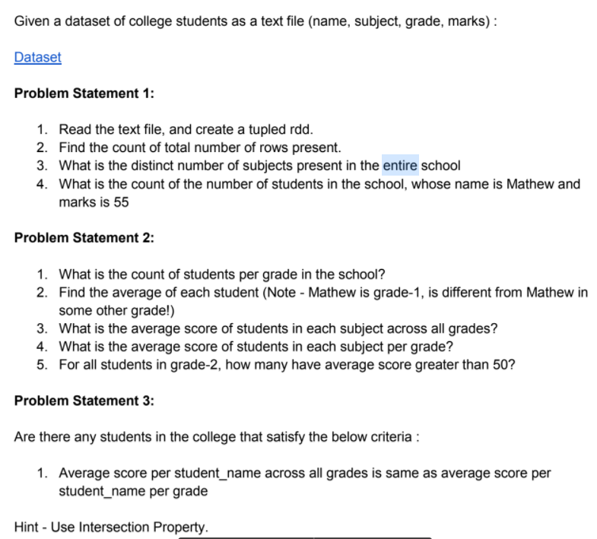

**The dataset:**



Mathew,science,grade-3,45,12  
Mathew,history,grade-2,55,13  
Mark,maths,grade-2,23,13  
Mark,science,grade-1,76,13  
John,history,grade-1,14,12  
John,maths,grade-2,74,13  
Lisa,science,grade-1,24,12  
Lisa,history,grade-3,86,13  
Andrew,maths,grade-1,34,13  
Andrew,science,grade-3,26,14  
Andrew,history,grade-1,74,12  
Mathew,science,grade-2,55,12  
Mathew,history,grade-2,87,12  
Mark,maths,grade-1,92,13  
Mark,science,grade-2,12,12  
John,history,grade-1,67,13  
John,maths,grade-1,35,11  
Lisa,science,grade-2,24,13  
Lisa,history,grade-2,98,15  
Andrew,maths,grade-1,23,16  
Andrew,science,grade-3,44,14  
Andrew,history,grade-2,77,11

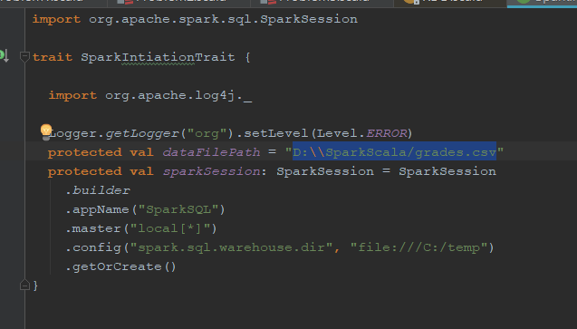

First of all we need to make a trait for example with needed vals ( look above ) which will help to us in the problem 2 and 3

The problem 1

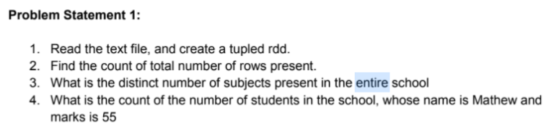

**The solution**

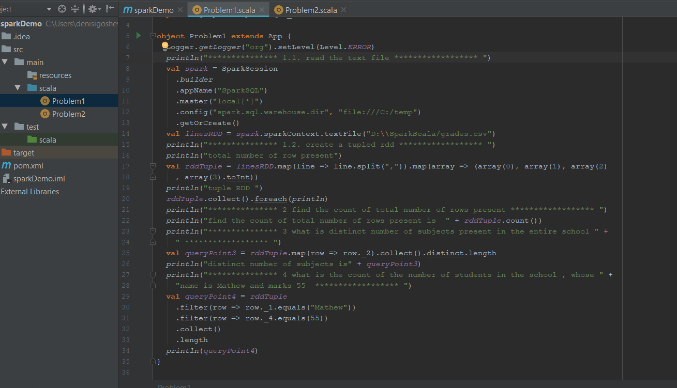

**The results**

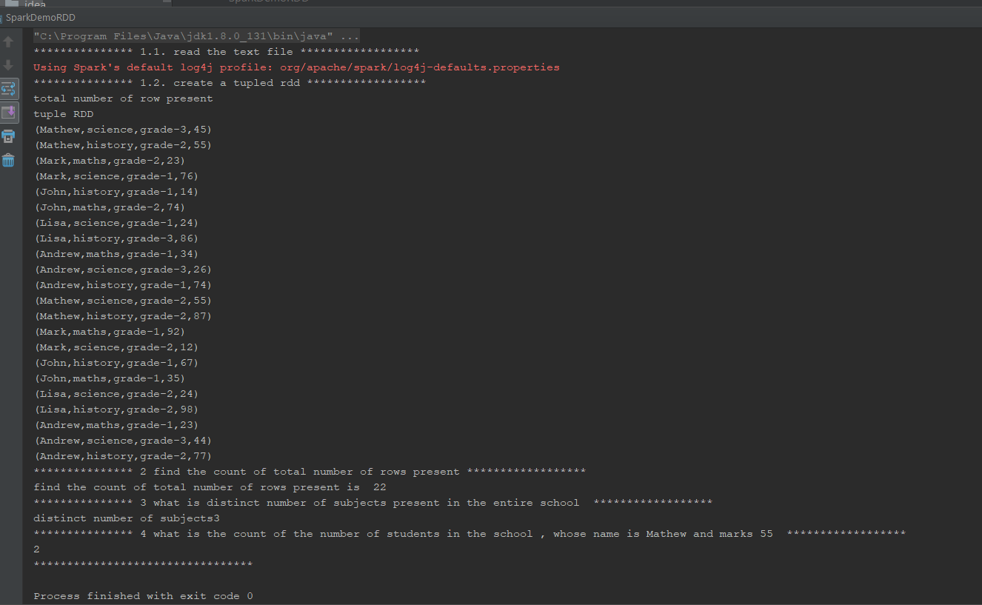

The problem 2

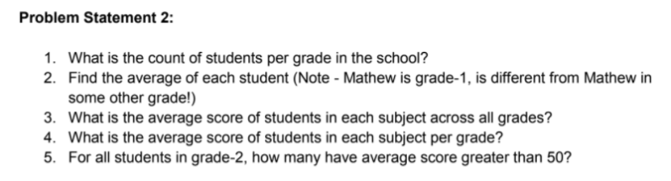

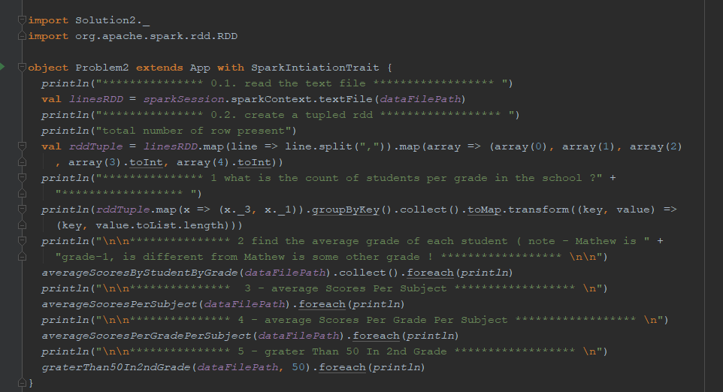

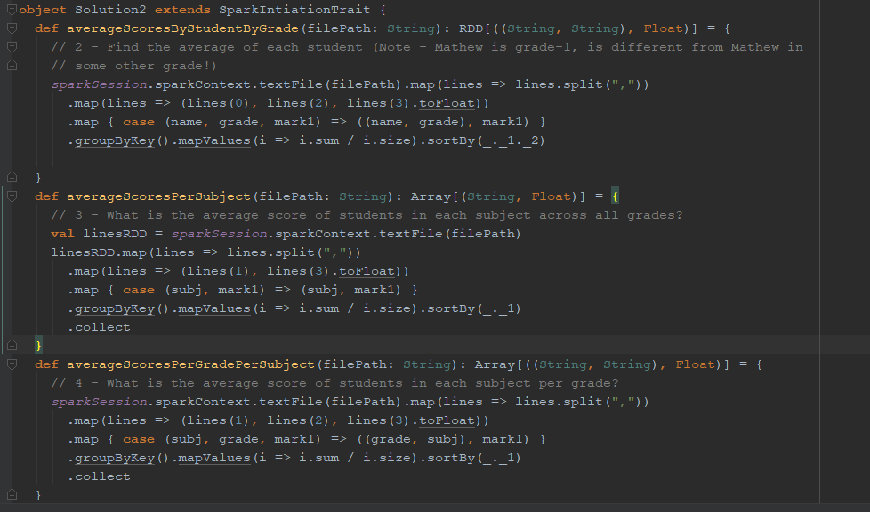

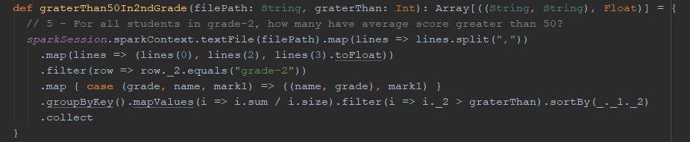

The result :

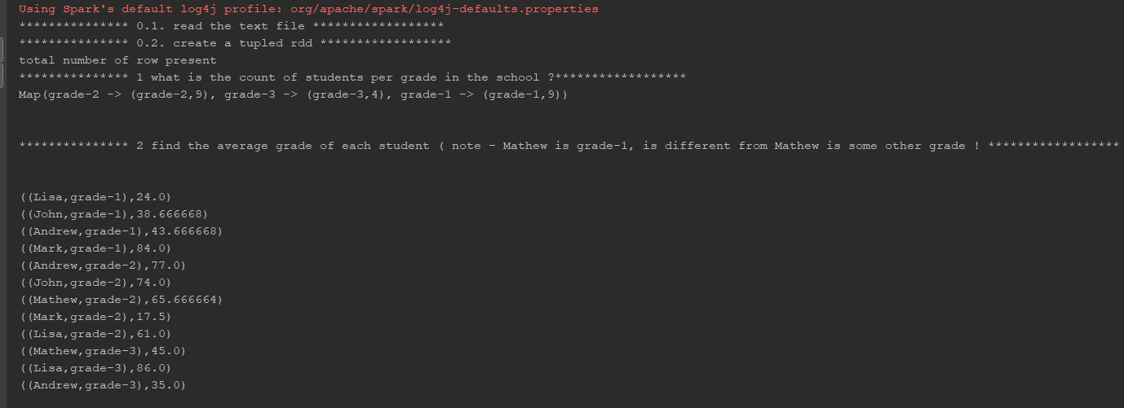

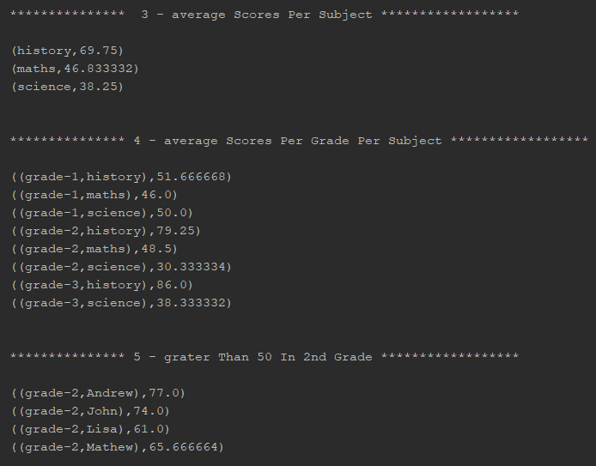

The problem 3

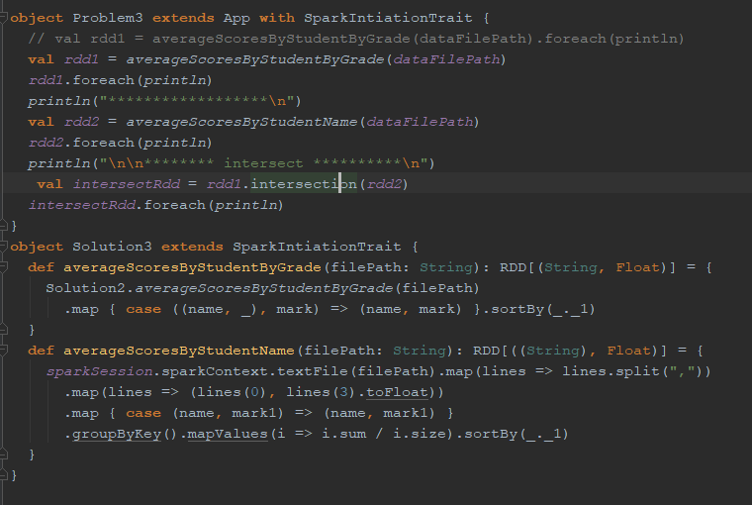

The result :

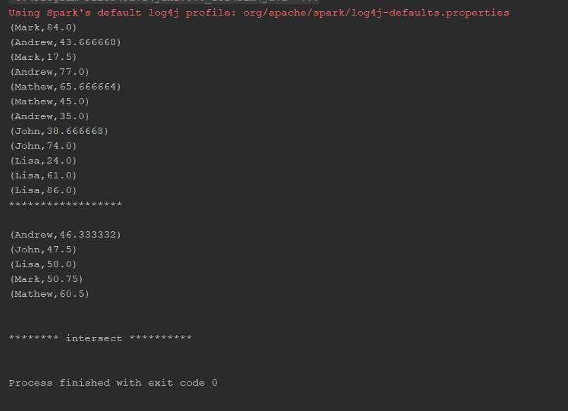

There isn’t a single intersection with the given condition