

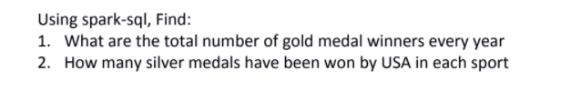

<https://drive.google.com/drive/folders/0B_P3pWagdIrrTEVTVE1VWXI0YVk>

DataSet

firstname,lastname,sports,medal_type,age,year,country  
lisa,cudrow,javellin,gold,34,2015,USA  
mathew,louis,javellin,gold,34,2015,RUS  
michael,phelps,swimming,silver,32,2016,USA  
usha,pt,running,silver,30,2016,IND  
serena,williams,running,gold,31,2014,FRA  
roger,federer,tennis,silver,32,2016,CHN  
jenifer,cox,swimming,silver,32,2014,IND  
fernando,johnson,swimming,silver,32,2016,CHN  
lisa,cudrow,javellin,gold,34,2017,USA  
mathew,louis,javellin,gold,34,2015,RUS  
michael,phelps,swimming,silver,32,2017,USA  
usha,pt,running,silver,30,2014,IND  
serena,williams,running,gold,31,2016,FRA  
roger,federer,tennis,silver,32,2017,CHN  
jenifer,cox,swimming,silver,32,2014,IND  
fernando,johnson,swimming,silver,32,2017,CHN  
lisa,cudrow,javellin,gold,34,2014,USA  
mathew,louis,javellin,gold,34,2014,RUS  
michael,phelps,swimming,silver,32,2017,USA  
usha,pt,running,silver,30,2014,IND  
serena,williams,running,gold,31,2016,FRA  
roger,federer,tennis,silver,32,2014,CHN  
jenifer,cox,swimming,silver,32,2017,IND  
fernando,johnson,swimming,silver,32,2017,CHN

The solution

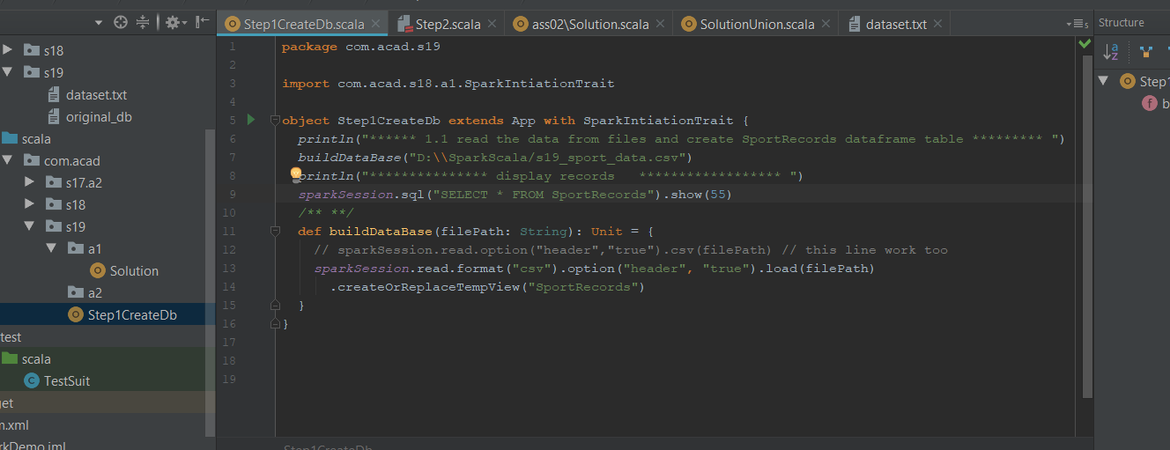

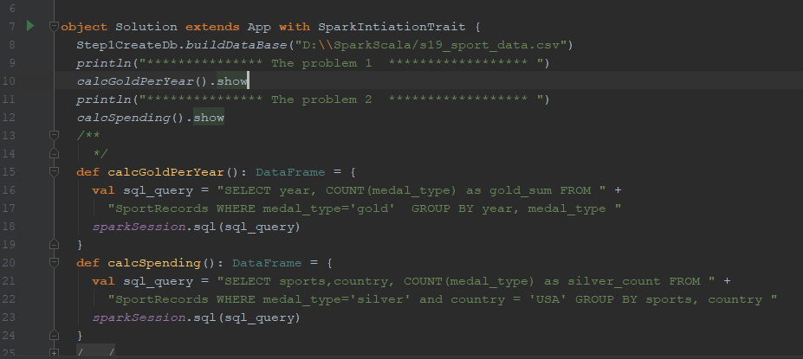

The output

