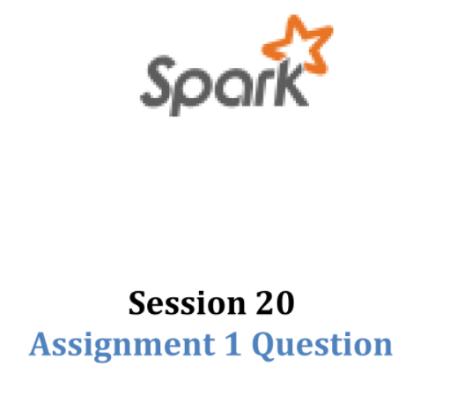

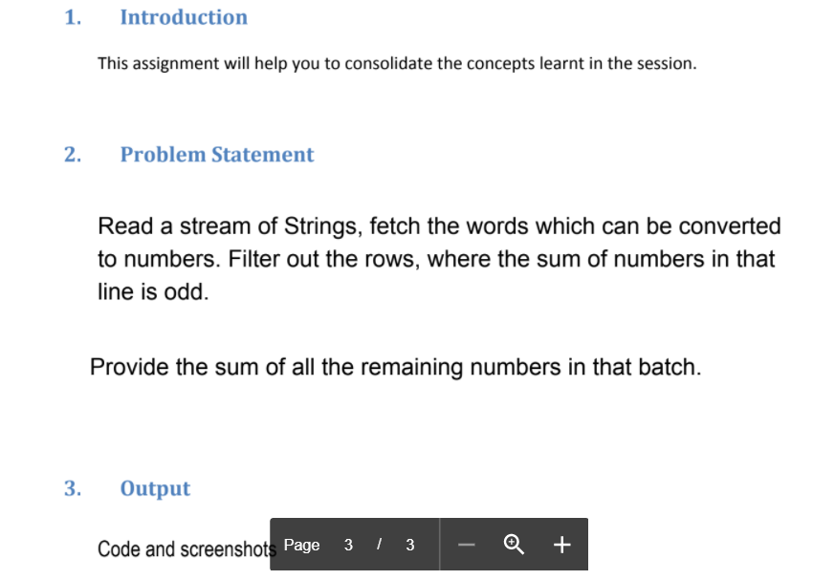

Let’s stream twits data from the twitter. In order to not get outofmemory exception we will filter the tweets that contains the words from outlist and sentences contain at least some words.

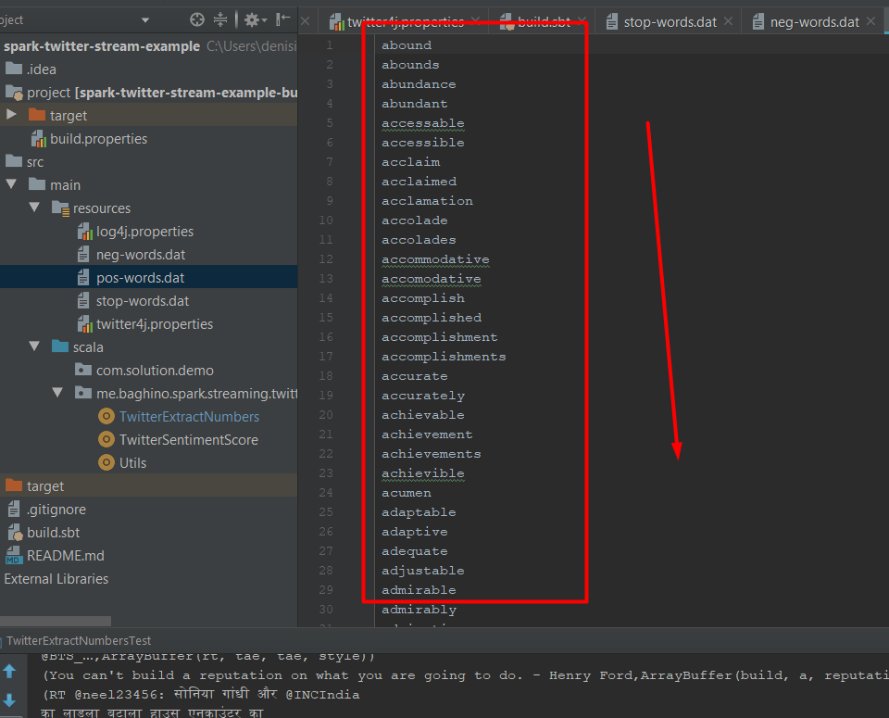

Some basic words list

Util class

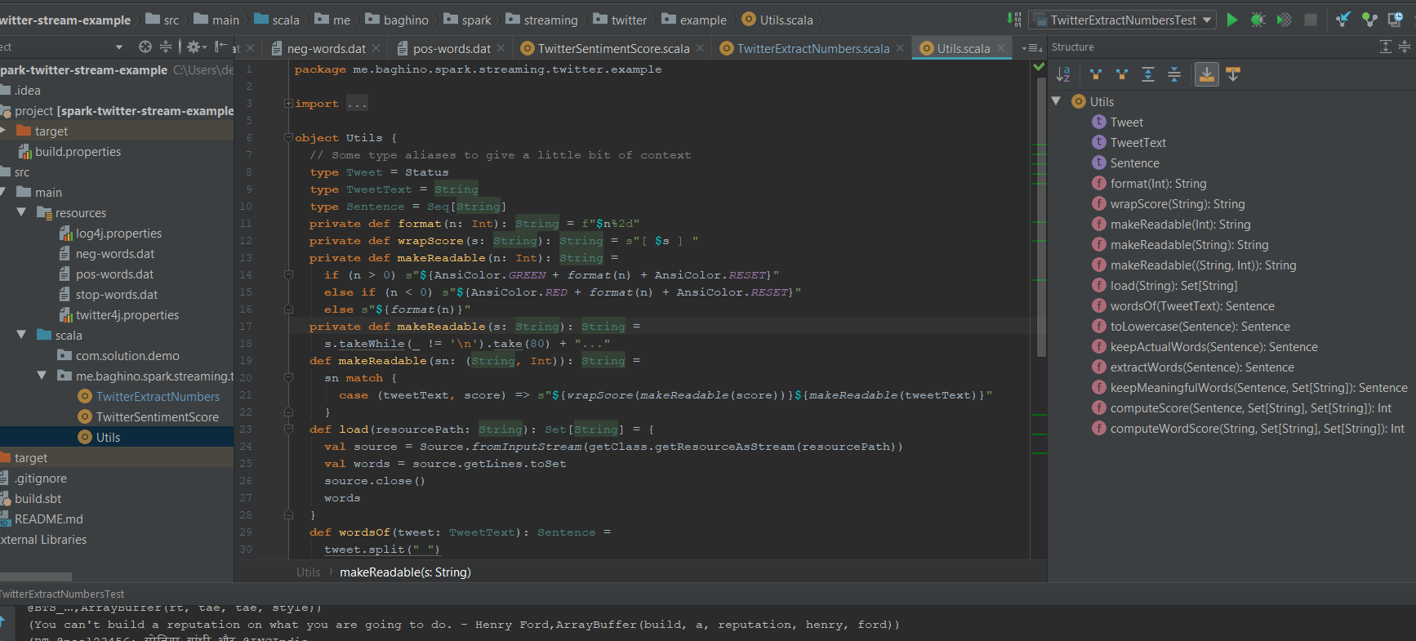

As u can see in the slide, we are managed to receive data and output it in console

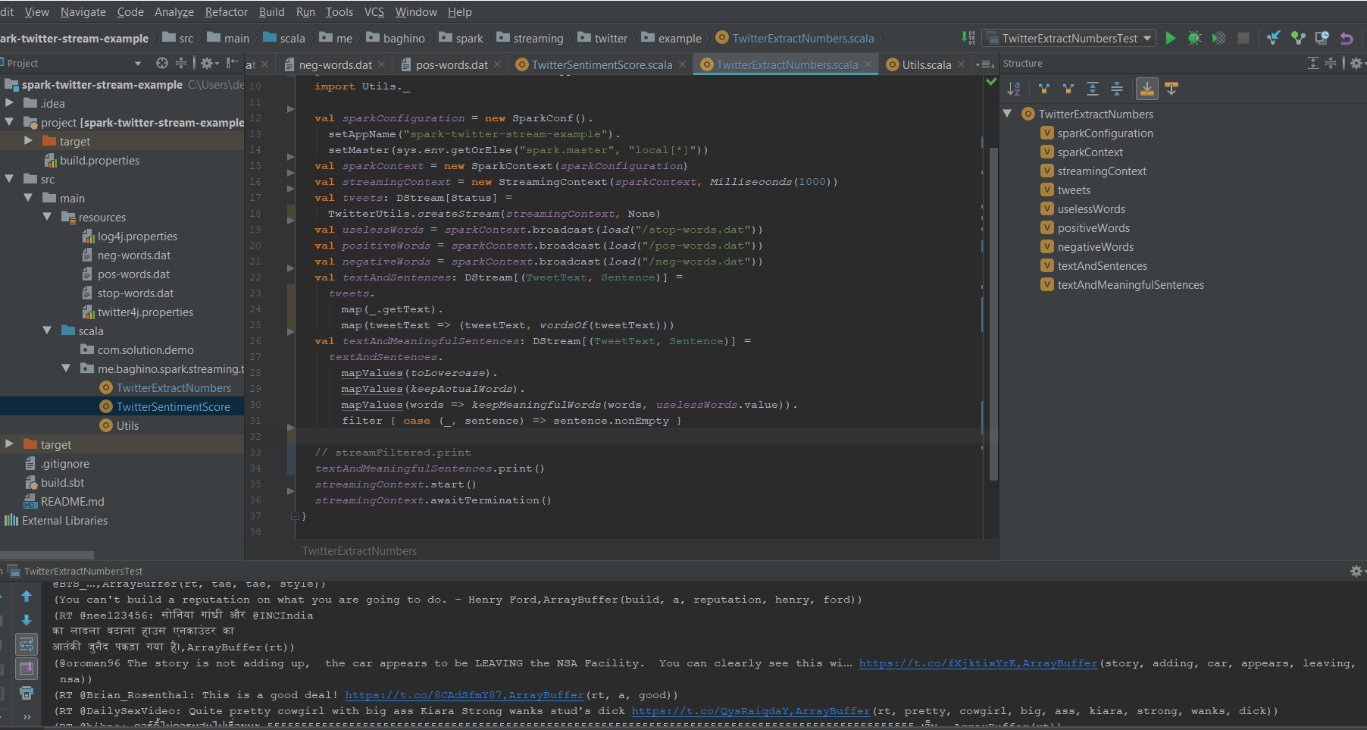

Now lest extract numbers from the twits and make the sum from this numbers according to problem statements

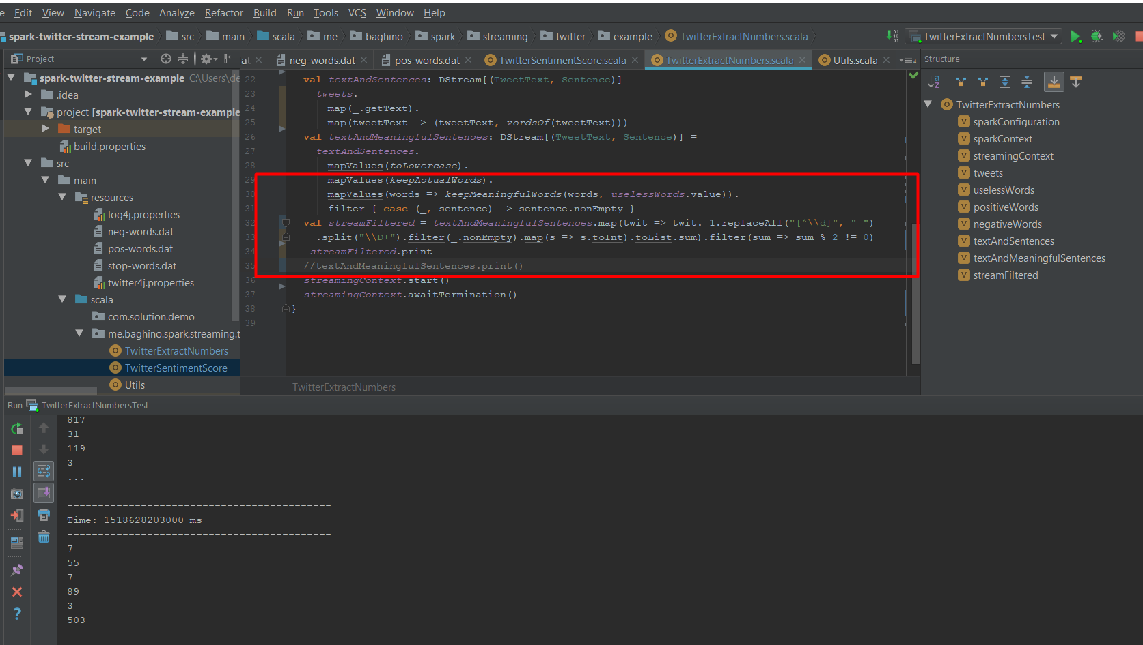

As u can see everything work correctly. The main logic of extraction in the red rectangle.