10.​ ​Open​ ​the​ ​terminal​ ​and​ ​start​ ​the​ ​ssh​ ​server.

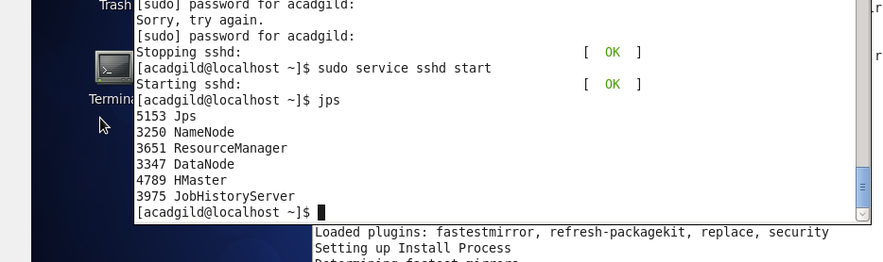

11.​ ​Start​ ​all​ ​the​ ​daemons.

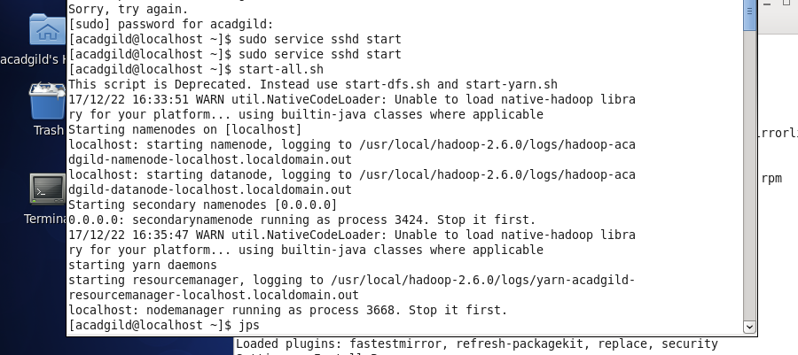

12.​ ​Start​ ​the​ ​historyserver:

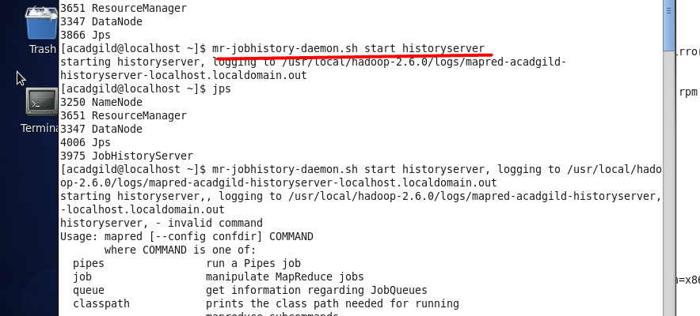

13.​ ​To​ ​start​ ​pig​ ​in​ ​hdfs​ ​mode​ ​,type​ ​the​ ​command​ ​ ​pig​ ​in​ ​terminal.

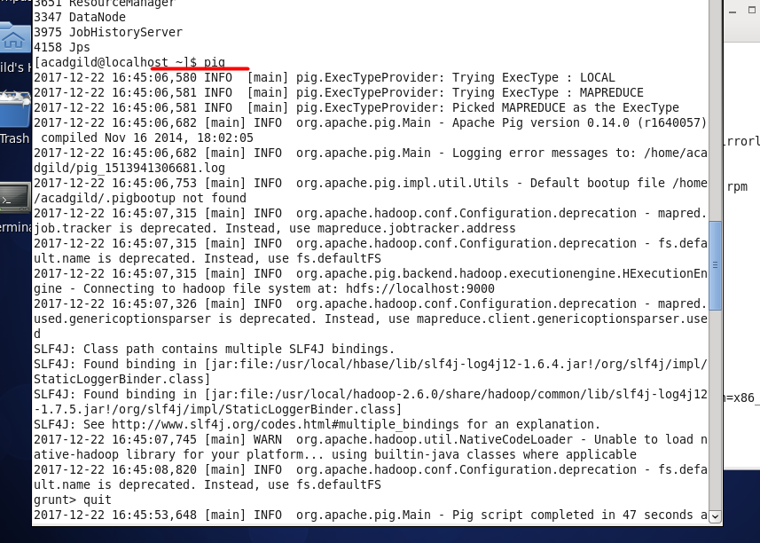

14.​ ​To​ ​start​ ​hive​ ​first​ ​start​ ​mysql​ ​service​ ​and​ ​then​ ​type​ ​the​ ​command​ ​hive.

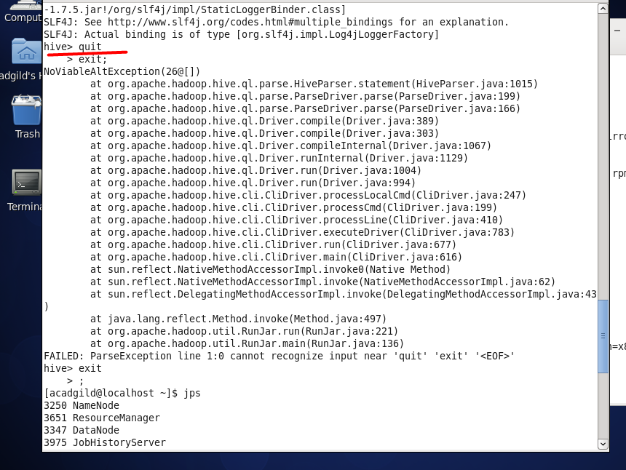

15.​ ​To​ ​start​ ​hbase​ ​type​ ​the​ ​below​ ​command​ ​as​ ​shown​ ​in​ ​the​ ​below​ ​screenshot.

