**Place to be:** Khartoum, Sudan  
**Time to be next year:** October 28, 2020

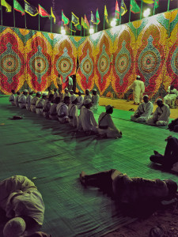Celebrating the Mawlid in Sudan – Personal trip, 2018

The mawlid is the celebration of the birthday of Prophet Muhammad. This festival is celebrated all over the muslim world, officially except of Saudi Arabia and Qatar, where it is forbidden, however, even there you can experience people celebrating it despite the law. However, if you want the best of all festivals, you should visit a strong Sufi dominated area. I can strongly recommend the Khalifa House Square in Khartoum. On the day, you will see Sudanese from all over the country arriving by foot and putting up a great festival in this square with lots of songs, dances, food and religious speeches. Every Sufi Tarika (Meaning “way of practice”) have their own tent and their own way of celebrating. Walk from place to place and participate in the event.