**Tabuik  
Place to be:** Pariaman, Sumatra, Indonesia  
**Time to be next year:**August 20, 2020

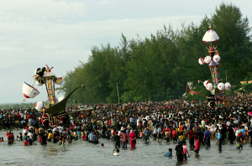Tabuik ceremony (Source: Wikipedia)

This festival is very closely connected to the Ashura and Arbaeen, as it also commemorate the Battle of Karbalaa and Imam Hussein’s sacrifice for the religion. This ceremony however is very different in execution, as it is held by predominately Sunni Indonesian Muslims rather than Shia Iraqi ones. Here they prepare tall funeral biers made of bamboo and send them into the sea. Then people would swim after them. The whole festival is filled with sport activities like swimming and kite running and also plays are performed.