- Basic of e-Leave Module
  - Change Password
    - Press [Change Password]
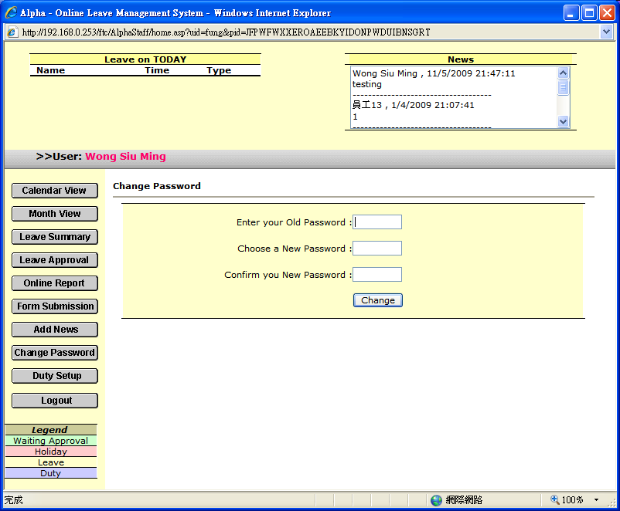

1.2.2 Enter your old password
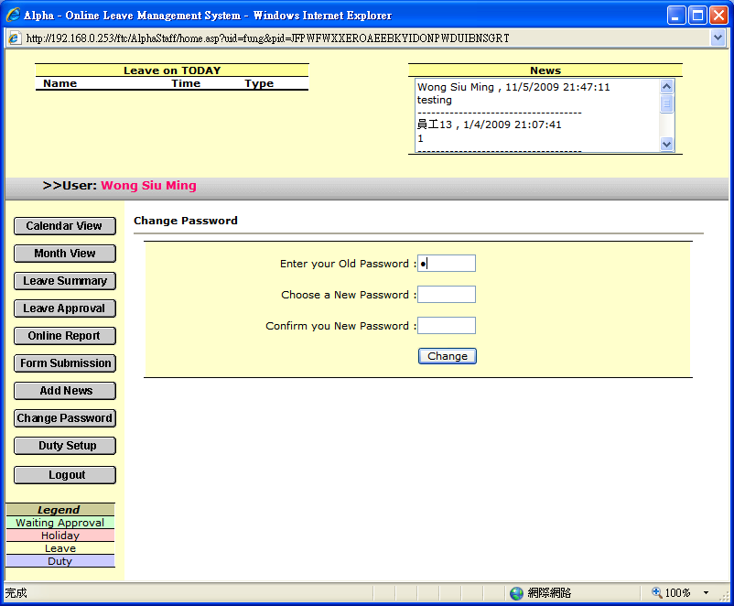

1.2.3 Enter new password and confirm your new password (Both new password must be match)
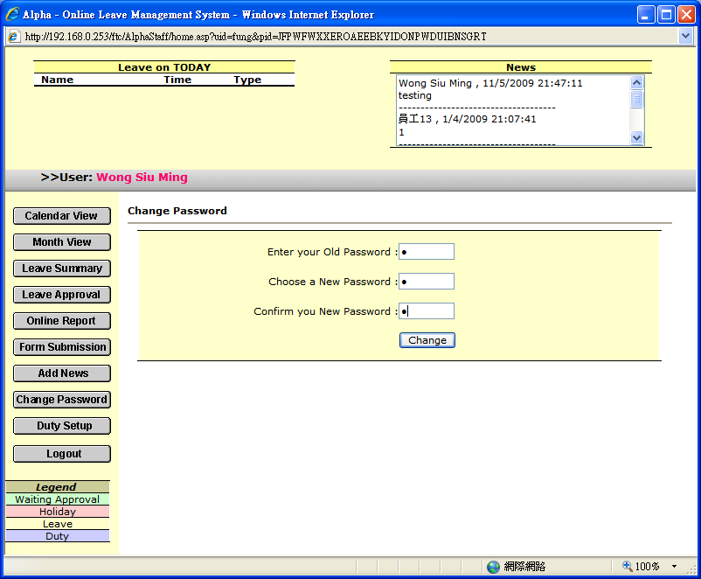

1.2.4 Press [Change] to save

1.2.5 System will prompt message for your changes (If change password success, new password will be effected on next login time)
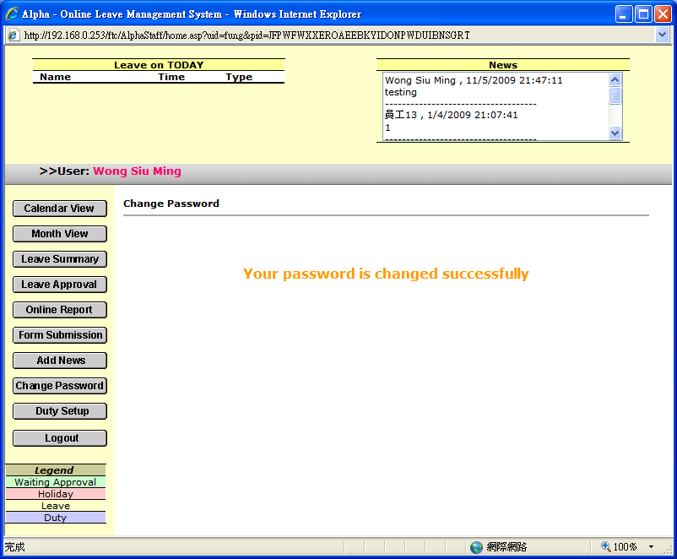

1.2.6 If old password is incorrect, change password will fail
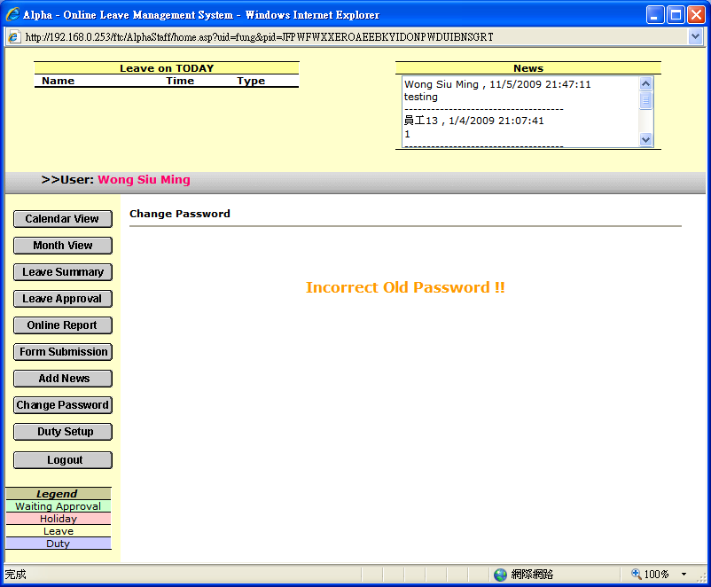

1.2.7 if new password and confirm password not match, change password will fail
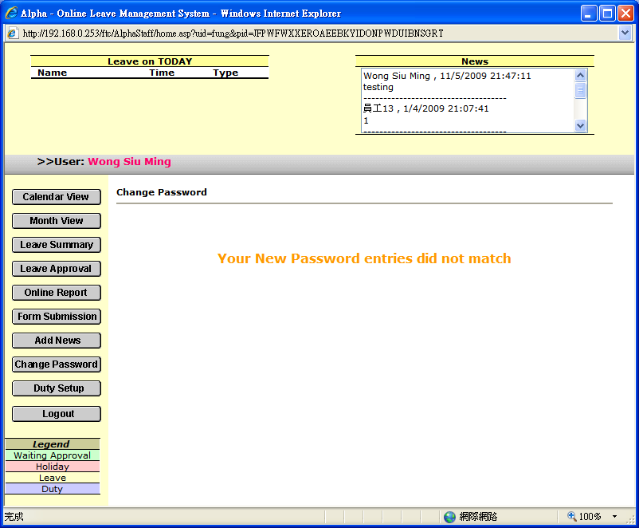

1.2.8 Please re-enter the correct one

