- Usage of e-Leave Module
  - Calendar View
    - Leave Application
2.1.2.1 Press [Calendar View]
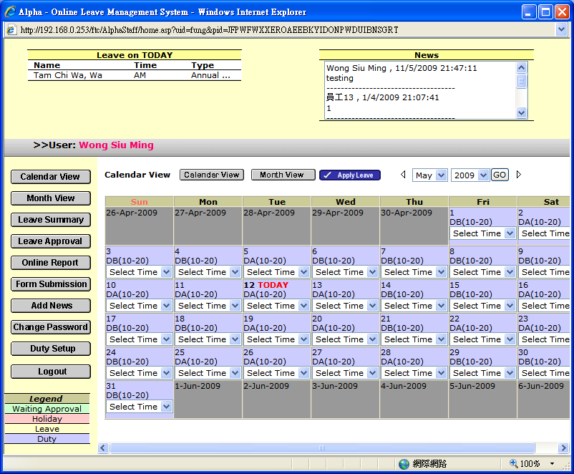

2.1.2.2 Select a day and time section for Leave Application
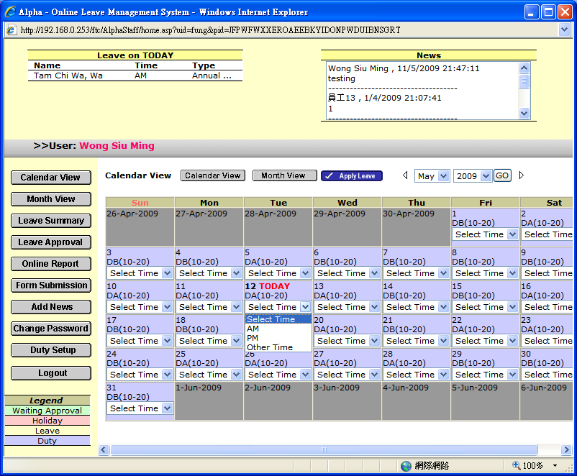

      - Press [Leave Apply] to continue
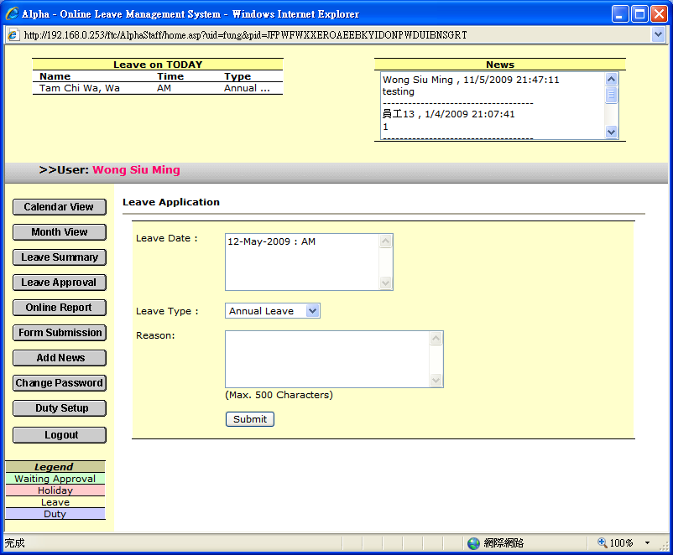

      - Select [Leave Type] and enter [Reason]

      - Press [Submit] to submit
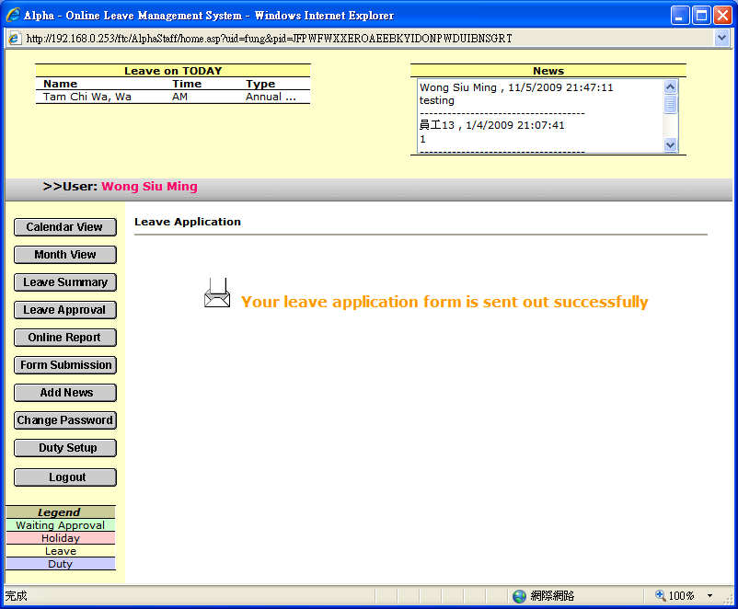

      - Go to [Calendar View] again, you will see your leave application status [Waiting Approval]
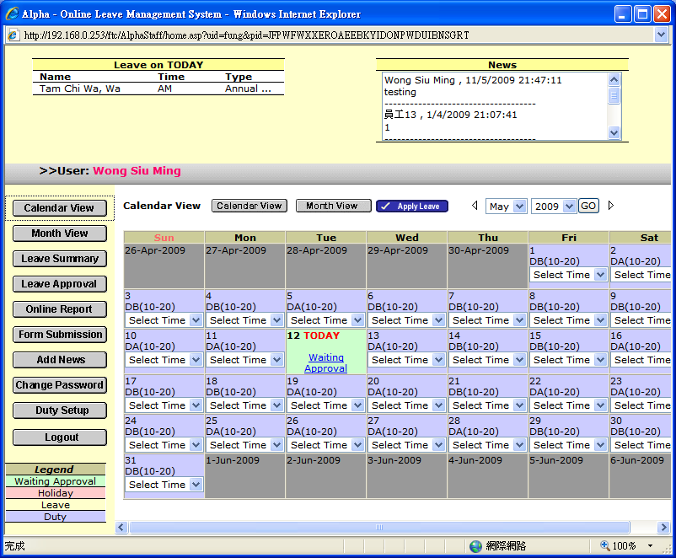

      - Press [Waiting Approval] to check the detail
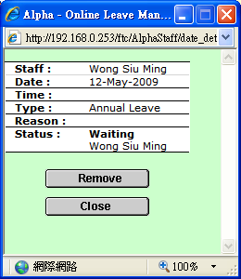

2.1.2.8 Press [Close] to Close the screen

2.1.2.9 Press [Remove] in case of cancel leave application
