- Usage of e-Leave Module
  - Month View
2.2.2 Usage of Month View
2.2.2.1 Press [Month View]
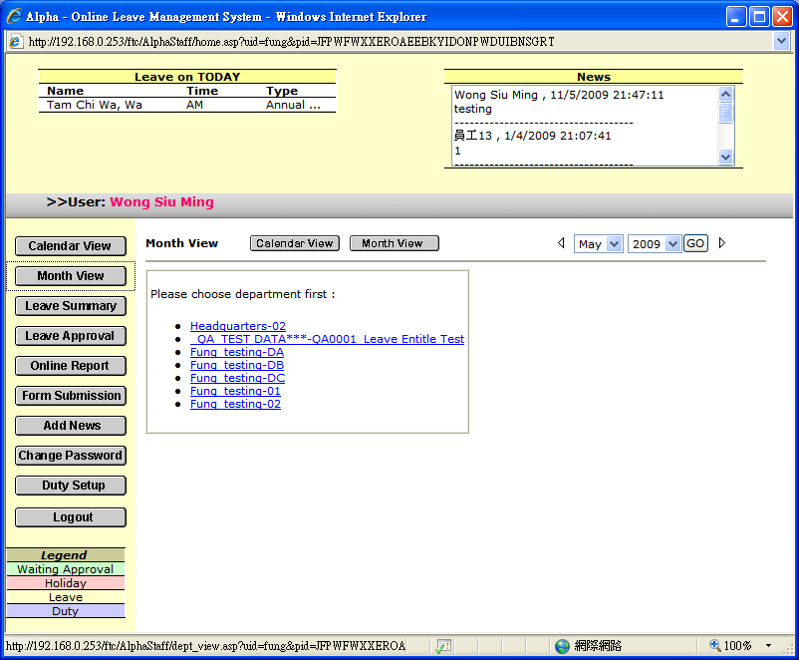

2.2.2.2 Select [Department] to view
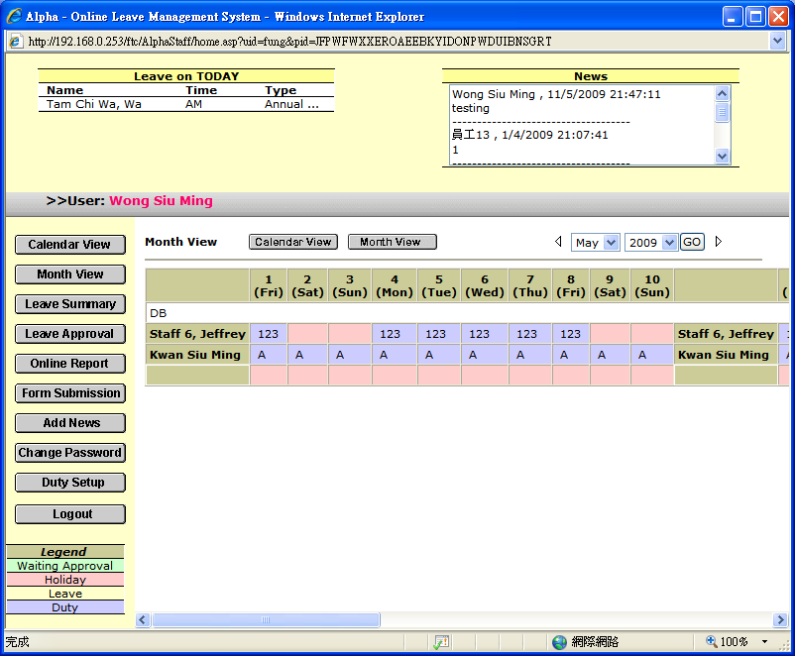

2.2.2.3 Select [Date Range] and press [GO]

or Press『』/ 『』to display previous or next month calendar

2.2.2.4 Press [Waiting Approval] to check the detail
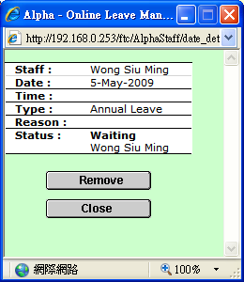

2.2.2.5 Press [Close] to Close the screen

2.2.2.6 Press [Remove] in case of cancel leave application
