- Usage of e-Leave Module
2.4 Leave Approval
2.4.1 Introduction
2.4.1.1 Press [Leave Approval]
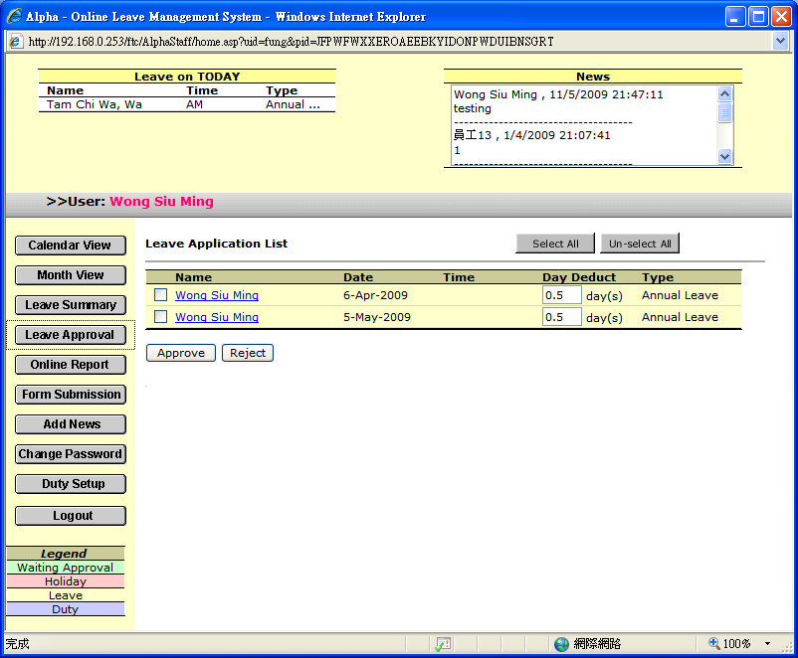

2.4.1.2 [Day Deduct] can be modify manually

2.4.1.3 You can use [Select All] or [Un-select All] to select all or un-select records

2.4.1.4 If you want to approve leave application on TAMS, please refer to 3.4

