- Usage of e-Leave Module
2.4 Leave Approval
2.4.2 Approve a Leave
2.4.2.1 Press [Leave Approval]
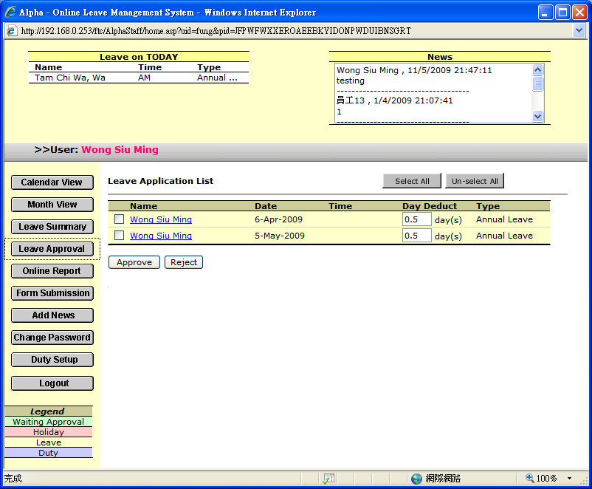

2.4.2.2 Directly approve a Leave
2.4.2.2.1 Select a leave application
2.4.2.2.2 Press [Approve]
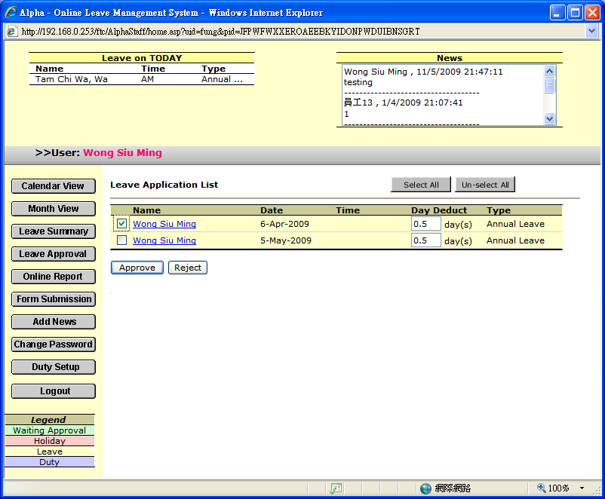

2.4.2.3 Check the application detail before leave approval
2.4.2.3.1 Check the employee name to check the detail
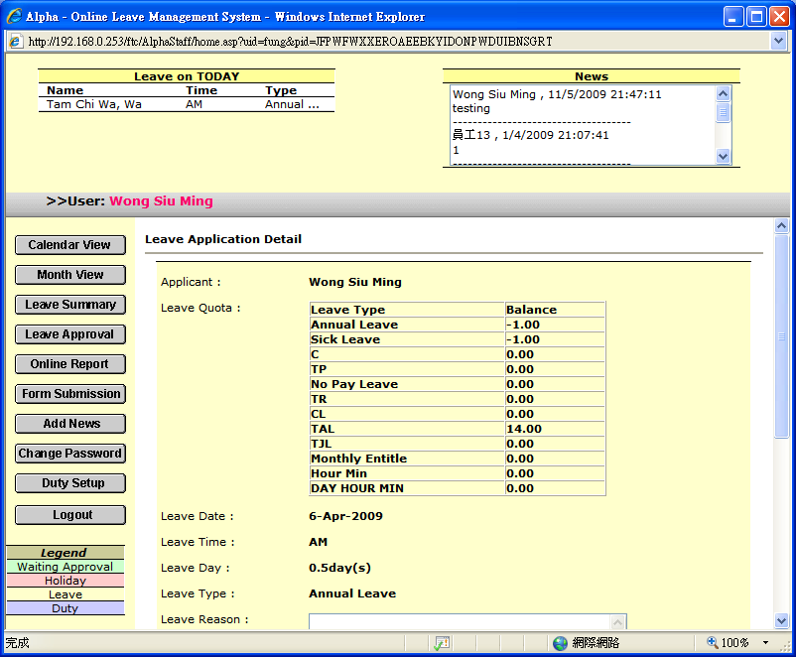

        - Leave down message for next approver or applicant (If any)
        - Press [Approve] to approve

      - Message will prompt after leave approval
