- Usage of e-Leave Module
2.5 Online Report
2.5.1 Individual Leave Report
2.5.1.1 Press [Online Report]
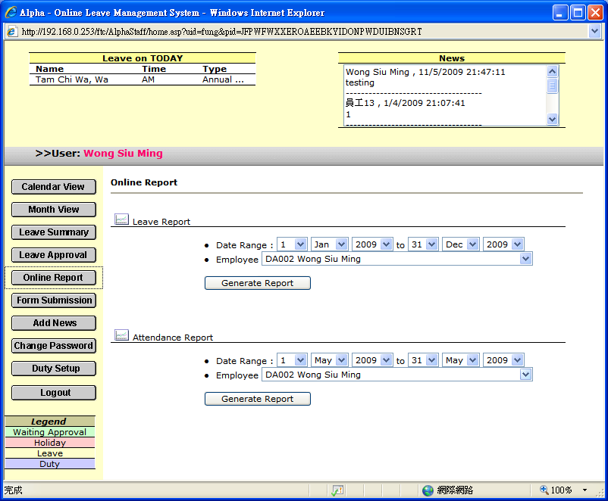

2.5.1.2 Select a [Date Range]

2.5.1.3 Select [Employee]

2.5.1.4 Press [Generate Report]

