- Usage of e-Leave Module
2.5 Online Report
2.5.2 Individual Leave Report
2.5.2.1 Press [Online Report]
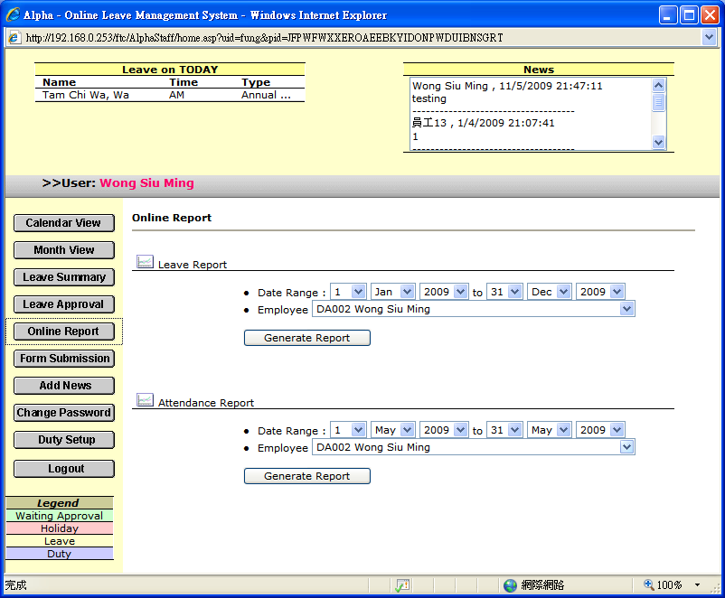

2.5.2.2 Select a [Date Range]

2.5.2.3 Select [Employee]

2.5.2.4 Press [Generate Report]

