- Usage of e-Leave Module
2.6 Add News
2.6.1 Usage of Add News
2.6.1.1 Press [Add News]
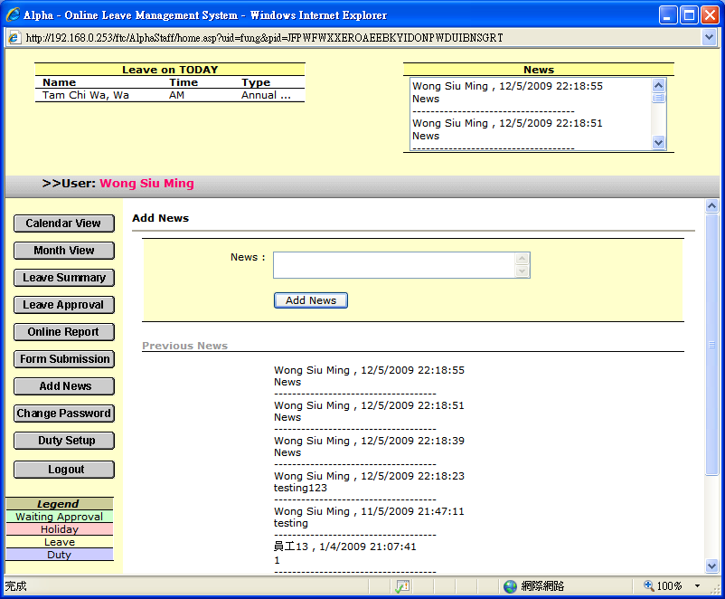

2.6.1.2 Enter message

2.6.1.3 Press [Add News]

2.6.1.4 News will show up on top right hand corner

2.6.1.5 Besides, on the top left hand corner, you can check staff name which take leave on today
2.6.1.6 If you want to check news on TAMS, please refer to 3.5

