- Usage of e-Leave Module
2.7 Duty Setup
2.7.1 Introduction
2.7.1.1 Press [Duty Setup]
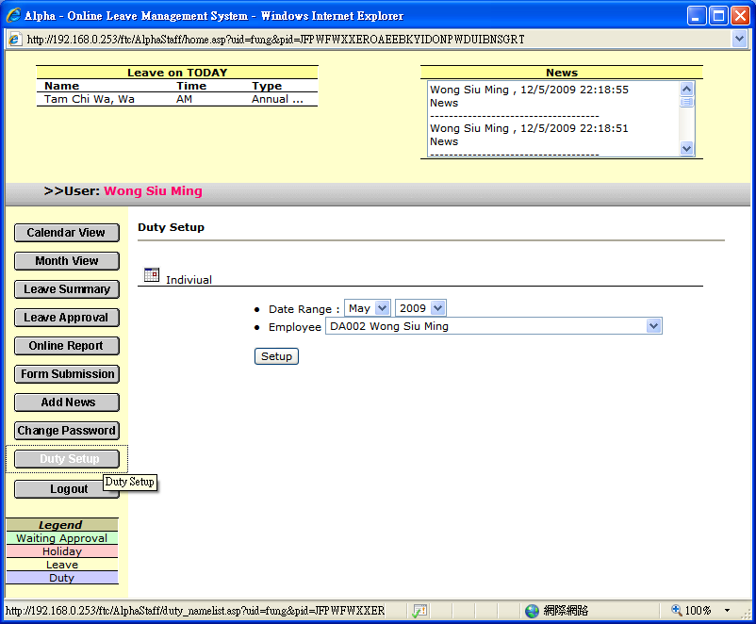

2.7.1.2 Select [Date Range]

2.7.1.3 Select [Employee]

2.7.1.4 Press [Setup] to enter employee roster
