- Usage of e-Leave Module
2.7 Duty Setup
2.7.2 Usage of Duty Setup
2.7.2.1 Press [Duty Setup]
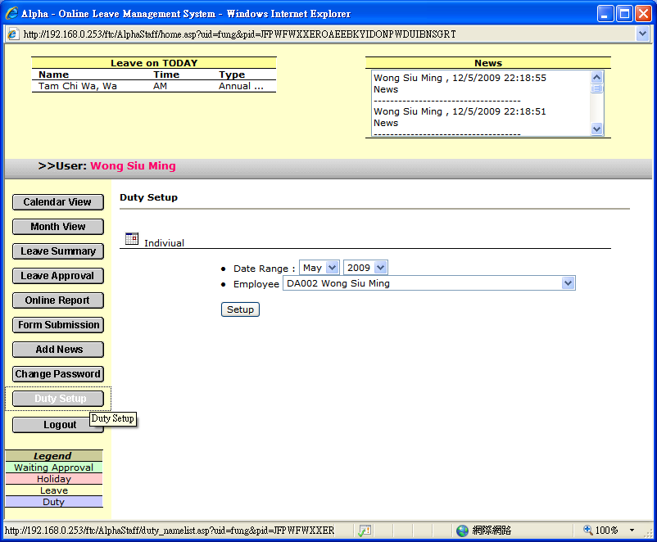

2.7.2.2 Select [Date Range]

2.7.2.3 Select [Employee]

2.7.2.4 Press [Setup] to enter employee roster
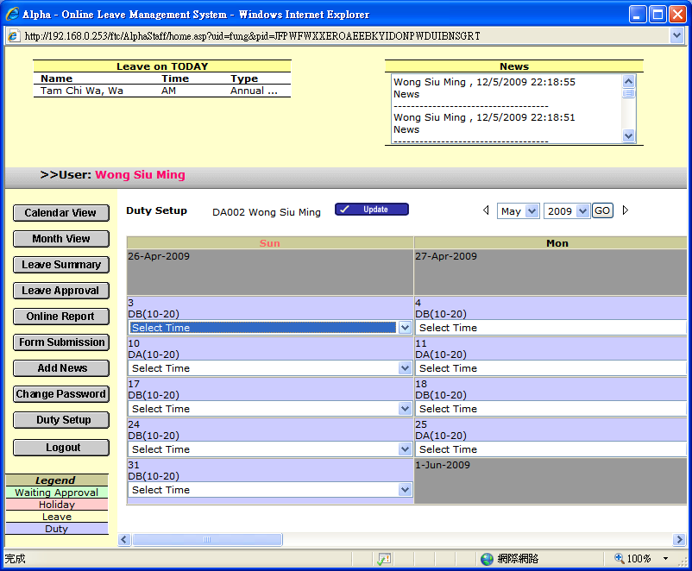

2.7.2.5 Select suitable [Duty Rule]
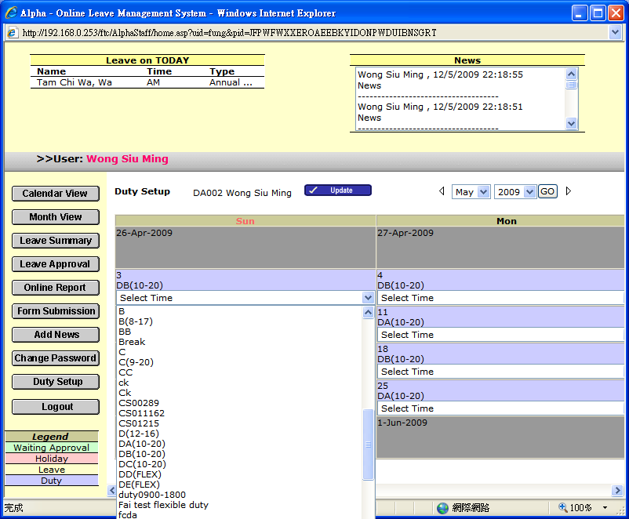

2.7.2.6 Press [Update] to update roster

