- Usage of e-Leave Module
  - Form Submission
    - Usage of Form Submission
      - Press [Form Submission]
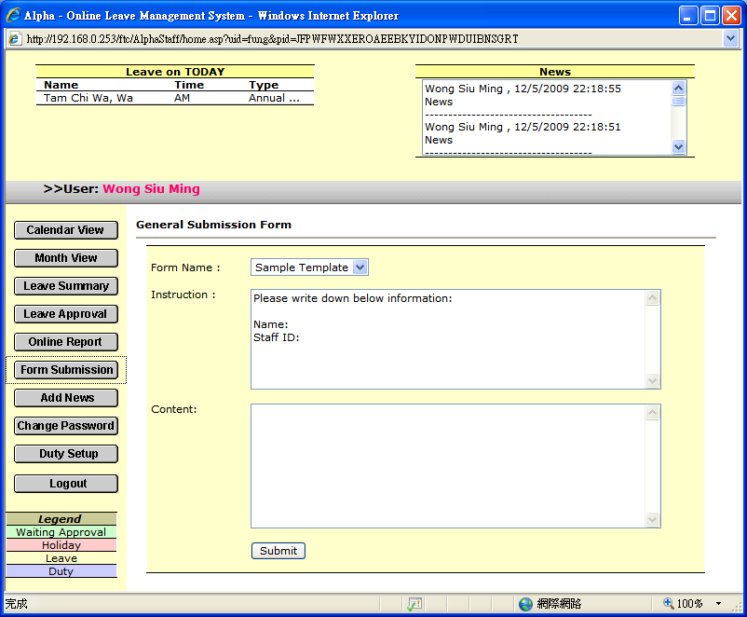

      - Select a pre-set template

      - Follow the instruction to fill in required information, then press [Submit] to submit
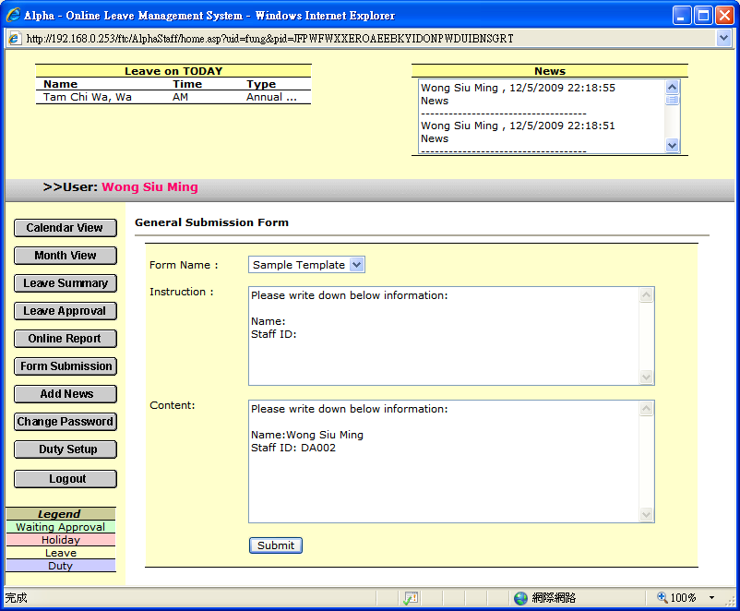

      - Message will prompt after form submission
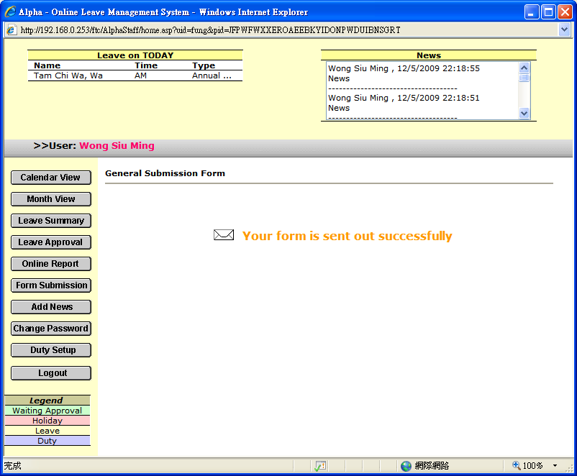

      - A pre-set receiver will receive your submitted form by e-mail
(For form submission checking on TAMS, please refer to 3.6)

