- e-Leave Module setting on TAMS interface
  - Introduction
    - Open [TAMS] program

    - Press [Web Module Setting]

    - Setting screen will show
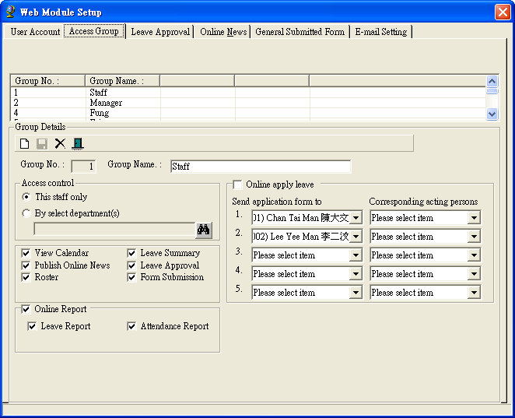

Related setting:
  - Access Group Setup
  - User Setup
  - Leave Approval Checking
  - News Checking
  - Form Submission Checking

