- e-Leave Module setting on TAMS interface
  - Access Group Setup
    - Open [TAMS] program

    - Press [Web Module Setting]

    - Setting screen will show
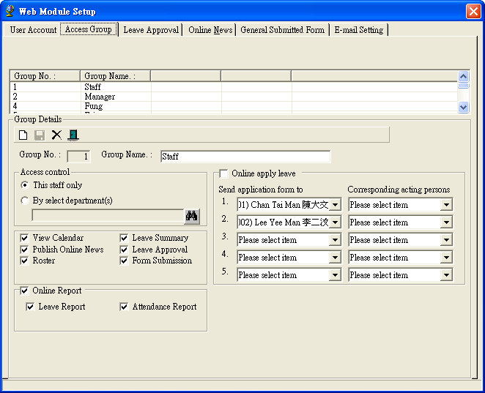

    - Select [Access Group]

    - Press [New] to add new

    - Fill in related authorize setting
Fill in [Group Name]
Select [Access control] setting (This staff only / Specific Department)
Select e-Leave function
Set [Send application form to] and [Corresponding acting persons] **sample below**

Send Application form to | Corresponding acting persons
Staff B | Staff C
Staff D
Suppose Staff A using this setting for leave application
When Staff A applies leave, his Leave application form will send to Staff B
When Staff A apply leave (While Staff B taking leave on the same day), his Leave application form will send to Staff C
When Staff A apply leave (While Staff B and Staff C taking leave on the same day), his Leave application form will send to Staff B
Either Staff B or C approve the leave application, his Leave application form will send to Staff D
Either Staff B or C approve the leave application (While Staff D taking leave on the same day), his Leave application form will send to Staff D
When Staff D approves the leave application, his Leave application form will return to inform Staff A
When Staff D rejects the leave application, his Leave application form will return to inform Staff A

    - Press [update] to update

    - For edit [Access Group]
      - Select [Access Group] to edit
      - Modify the setting according to 3.2.6
      - Press [Update] to update

    - For Delete [Access Group]
      - Select [Access Group] to delete
      - Confirm Deletion

