- e-Leave Module setting on TAMS interface
  - User Setup
    - Open [TAMS] program

    - Press [Web Module Setting]

    - Setting screen will show
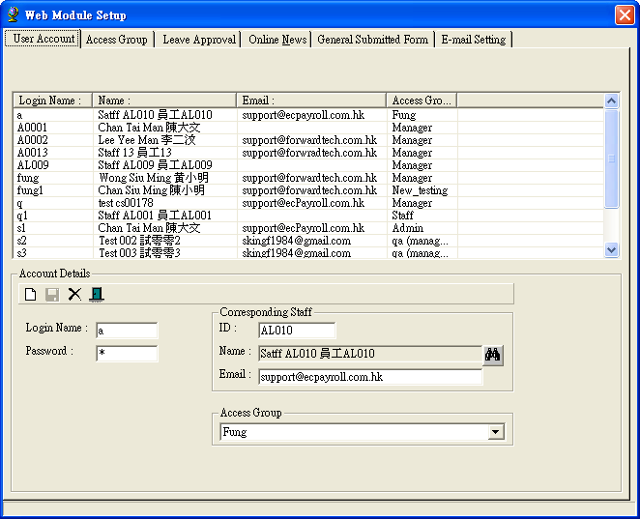

    - Press [User Account]

    - Press [New] to Add new

    - Fill in related information:
      - Login Name
      - Password
      - Account corresponding staff
      - Staff e-mail (auto fill in if you filled e-mail address information on employee’s contact page)
      - Access Group

    - For edit [User Account]
      - Select [User Account] to edit
      - Modify the setting according to 3.2.6
      - Press [Update] to update

    - For Delete [User Account]
      - Select [User Account] to delete
      - Confirm Deletion

