- e-Leave Module setting on TAMS interface
  - Leave Approval Checking
    - Open [TAMS] program

    - Press [Web Module Setting]

    - Setting screen will show
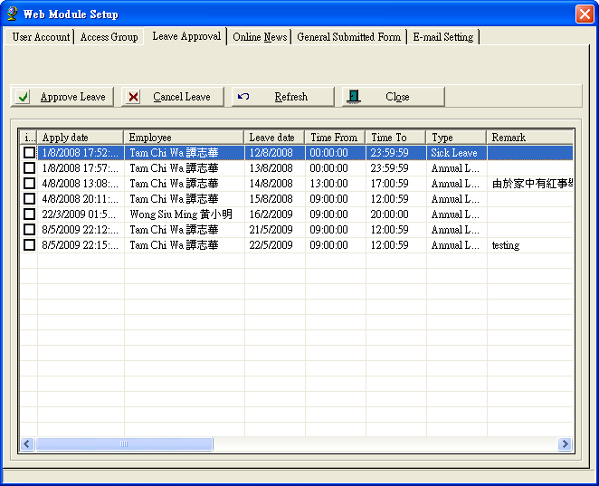

    - Select [Leave Approval]

    - Approve Leave
      - Select Leave application to approve
      - Press [Approve Leave] to approve

    - Reject Leave
      - Select Leave application to reject
      - Press [Approve Leave] to reject

