- e-Leave Module setting on TAMS interface
  - News Checking
    - Open [TAMS] program

    - Press [Web Module Setting]

    - Setting screen will show
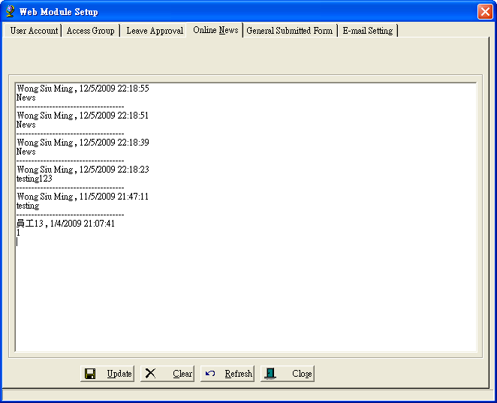

    - Select [Online News]

    - For edit [News]
      - Edit news
      - Press [Update] to update

    - For clear [News]
      - Press [Clear] to clear online news

