- e-Leave Module setting on TAMS interface
  - Form Submission Checking
    - Open [TAMS] program
    - Press [Web Module Setting]
    - Press [Form Submission]
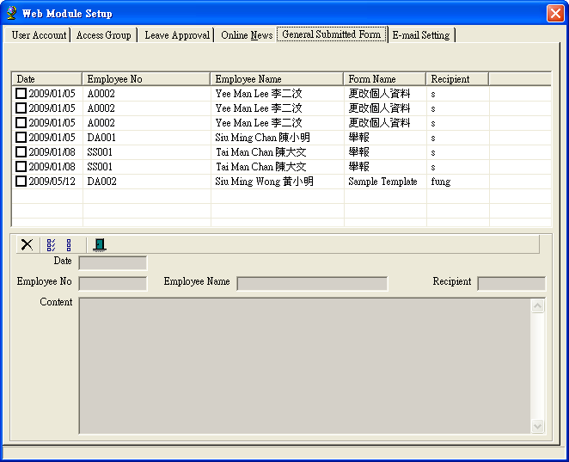

    - Check form submission records

    - For deletion
      - Selection record to delete
      - Press [Delete] to delete

