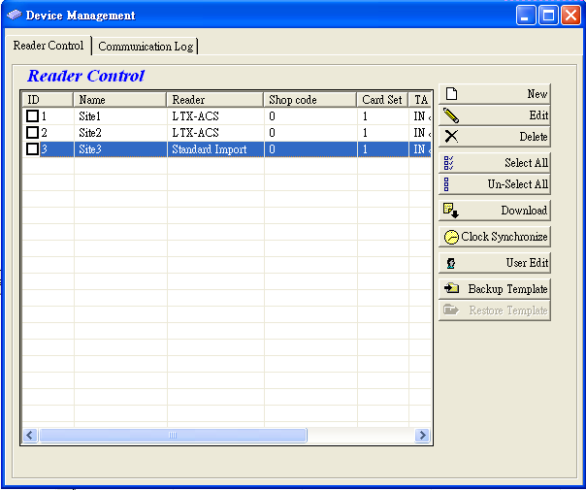
Readers setup screen. Multi-reader is supported.
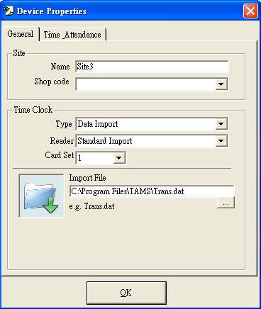
For each reader, select “Data Import” type, and define the import folder path for auto search file.
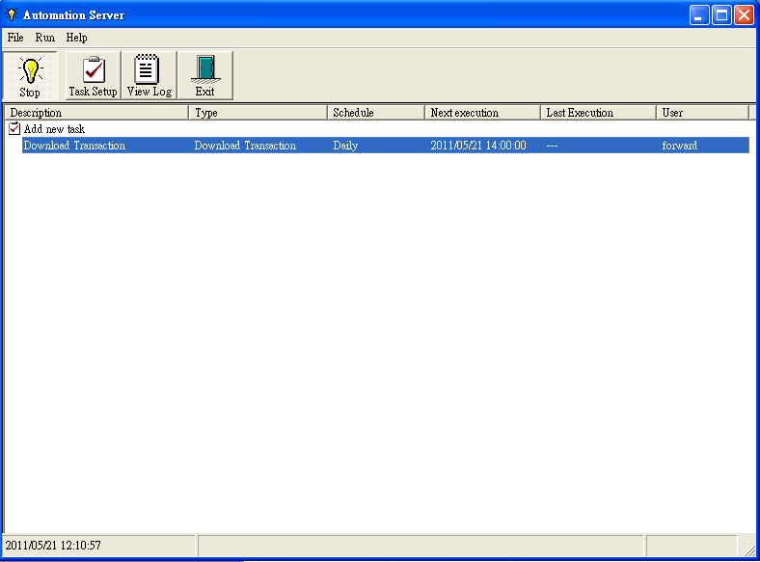
Add a “Download” task in automation server so that the system will import the file automatically by schedule.
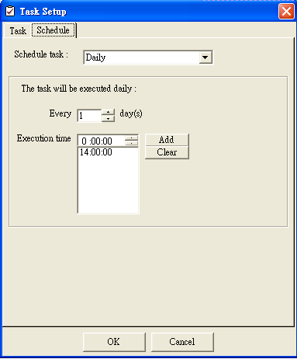
User may define the file import schedule
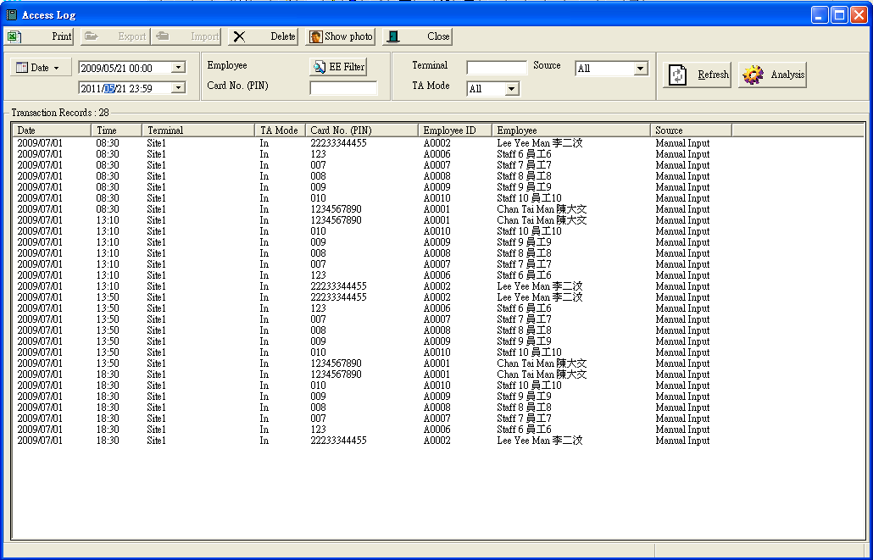
All imported punch records will be shown on screen

