FX Sentiment Anti – Grid Trading System

# **The trading system**

This is a contrarian system, which uses sentiment Moving Average crossings in Sentiment to determine direction. For now, we are using FXCM’s SSI indicator, set to 8 h candles.

While the system is a robot, the initial entry price and stop loss should be set on a discretionary basis. As the system is a breakout system at heart, entries should be located close to previous swing hi/los. Generally, we want to pre-empt the other orders in the market. Place the order a bit shy of the previous swing and/or point at which a (possible) breakout of the range is confirmed. Being a bit shy adds additional protection on retests if the trade has moved to breakeven after a breakout. It also triggers more trades, however, which often end up as losers in ranging environments.

**Scaling**

We mitigate these effects by keeping sizing small for initial trades, then scaling in.

We send a buy or sell stop trade grid spaced using ATR (“200% of the 336 h1 atr” in this case). We scale into the position with ‘3 gears’, starting with a quarter of the overall risk, then three quarters, then full.

lot sizes increase arithmetically for the first three trades, depending on the asset. Ie. .01-.02-.03, .02-.04-.06, .03-.06-.09.

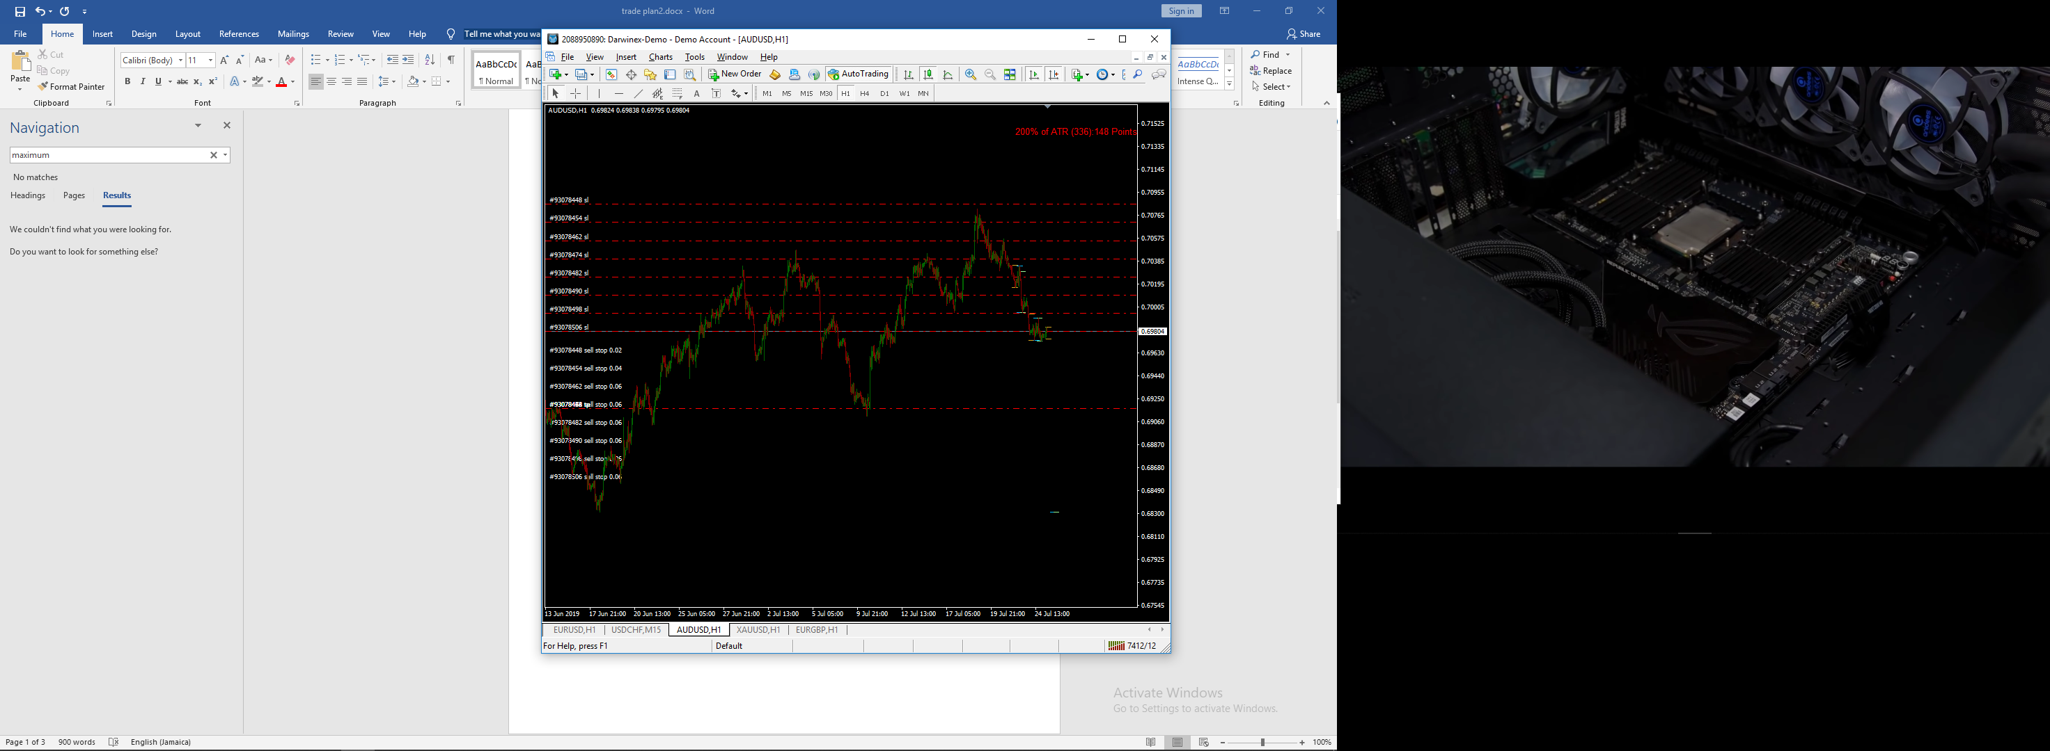

we set all trades to breakeven once they have gone over twice the ATR in profit. This means that only two orders have true risk on the table at any given time. The idea is to accumulate ‘broken-even’ trades in trending environments and treat them as free leverage. Over the long term this should shift the risk reward ratio in our favour. This is the anti-grid nature of the heart of this strategy, inspired by this:

<https://sites.google.com/site/prof7bit/snowball>

we have two phases or ‘levels’ for the trade grid. The first level consists of the first three stop orders that scale up in lotsize. These orders have a tp set to the open price of the fourth order (the start price of the second level).

Once the second level starts, the lotsize is fixed, with only 2 percent at risk at any time, (excluding broken-even trades, of course).

**Exit Scenarios**

We must avoid letting constant signal switches and choppy action prevent us from profiting in trending environments. With this in mind, we should account for a few different scenarios before closing positions and sending new trade grids on signal reversals.

Upon signal reversal,

Scenario 1

if existing position is still in level one, close the position.

execute new entry.

Scenario 2

If existing position is in level 2, and it is in negative pnl, close the position.

execute new entry.

Scenario 3

if existing position is in level 2 and the pnl is positive, close all individual trades in the position that are in loss. Set stop losses of remaining ‘father’ trades to the new position, or son’ level 1 tp (fourth trade in new tradegrid)

execute new entry.

Scenario 4

if scenario 3 has already happened, the tp of reversal signal is never hit and the previous trend is continuing, close previous ‘son’, now ‘father’ position that’s still in level one and keep original ‘grandfather’ positions. set sl of grandfather trades to sl of 1st new pending continuation stop order.

go straight to level 2 on a new entry

# the Code

Darwinex has provided a lot of the code. I’ll refer you to these resources first:

**Installation guide and Readme explaining how everything works**

<https://github.com/darwinex/dwx-zeromq-connector/blob/master/README.md>

**Darwinex github with original python and mql templates:**

<https://github.com/darwinex/dwx-zeromq-connector/tree/master/v2.0.2>

The DWX_ZeroMQ_Connector python file and DWX_ZeroMQ_Server mq4 files in this github are my versions, with some functionality added for the purposes of the strategy. I have also included a functions script, which has all the functions necessary to execute the strategy when given the atr, price, stop loss and symbol. The ‘CompleteScript’ is simply these two scripts put together and is the one you should run.

This is the part where I say don’t judge too harshly! I know its super janky haha. I’m sure there’s still a lot that’s not working. Still need to do a lot of testing!

I tried for a while to get ATR to calculate automatically, but its harder than I thought. The darwinex script seems to have trouble importing ohlc candle data for atr calculation. Could maybe use another source for tickdata? I dunno..

I also tried to literally copy the code of this ATR indicator I’ve been using and paste it into the ea code, but I didn’t know wtf I was doing at all and decided to move on:

<https://www.mql5.com/en/code/15793>

Plan is to do a risk management portion of the system as well. Need to do more learning before I can achieve that I think though. For now, I’ll be using two different mt4 EA’s on each symbol for the risk management portion:

**‘MULTI PURPOSE TRADE MANAGER’**

http://www.stevehopwoodforex.com/phpBB3/viewtopic.php?f=21&t=5190

setting all trades to breakeven once they have gone T W I C E the ‘200% 336 h1 atr’ in profit

**FXBLUE PNL MANAGER**

https://www.fxblue.com/appstore/6/pl-manager

setting a 2 percent max loss (in cash value) and closing all pendings on stopout.

I have also included a suuuuper basic script that scrapes [www.fxssi.com](http://www.fxssi.com) for sentiment data. This website seems promising as it takes an average from several different sources of sentiment data. Idea is to make our own indicator, and possibly code the robot to completely run on its own eventually.