**Windward:**

**DATA ANALYSIS TASK**

**Idan Fonea**

The analyze Algorithm steps: 3

About the data 4

Extra: Histogram tool 5

System design and assumptions 7

A talk about distances and Angles 8

Results: 9

references 12

The task is to identify a specific type of dock according to AIS data

# The analyze Algorithm steps:

1. Getting the data:

Read the CSV data to a Pandas Dataframe

Grouping by MMSI, instantiate ship Models

1. cleaning

Each ship record that is inconsistent (had encountered changes) in the size, Class, and distances, are discarded

Ships with a mismatch in the size and distances are discarded

1. analyzing ships:

Each ship, when **speed is 0** (stopped) for **at least 4 (configurable) hours**, was counted as docked for that period. The docking locations were saved

1. analyzing docking locations:

Each saved docking location, that its distance is larger than the configurable resolution, instantiates a dock Model

**The dock model has:**

Latitude, longitude and heading

And from the docked ships we can learn: the min/max size/width of the ships in can consist and the classes of ships docked

In addition I used Google Static Map API to get a satellite image and the

Elevation API (which was according to the documentation to give the depth, but only gives sea level according to my observations)

# About the data

General info about the given data

[56057 rows x 12 columns]

Columns:

Time, MMSI, Latitude, Longitude, Speed, Heading, Class, Size, DistanceToBow, DistanceToStern, DistanceToPort

Date format**:** “yyyy-MM-dd hh:mm:ss”

len (set(df['MMSI']))

There are 327 different MMSI

max(df['Latitude'])

52.010829999999999

min(df['Latitude'])

51.844949999999997

max(df['Longitude'])

4.5812230000000005

min(df['Longitude'])

3.9503330000000001

Stats:

30 ships has metadata consistency problem

109 ships are not well measured

215 ships are bigger the 200

# Extra: Histogram tool

The docks can be briefly identified using a histogram plot of all data’s longitude and latitude, assuming that a position should be occurring a lot more where it represents a dock ( a ship transmitted a lot from the same position: the location can be obtained by comparing the occurrences of the specific coordinate. Figure [1] and Figure [2]

A docking state can be flagged also where the heading of ship equals to one of the occurring heading in the heading histogram Figure [3]

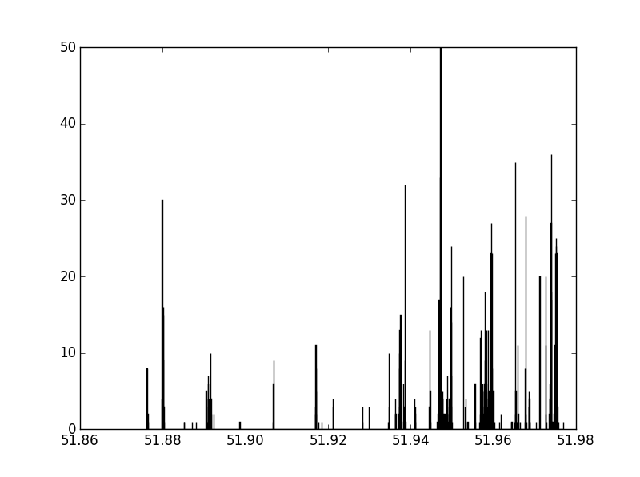

Figure histogram of ships longitudes

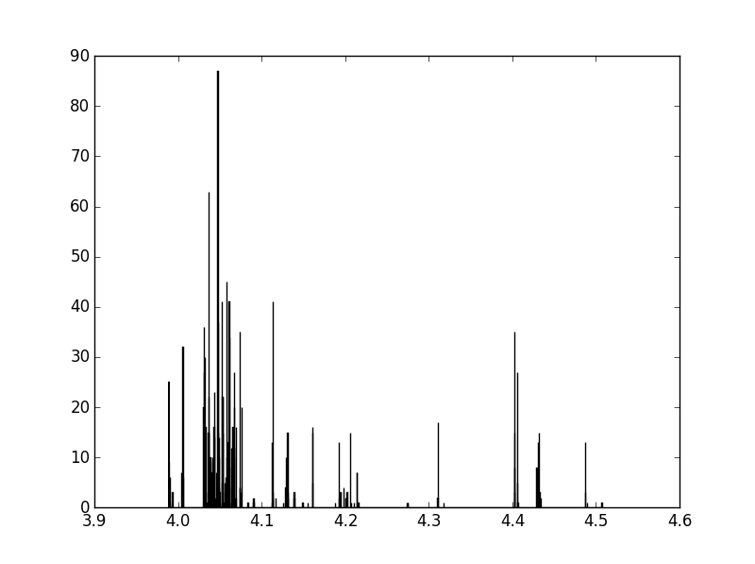

Figure histogram of ships latitudes

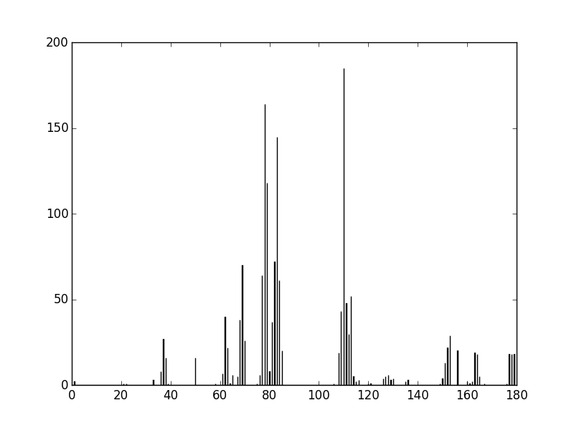

Figure Heading angle of all ships

# System design and assumptions

Data Integrity tests:

1. Consistency of data that is entered manually: 'MMSI','Class', 'Size', 'DistanceToBow', 'DistanceToStern', 'DistanceToPort', 'DistanceToStarboard'
2. size == distance to bow + distance to stern

width < size

Configuration:

All system configuration and parameters controlled via the configuration module

Assumptions

Docking locations assumptions:

1. Docking meaning speed =0
2. minimal docking time: 4 hours (configurable)
3. heading = constant on docking ( not used)
4. Elevation (depth) google api – only sea level acquired, can disqualify terrain errors
5. What google api: locations (optional )
6. satellite image with orientation [2]

Relevant ship assumptions:

1. minimal size of ship = 250m (configurable)
2. not marked as classes: “High speed craft”, “Military or law”, “Fishing”, “Passenger”, “Pleasure”
3. are consistent in entered parameters (mmsi, class, size and distances ) meaning the AIS was set professionally and is reliable

# A talk about distances and Angles

x amount of size (in meters) is equivalent to :

ra = 6378134 m , rb = 6356752.31 m (Wikipedia[1])

1. earth is sphere:
2. earth is ellipsoid- [out of scope]

we will talk only on the sphere case

r = (ra + rb) /2 = 6367443.155 m

∆x = (∆long/360 ) * pi * r

∆y = (∆lat/360 ) * pi * r

a * Angle= Distance

(Or in short, multiply by a = 55566.424 do get the distance between two angles)

Now let’s calculate the Google maps zoom size:

We want to see about 5 cm : 200 m ratio (sized ship), meaning : 200/0.05 =times: 4000

Where zoom = 1, the closest zoom we have is 2^ZOOM = 12: 2^12 = 4096.

Meaning a fraction of times 4096 of each axis comparing to full map: zoom=1 ->[-180:180],[-90:90]

Given L is the latitude axis length, L / 4096 = ∆y = a * ∆lat

∆limit_latitude, ∆limit_logitude = Lx, Ly / (a*4096)

a = 55566.424, Ly = 40007860 m, Lx =40075016 m

let’s determine minimal angular resolution: let say 100 m [0.1?], (minimal angle of where we wish to classify an object in space. Well take it slightly less than the ships size)

Meaning :

∆lat_reolution = 100/ ( 555.66424 * 2^ZOOM) = 10/ 2276000.72704 =4.39 *10^-5[degrees]

Meaning we need only 5 numbers after a decimal point accuracy

**REMARK-** it turned out I could not predict the Google Api Zoom scale, but this exercise did a great deal to understand and asses the resolution

# Results:

On the setting of resolution = 0.001647 degrees: the system detected 58 docks.

Here are the first 4 out of total 58 desired docks found (can be maybe calibrated to more, with the cost of duplicates by setting the resolution)

more images can be found at:

https://picasaweb.google.com/116781616540240633183/PredictedDocks

The code:

<https://github.com/forye/docks_images>

After installing all the correct module, run get_docks_candidates.py, to replicate the results,

Play with the configuration at config\configuration.py

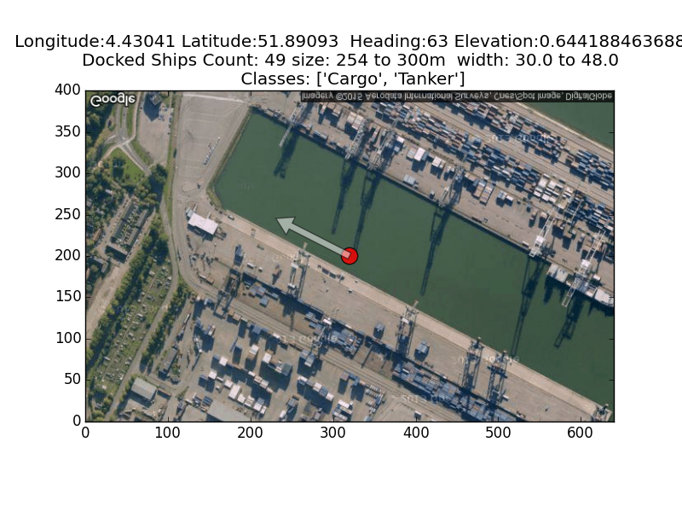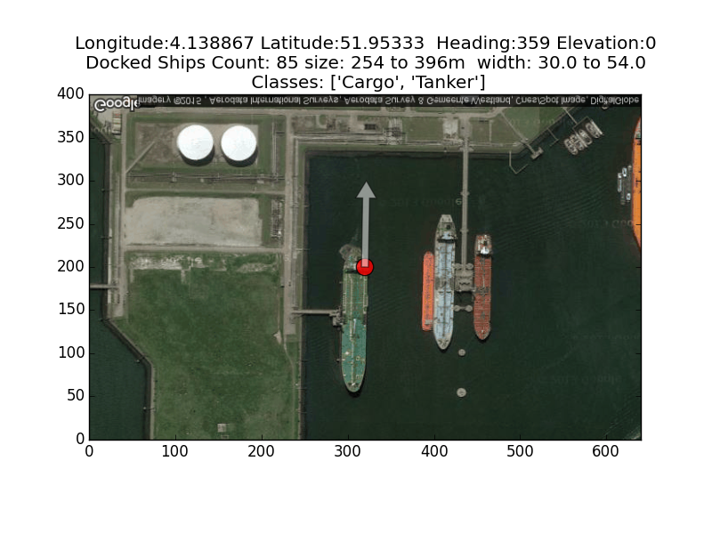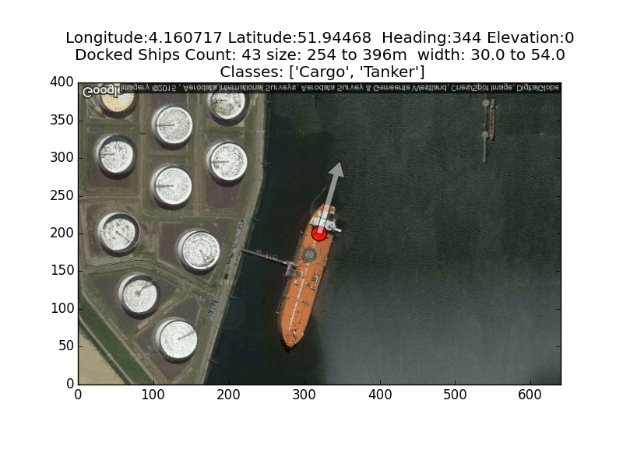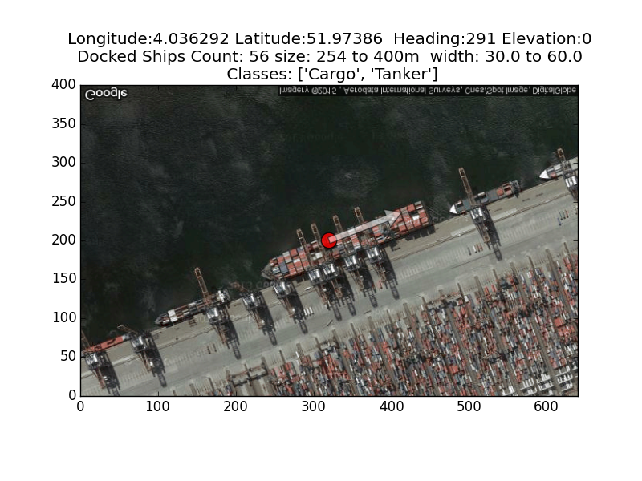

# references

[1] Wikipedia

https://en.wikipedia.org/wiki/Earth

[2] Google Static Maps API

<https://developers.google.com/maps/documentation/static-maps/>

[3] Google Elevation API

<https://developers.google.com/maps/documentation/elevation/intro>

[4] GitHub public repository: the code, resources and results

https://github.com/forye/docks_images.git