* **Question 1:** How does the number of inspections change over time (use month as the level of temporal granularity)? Does the number of inspections increase or decreate over time? Are there any peak times? Is there any seasonal effect (like inspections being more common during cretain seasons or months)?

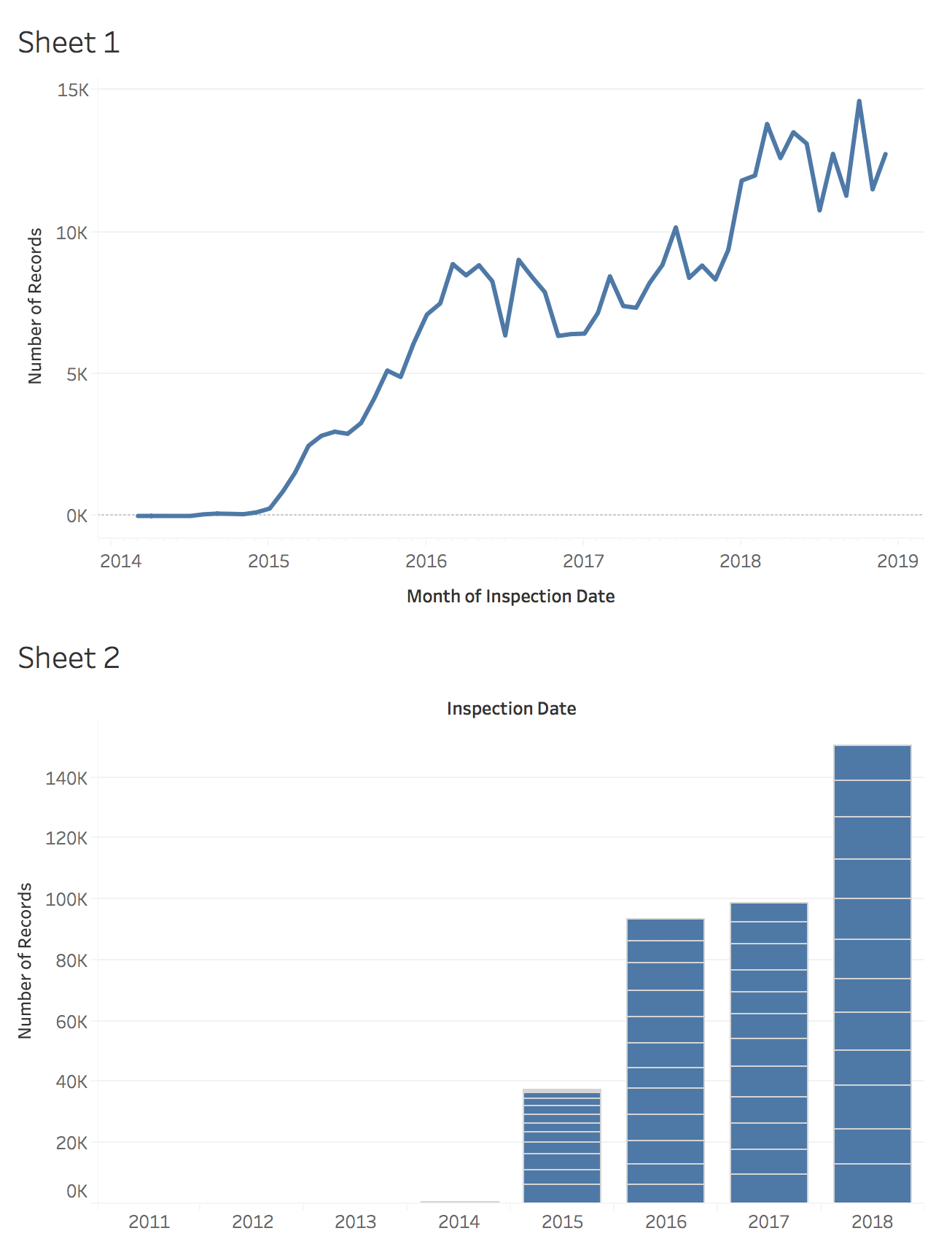

Inspections are increasing over time. As shown in both charts. There are trends downward around November and July as can be seen from Sheet 1, however, using the stacked bar chart on Sheet 2 the monthly distribution appears much more even.

* **Question 2:** Is there any difference in how the number of inspections changes over time in the 5 different boroughs of New York City?

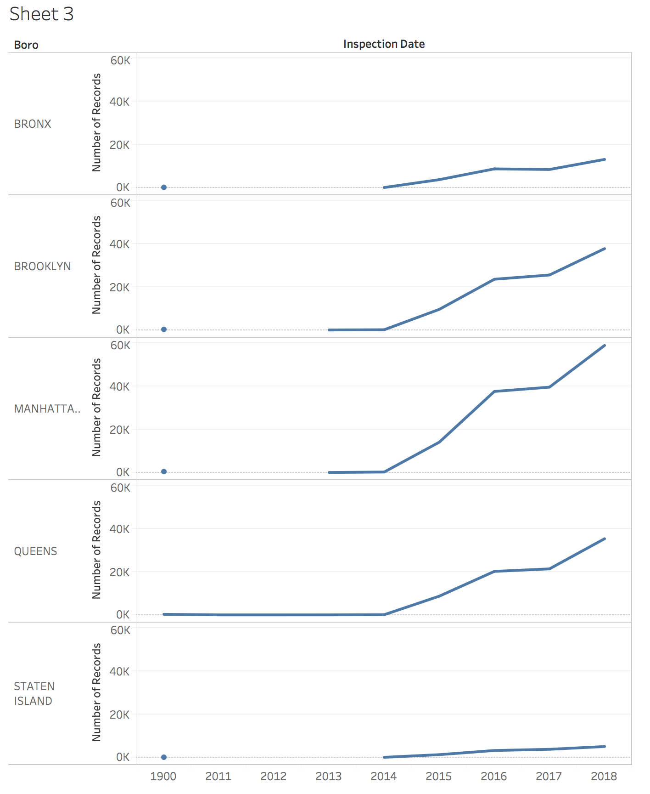

All the different boroughs have yearly increases in total inspections. Manhattan has the greatest total number of inspections in 2018.

* **Question 3:** How are cuisines types distributed across the New York area? Are there geographical areas where certain cuisines tend to concentrate (that is are there any areas where certain cuisines are more prevalent than others)? NOTE: focus only on the top 5 most frequent “Cuisine Description” categories.

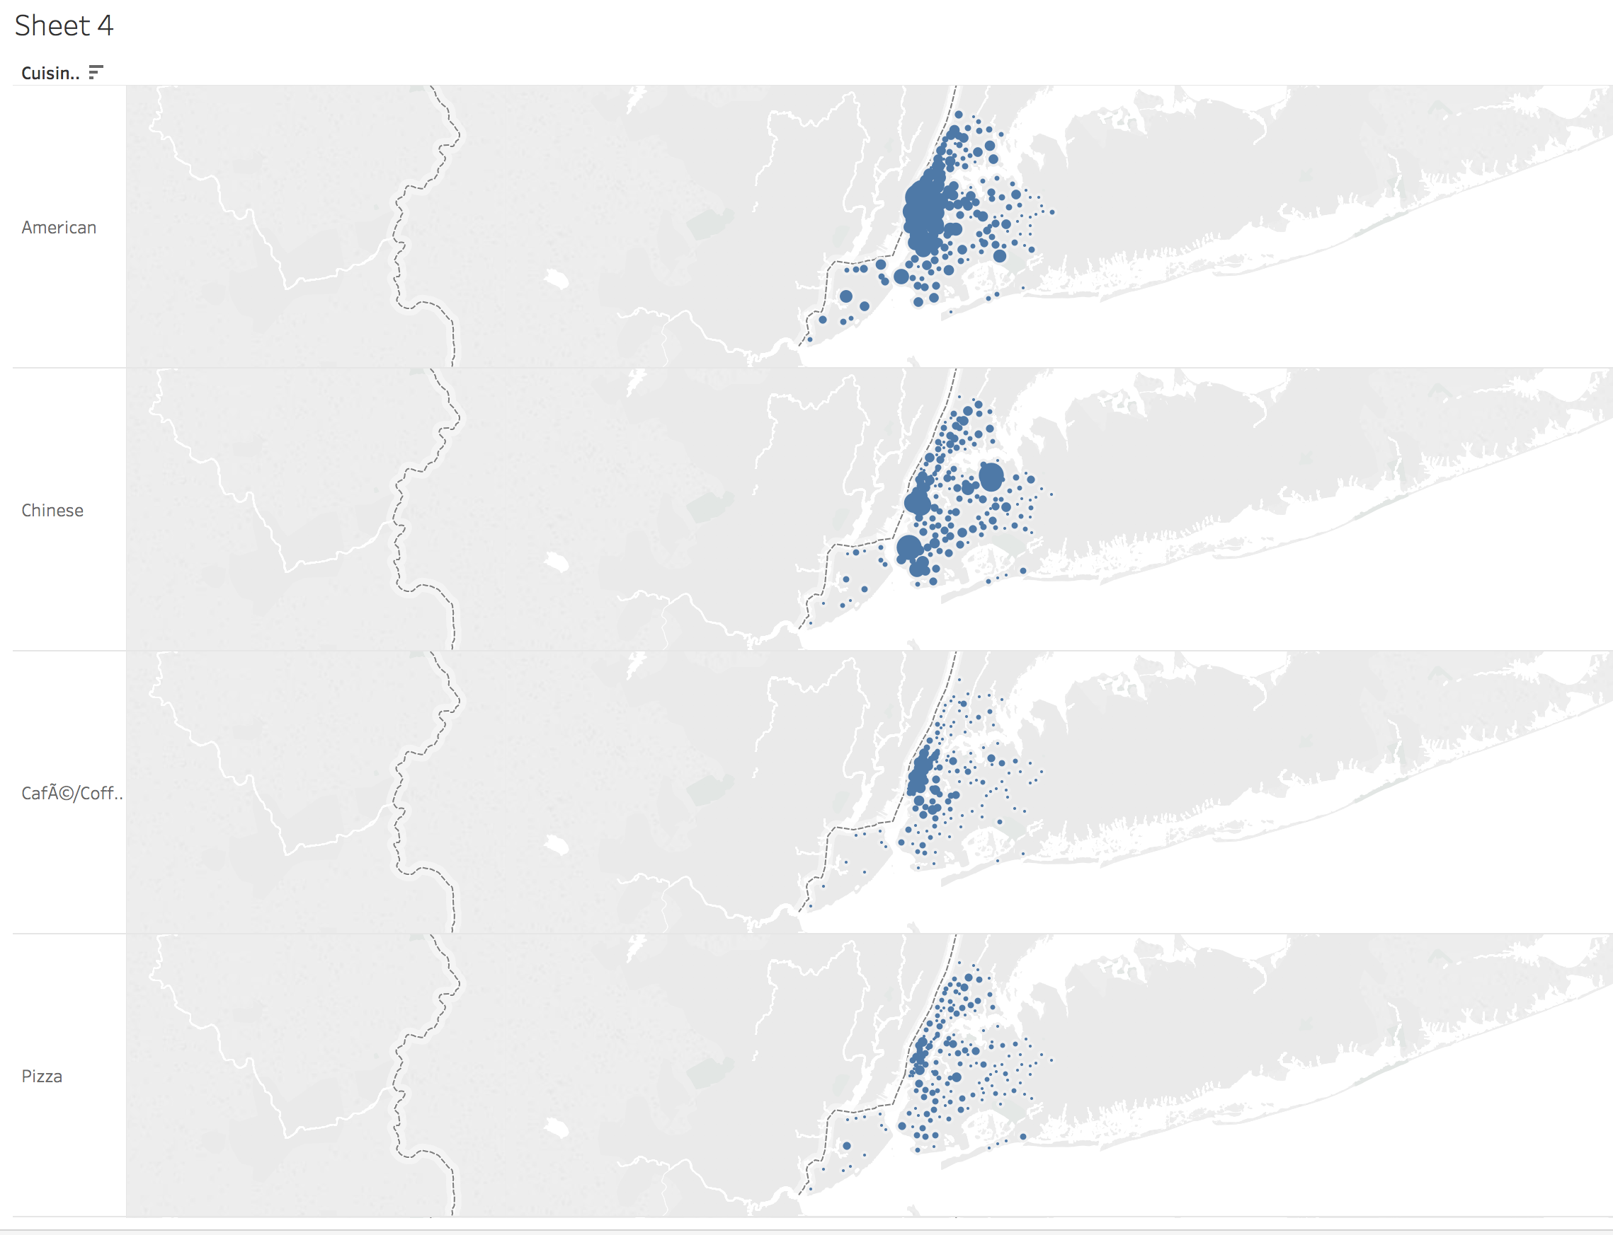

Geo-spatial plot of the top 5 Cuisine types. Chinese has 3 notable geographic areas with high concentrations of restaurants.

* **Question 4:** How does the average score compare across different cuisine types? Are there cuisines that tend to have consistently lower/higher average scores compared to the others? NOTE: focus only on the top 5 most frequent “Cuisine Description” categories.

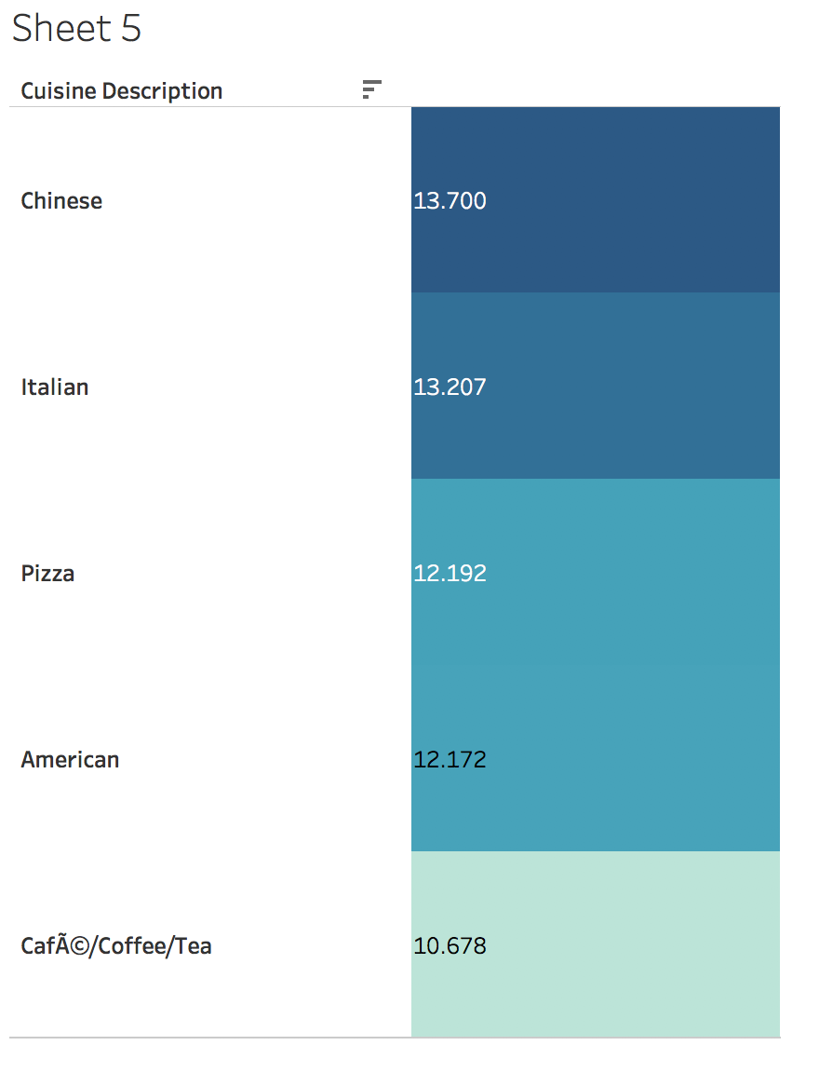

Average score of the five most common categories.

* **Question 5:** Is there a relationship between cuisine type and violation? For instance, do some cuisine types tend to have more of some type of violations that other cuisine types?

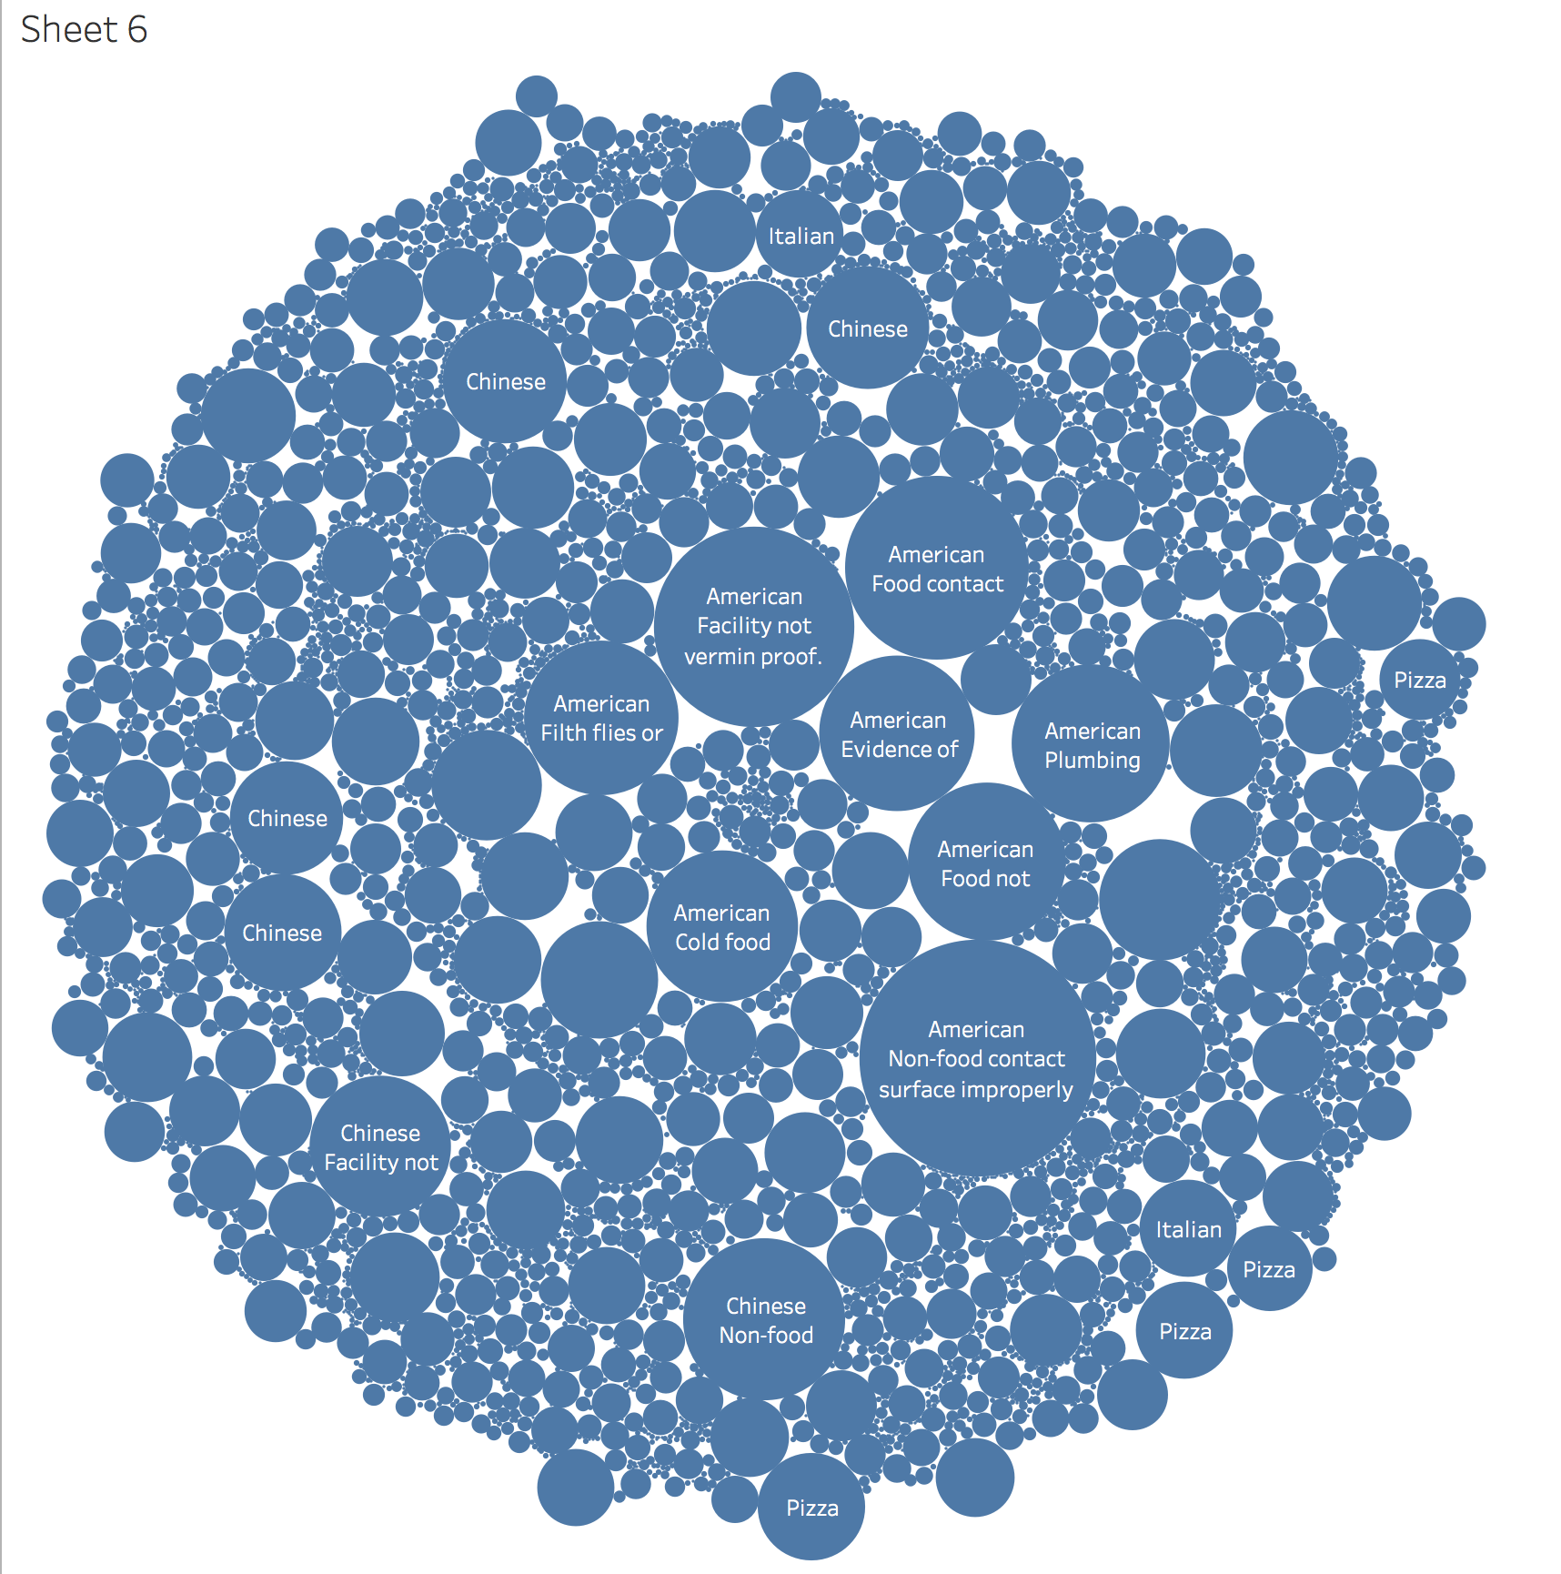

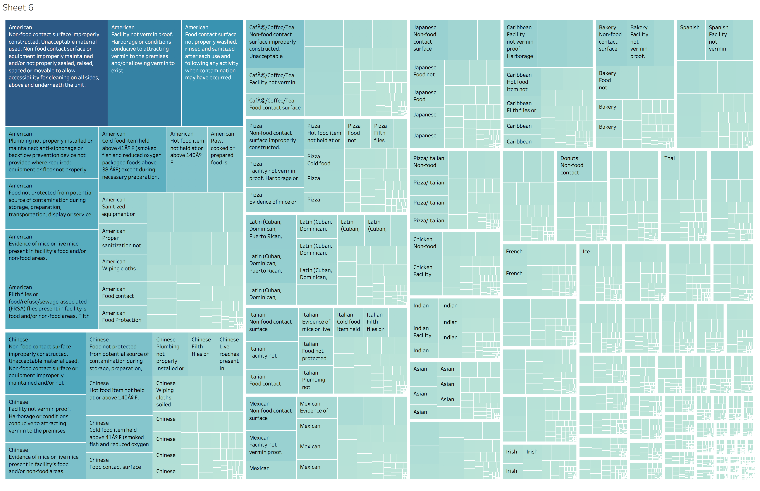

Two Chart showing violation per cuisine type. Non-food contact surface violation is common for many cuisine types. The violation types are distributed evenly across cuisine types.