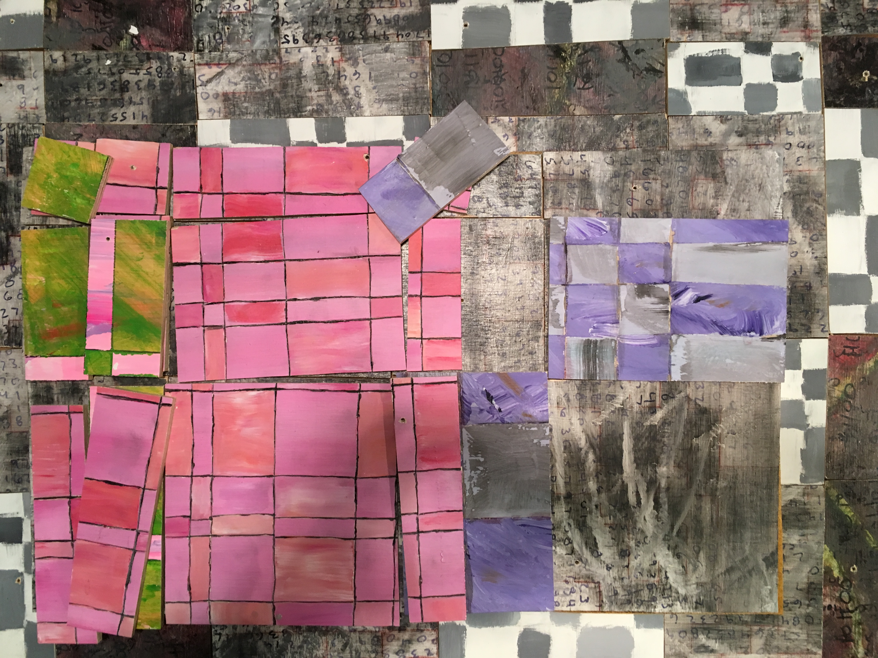**Tectonics**

An exhibit of materials under geological movements

**Artist, Jarvis Fosdick**

Beginning March 3rd, 2017

Every First Friday

3525 Walnut Street, RINO

Inside the Walnut Workshop

**Interactive painting and**

**graffiti space open**

**to visitors.**