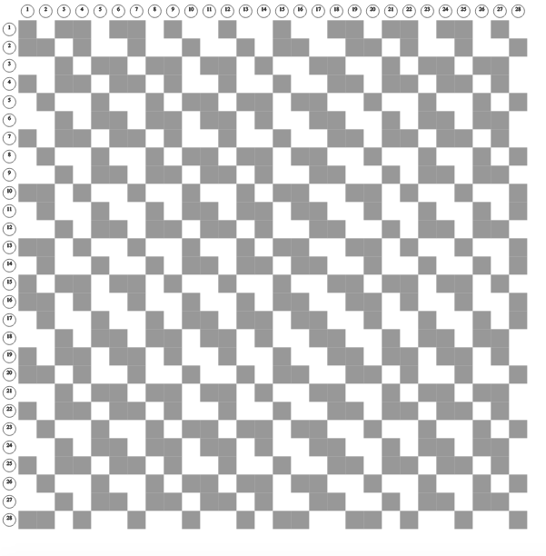

lg_ss3x1_28

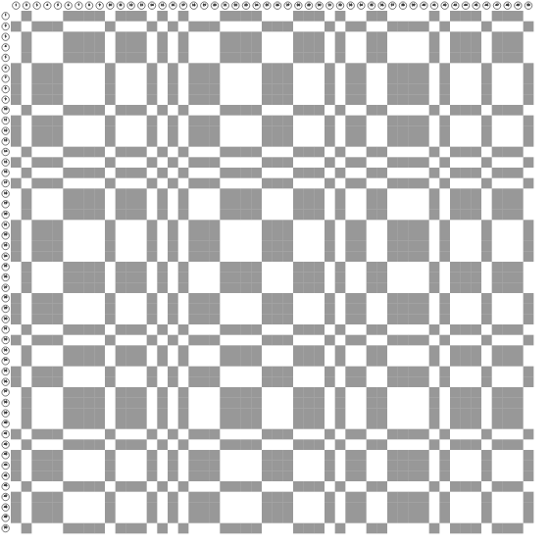

**lg_sqrt5**

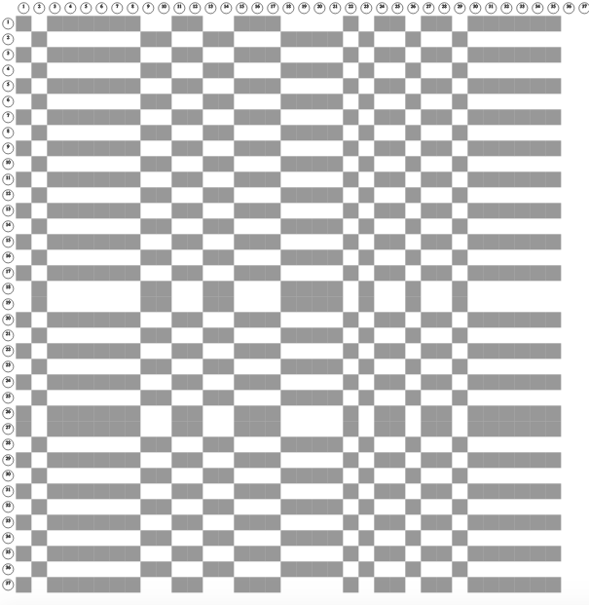

#### sqrt5andsig26

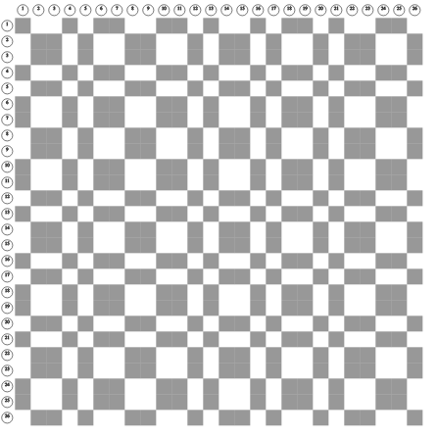

**lg_mth1**

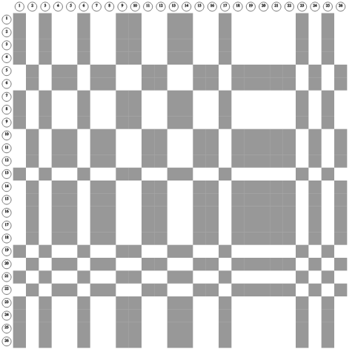

**lg_sqrt3and7x23_27d-4**

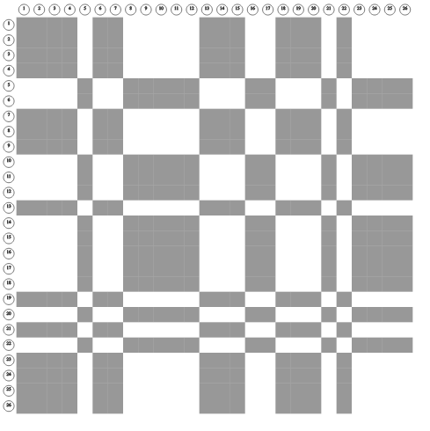

#### g_sqrt3and7x23_27c-3

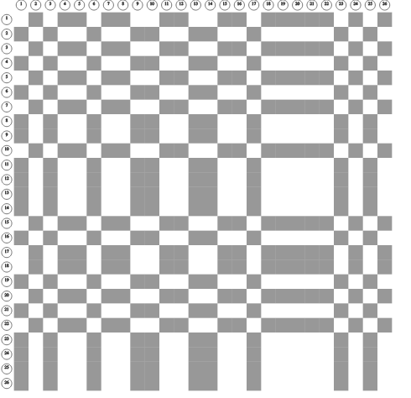

**lg_sqrt3and7x23_27b-2**

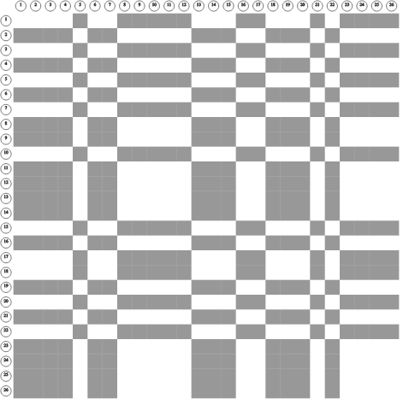

**lg_sqrt3and7x23_27a**-4