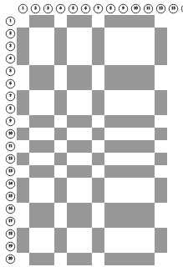

lp_sqrt5and11z_104x100_160a

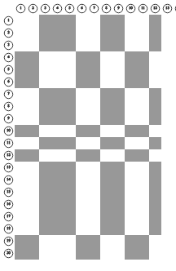

lp_sqrt5and11z_104x100_160b

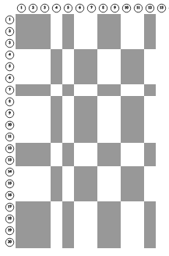

lp_sqrt5and11z_104x100_160c

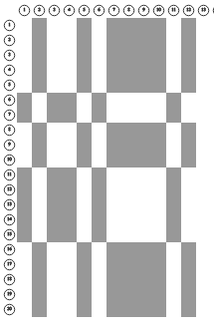

lp_sqrt5and11z_104x100_160d

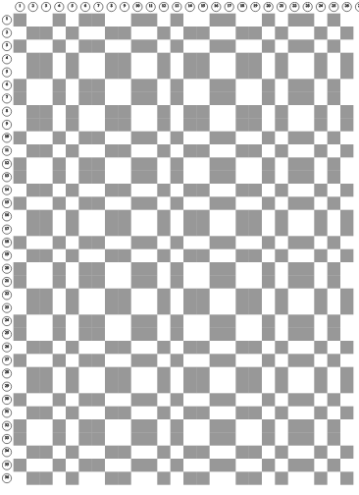

lg_mth3

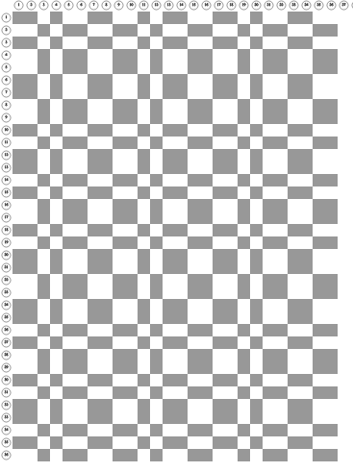

lg_mth2



lg_mth3



lg_mth2