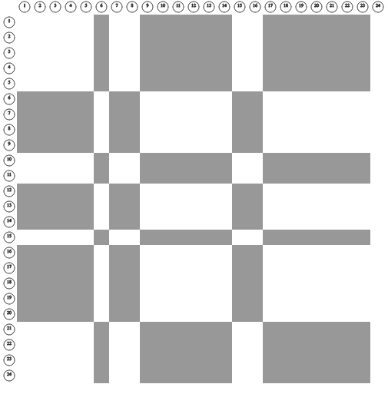

**pp_sqrt13x5r150_300**

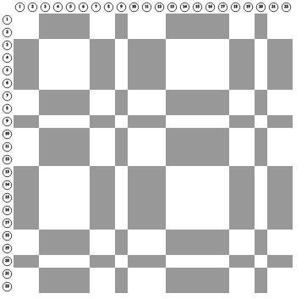

#### pp_sqrt23z50_22

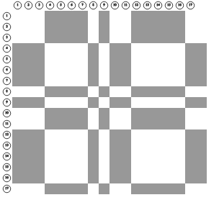

**pp_sqrt23z28_20**

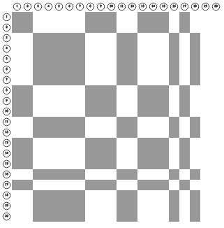

#### pp_sqrt7mod6z18_20

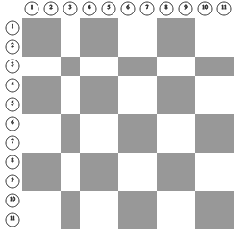

#### pp_sqrt7mod6z75_86

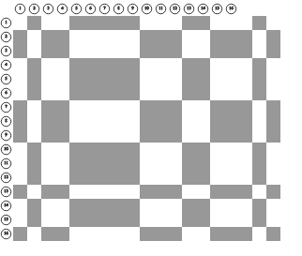

#### pp_sqrt3and7z19_16

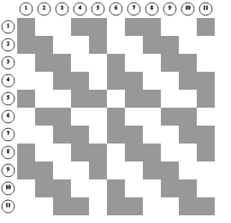

#### pp_ss3_notes

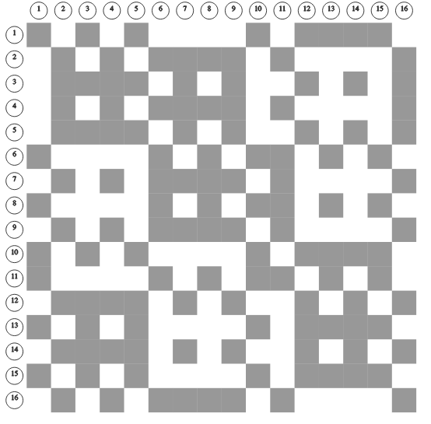

#### pp_ss2

#### 

#### pp_sqrt7mod6z67_92

#### 

#### pp_sqrt11and11z_66