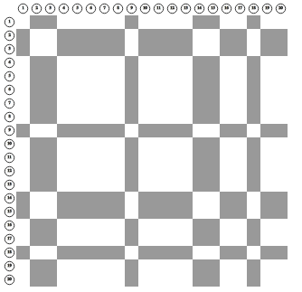

pp-sqrt5_14883

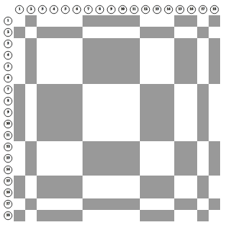

pp_sqrt5_4440

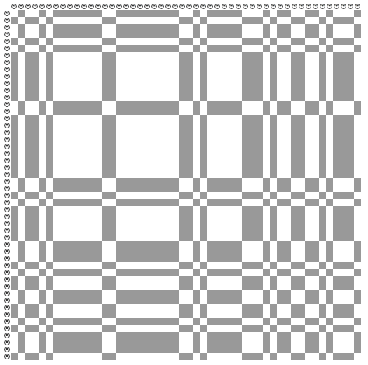

lp_sqrt5_5280x50

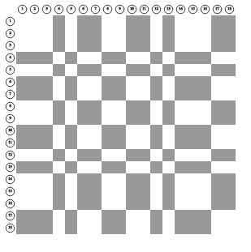

**pp_sqrt5_5332x18**

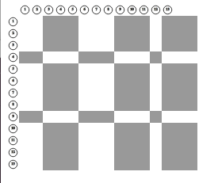

#### pp_sqrt5_5650_5605x15_13

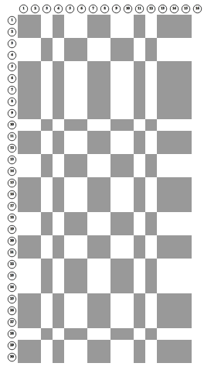

#### lp_sqrt5_5314_5337x18_30