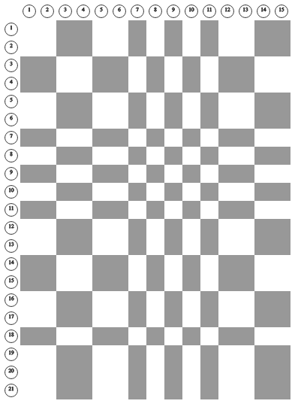

**sqrt11and11z106_15x24**