**sqrt5_1248x600_lw_20_30**

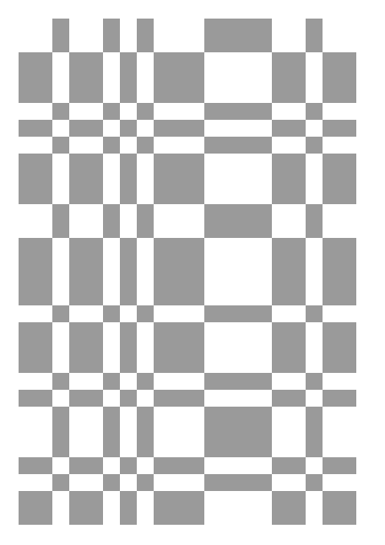

**sqrt5_1248x650_lw_20_30**

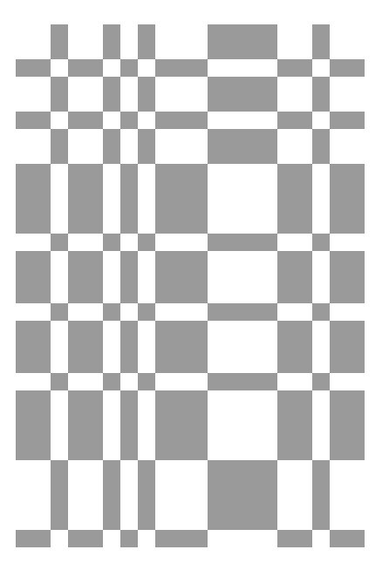

**sqrt5_1248x650_lw_20_30**

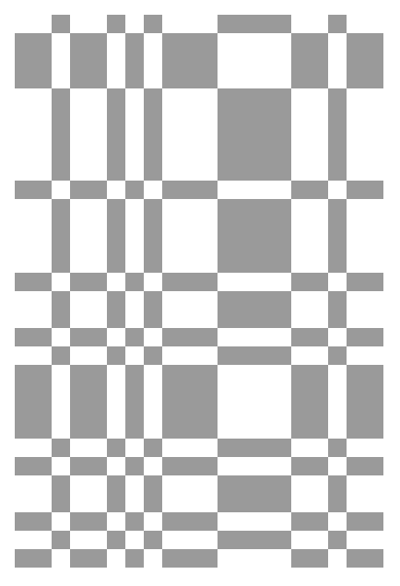

**sqrt5_860x799_lw_20_30**

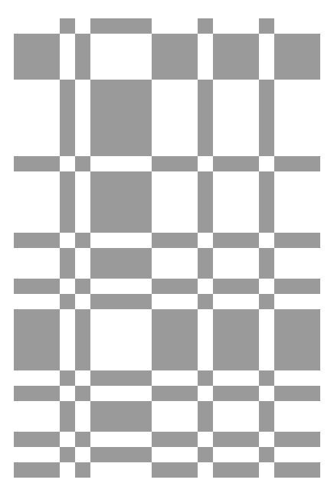

**sqrt5_786x2378_lw_20_30**

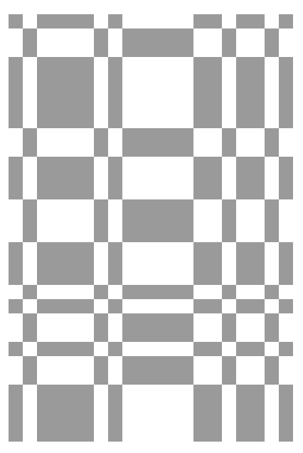

**sqrt5_3786x23780_lw_20_30**

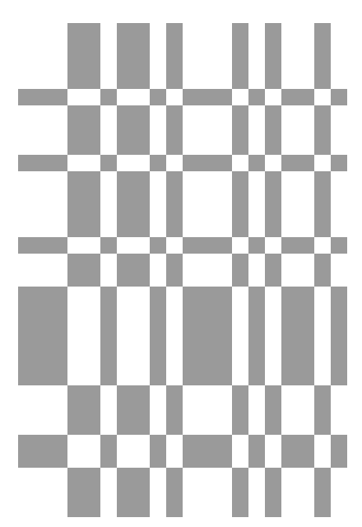

**sqrt5_3686x23780_lw_20_30**



**sqrt5_7686x23780_lw_20_30**



**sqrt5_7686x21740_lw_20_30**



**sqrt5_7696x11740_lw_20_30**

