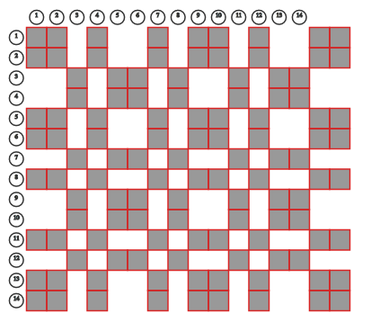

**mth1z16_14**

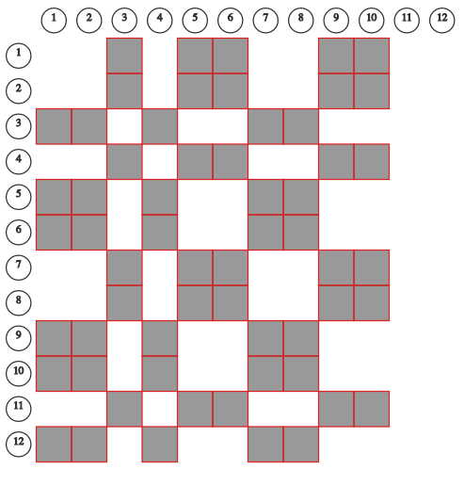

#### mth1z8_7

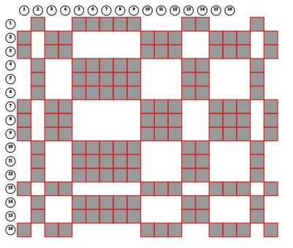

**sqrt3and7z19_16**

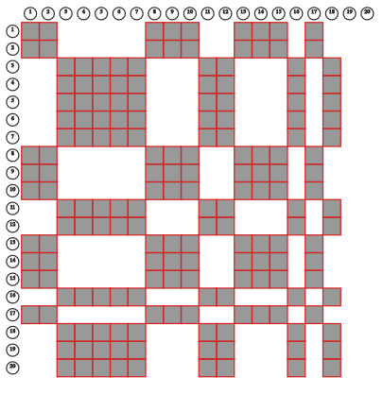

#### sqrt7mod6z18_20

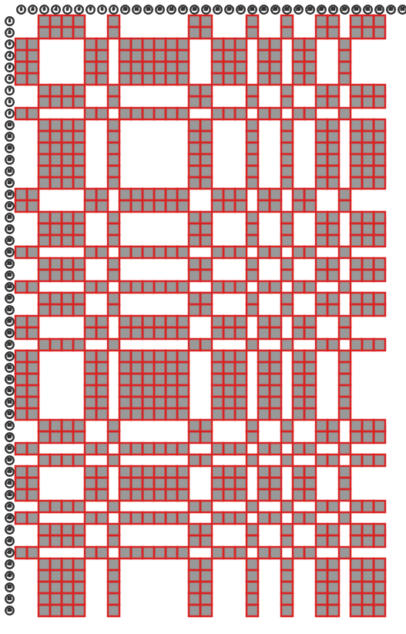

#### sqrt11zoom52x32

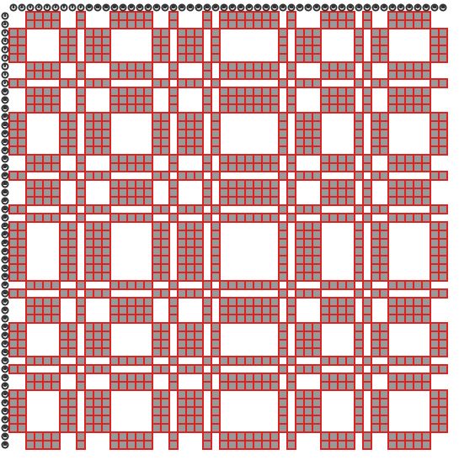

#### sqrt23zoom52sq

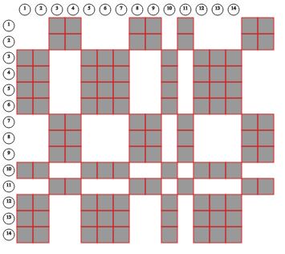

#### sqrt29z22_2 (16x14)