An artist book

Jarvis Fosdick

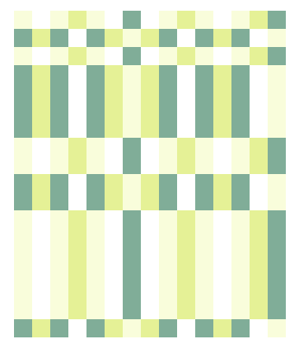

sqrt7x10862_8450z15_18

An artist book

Jarvis Fosdick

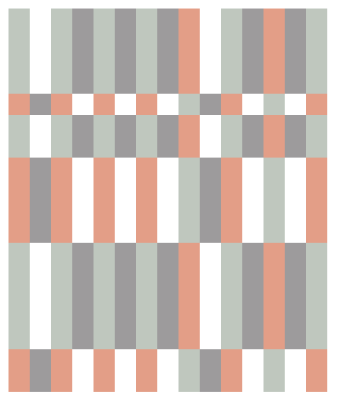

sqrt5x7573_16564z15_18