**SEARCH FOR A USER AND RETURN ASSOCIATIVE ARRAY RESPONSE - ACTIVITY**

**NAME: Montemayor, Charles David A.**

**SECTION: UCOS 3-1**

**INSTRUCTIONS.**

* Our goal for this activity is to improve the **JOB APPLICATION SYSTEM** you just created. How are you going to identify the user who created the applicant? We can implement a login/registration feature. How can we identify which applicants’ data are inserted, updated, or deleted? We can create the activity_logs table like I did from the recent lecture.
* What you must submit here is the last system you created but now, with a **LOGIN/REGISTRATION** and monitoring of **ACTIVITY LOGS** feature. Please keep in mind that all activity logs from users should be stored, **INSERTION, UPDATING, DELETION** and even search keywords a **USER SEARCHED**.

1. What does your entire SQL schema look like? Paste a screenshot below.

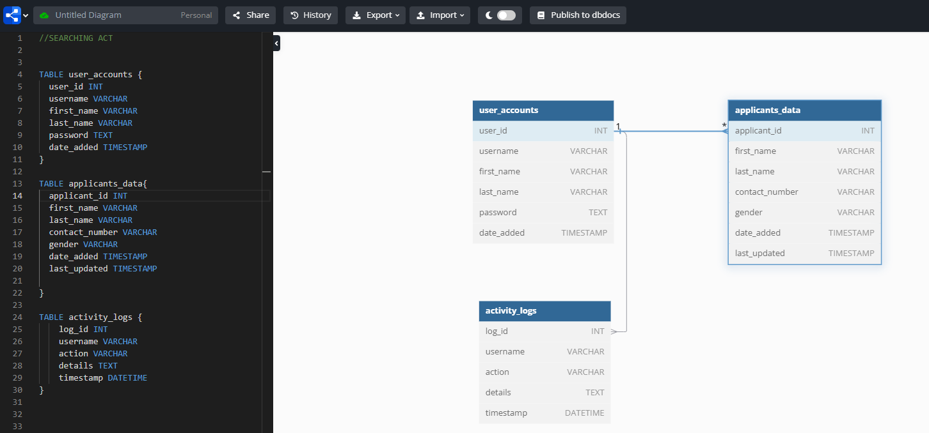

1. Please paste a Google Drive link below of a video presentation where you **create a new applicant, edit an applicant, delete an applicant, search for an applicant,** and an indication that each activity is inserted to the activity logs table. Every row stored there should contain the **USERNAME** of whoever **PERFORMED THE ACTION** and the **DATE ADDED**. Please make sure you set the visibility to **anyone with a link**.

<https://drive.google.com/drive/folders/13V7zCt-qNEpjQ0fGbJ8m9BXy1I40wH-3?usp=sharing>

1. Paste the GitHub link of your job application system below.

<https://github.com/foshoo0/searchingitcompanyapplicants_act2finals>